Marc Beutner / Rasmus Pechuel (Ed.)
  - IDEAL-GAME:
  - Improving didactics, education and learning in higher education with the Online Serious Game Creator

IK-Verlag

  - Handbook for students

The IDEAL-GAME project, addressed in this book, is co-funded by the ERASMUS+ programme of the European Union, The European Commission is not responsible for any uploaded or submitted content. Such content expresses the views of its author(s) only.

Bibliographische Information Der Deutschen Bibliothek

Die Deutsche Bibliothek verzeichnet diese Publikation in der Deutschen Nationalbibliographie; detaillierte bibliographische Daten sind im Internet verfügbar über:
http://dnb.ddb.de abrufbar.

ISBN:
1. Aufl. 2022
© Lehrstuhl Wirtschaftspädagogik II, Universität Paderborn

und
©

Ingenious Knowledge Verlag
Hausanschrift: Friedrich-Karl-Str. 200, 50735 Köln
Telefon: (0221) 16820019
Köln, December 2022
All rights, including partial reprinting, photomechanical reproduction (including microscopy) and evaluation by databases, are reserved.

Content

Introduction 7
Part A – The IDEAL-GAME project 10
1. The IDEAL-GAME partners 10
2. Main objectives and core aspects of IDEAL-GAME 14
3. Developments of IDEAL-GAME 15
4. The IDEAL-GAME results 17
Part B - The IDEAL-GAME Creator Tool 23
5. IDEAL-GAME Creator -Structure and aims 23
6. How to use the IDEAL-GAME Creator 24
7. Functions of the IDEAL-GAME Creator 26
Part D Pedagogical and Didactic Implementation 28
8. A Step by Step Guide to the IDEAL-GAME Creator 28
a. Raining Words 38
b. Collect Words 44
c. Memory 48
d. Build a Bridge 52
e. Conversation Game 55
f. Quiz Game 60
g. Explore Campus 64
h. Crane 67
9. Conclusions 70

Figures

Figure 1: Homepage of IDEAL-GAME Creator 28
Figure 2: Login of IDEAL-GAME Creator 29
Figure 3: Control Panel of IDEAL-GAME Creator 30
Figure 4: Control Panel - Create New Game of IDEAL-GAME Creator 31
Figure 5: Create game of IDEAL-GAME Creator 31
Figure 6: Select a game type of IDEAL-GAME Creator 32
Figure 7: Manage Groups of IDEAL-GAME Creator 33
Figure 8: Edit Group (1) of IDEAL-GAME Creator 34
Figure 9: Edit Group (2) of IDEAL-GAME Creator 35
Figure 10: Feedback Button of IDEAL-GAME Creator 35
Figure 11: Games and Groups of IDEAL-GAME Creator 36
Figure 12: All Categories of IDEAL-GAME Creator 37
Figure 13: Raining Words, Manage Game 38
Figure 14: Raining Words, Word Overview (1) 39
Figure 15: Raining Words, Word Overview (2) 40
Figure 16: Raining Words, Category Overview 41
Figure 17: Raining Words, General Settings 42
Figure 18: Collect Words, Manage Game 44
Figure 19: Collect Words, Word Overview 45
Figure 20: Collect Words, General Settings 46
Figure 21: Memory, Manage Game 48
Figure 22: Memory, Node Overview 49
Figure 23: Memory, General Settings 50
Figure 24: Build a Bridge, Manage Game 52
Figure 25: Build a Bridge, Node Overview 53
Figure 26: Build a Bridge, General Settings 54
Figure 27: Conversation Game, Manage Game 55
Figure 28: Conversation Game, Node Overview (1) 56
Figure 29: Conversation Game, Node Overview (2) 56
Figure 30: Conversation Game, Result Overview (1) 57
Figure 31: Conversation Game, Result Overview (2) 57
Figure 32: Conversation Game, General Settings 59
Figure 33: Quiz Game, Manage Game 60
Figure 34: Quiz Game, Question Overview 61
Figure 35: Quiz Game, Result Overview 62
Figure 36: Quiz Game, General Settings 63
Figure 37: Explore Campus, Manage Game 64
Figure 38: Explore Campus, Upload an image 65
Figure 39: Explore Campus, General Settings 66
Figure 40: Crane, Manage Game 67
Figure 41: Crane, Node Overview 68
Figure 42: Crane, General Settings 69

Abbreviations

cf cited from
HE Higher Education
Ibid. abbreviation for the Latin word ibīdem, meaning ´in the same place´
IDEAL GAME Project -
"Improving didactics, education and learning in higher education
with the Online Serious Game Creator"
IK Ingenious Knowledge GmbH
IO Intellectual Output
IT Information Technology
OER Open Educational Resources
PR Project Result
UDIMA Universidad a distancia de Madrid SA, Spain
UPB University Paderborn, Chair Business and Human Resource Education II Germany
UoD University of Dundee, United Kingdom
UPIT Universitatea din Pitesti, Rumania
WSEI Wysza Szkola Ekonomii i Innowacji w Lublinie, Poland

Introduction
UPB -Marc Beutner
Digitisation and the use of modern media is becoming more and more crucial in Higher Education (HE). Lectures are not only held face-to-face these days. At least since the COVID-19 pandemic but also in the years before, the use of video inputs, online tools like padlets, etc. as well as online synchronous and asynchronous ways of teaching have become a standard in HE. Lecturers use their lectures within modules or courses to support their students when there is a need to acquire knowledge of terms, facts, and concepts. This can be on a basic but also on an advanced level of knowledge acquisition. Blight stated already in the year 2000 that lectures are as effective (Bligh, 2000). Nevertheless, it became pretty clear to Bligh that lectures are not really more effective, than other teaching methods (Bligh, 2000). Moreover Bunce / Flens / Neiles pointed out students cannot pay attention in class for longer periods of time (Bunce / Flens / Neiles 2010, p 1438ff.). This means that motivation of students is an important issue.
Baylor University stated that “lectures worth listening to
- Are organised […]
- Are delivered with Authenticity […]
- Are Accompanied by Guidance and Opportunity for Note-Taking […]
- Invite Questions […]
- Solicit and Act on Feedback […]” (Baylor 2022)
So, it is obvious that with regard to teaching methods in HE there are some more teacher related ones, like the lectures mentioned above or worked examples, and some more student related one, like collaborative or inquiry-based or project-based approaches (see as well at Faculty Center 2022). Many teaching methods in HE refer to specific principles for smart teaching like the one mentioned by Ambrose in 2010, e.g. Goal-directed practice, targeted feedback or self-directed learning. Emerging online environments as younger fields of teaching methods, had influence to educational learning in HE. You can find several students who thrive in this digital supported learning environments. However, you can also find those who become amotivated and who are not engaged any more.
One way to increase students’ motivation within digital learning environments is to focus on serious games. But, usually serious games are rare and do not fit so good to a specific topic or they are not as flexible as the lecturers need them to be. Here, mini-serious games can come into action and this is also the point where our project IDEAL-GAME - Improving didactics, education and learning in higher education with Online Serious Game Creator – has a specific focus with the design and implementation of our Mini-Serious Game Creator that helps to create Mini-Serious Game easily and offers a chance to integrate aspects in our scenarios which are both motivational but also an innovative way of providing knowledge.
Our approach in IDEAL-GAME goes hand in hand with trends towards intensive use of the internet, social media approaches and smart HE teaching solutions. The integration of such types of digital methods offer and create added value to learning and teaching processes and offers high quality services and innovative instruments for HE.
This book is based on the results of the Erasmus+ project IDEAL-GAME which is situated in the EU ERASMUS + programme as a strategic partnership in the field of Higher Education.
Core idea of this project was to address new and innovative ways of learning and teaching in HE to improve teaching and learning in higher education institutions. The project is developing an online tool for creating small or mini serious games for higher education. This means that a game-based learning approach is incorporated in HE.
The partners of the international project IDEAL-GAME foster the quality of Higher Education and also foster lecturers with additional information. Moreover, we broaden the perspectives and ways to deal with digitisation in HE.
In total is becoming clear that digitization in HE is not only digitization of teaching processes but also the change of way of dealing with students at higher education organisations due to new processes and ways of improving academic outcomes. This book should be a guide to students and offers insights in our project. Focussing our tool, the IDEAL-GAME Serious Game Creator goes hand in hand with offering different aspects of teaching and learning in HE. We try to help the reader to establish their own position with regard to the current developments and use of game-based learning approaches in the digital parts of Higher Education.
Personally, I wish you a pleasant journey within our handbook and our ideas and solutions. Enjoy reading this lecturer handbook and remember that it is crucial to focus on your own specific situation. So, we would be happy if you apply our tool but with regard to your own HE-situation and your precise contexts.

Marc Beutner
Paderborn, December 2022
References
Ambrose, Susan A., eds. How Learning Works: Seven Research-based Principles for Smart Teaching. San Francisco, CA: Jossey-Bass, 2010.
Baylor (2022): Effective Lectures. On the Internet: https://www.baylor.edu/atl/index.php?id=965135, Access date: 15.11.2022.
Bligh, D. A. (2000). What’s the use of lectures? San Francisco: Jossey-Bass.
Bunce, D. M., Flens, E. A., & Neiles, K. Y. (2010). How long can students pay attention in class? A study of student attention decline using clickers. Journal of Chemical Education, 87(12), 1438-1443.
Faculty Center (2022): Teaching Methods Overview. On the Internet: https://fctl.ucf.edu/teaching-resources/teaching-strategies/teaching-methods-overview/, Access date: 15.11.2022.

Part A – The IDEAL-GAME project
UPB / UPIT
Marc Beutner / Georgeta Chirlesan / Alexandru Dan Toma

The IDEAL-GAME partners
“Improving didactics, education and learning in Higher Education with Online Serious Game Creator” [acronym IDEAL-GAME] is a project financed by the Erasmus+ Programme of the European Union – a Strategic Partnership for Higher Education, and has the reference number 2020-1-DE01-KA203-005682. It is situated under Key Action 2 - Cooperation for innovation and the exchange of good practices.
The project is implemented by a consortium of 6 partner-organisations from 5 European countries: Germany, Romania, Poland, United Kingdom and Spain. This consortium gathers five public and non-public universities and one IT company providing educational resources.
More precisely the IDEAL-GAME partners are:
Universität Paderborn (UPB) (Germany) is the project coordinator. Universität Paderborn is the University for the Information Society. Its strong foundation in computer science and its applications, as well as the importance of IT for a growing number of disciplines, are the pillars for this claim. Its mission includes a strong international and cultural presence, since the information society is decidedly global and should not remain a purely intellectual undertaking. The university orchestra, the drama group, and more than 70 different sports, are some of the important university activities that help characterize academic life here in Paderborn.
The five faculties cover a broad range of courses of study in the arts and humanities, business studies, natural sciences, and engineering. Universität Paderborn offers 63 degree programs at bachelor and master level.
With over 20,300 students, 255 professors and a library that is open 350 days a year, the compact campus of the university provides a friendly, green, connected environment with excellent services for student life.
For more information please visit: https://www.uni-paderborn.de/en/university
Ingenious Knowledge (IK) (Germany) prides itself in its ability to deliver cutting edge IT solutions and innovative approaches in education. They design and provide e-Tools (e.g., a system to analyse interests and skills as a basis for better orientation), serious games which includes advanced didactical concepts with tightly integrated mixtures of learning/training content and fun, new learning approaches technology-based and projects and services for career orientation.
For more information please visit: https://www.ingeniousknowledge.com/?id=1
Universitatea din Pitești (UPIT) (Romania) is a comprehensive and multidimensional state university that undertakes the mission of education and research, by achieving the modern university's trinomial: education - research - community services, as follows:
- Professional development at the undergraduate and postgraduate level and in the concept of lifelong learning, for the purpose of personal development, insertion of graduates into the labor market, satisfying the socio-economic environment's needs of competences and adaptability to permanent changes.
- Generating and transferring knowledge through fundamental and applicative scientific research, development, innovation and technology transfer, individual and collective creation, relevant and meaningful at the regional, national and international level.
- Promoting and developing partnerships at the local, regional and national level in order to involve the University in solving community problems and increasing visibility and prestige.
With 6 faculties and over 10.000 students enrolled in study programmes at Bachelor, Master and Doctoral levels, the UPIT’s educational offer is a very generous one, with branches opened in the areas of interest in the region.
For more information please visit: www.upit.ro
Wyzsza Szkola Ekonomii i Innowacji w Lublinie (WSEI) (Poland) is the largest non-public university in eastern Poland, known for its practical preparation for the profession and extensive cooperation with enterprises. Enjoying significant prestige, being a leader in terms of preparing graduates and receiving the highest awards for education for the needs of the labour market, WSEI has 22 years of existence, 40.000 graduates and 9.000 of students and listeners. The mission of WSEI is to prepare the highly qualified professionals, who will be able to meet European standards and who then reinforce the human resources potential and enhance the capacity of local government institutions in terms of public finance management, strategic planning or absorption and management of EU funds. In the context of economic development of the region those mentioned areas of activities are the key challenges that the public and private sector is to face in the next few years.
For more information please visit: https://rekrutacja.wsei.lublin.pl/en/
University of Dundee (UoD) (United Kingdom) was founded in 1881. Nowadays, its core purpose is to transform lives, working locally and globally through the creation, sharing, and application of knowledge. The university is organised into ten schools. In addition, all of these schools have associated research centres or units. Through the University of Dundee Strategy 2022-27, the university aims to develop itself as a place where they can each grow their abilities, where people come to be stretched, to contribute, and to have positive impact on the world.
For more information please visit: https://www.dundee.ac.uk/
Universidad a Distancia de Madrid SA (UDIMA) (Spain) is the first private online university in Spain. Its methodology is based on online training, making use of the latest information and communication technologies. In this way, it contributes to the fact that, despite the distances, the student feels accompanied by the teacher and his classmates at all times. Not surprisingly, the idea of being ´the closest university´ to the student throughout the learning process circulates in its DNA. The campus and main headquarters of the University are located in the Madrid town of Collado Villalba. UDIMA has 5 faculties and also affiliated centres. UDIMA is a private Higher Education institution whose specific purposes are the following:
- Train and provide access to university education and the continuity of studies to all those people qualified to pursue higher studies in accordance with State legislation.
- Improve educational methods based on information and communication technologies (ICT).
- Promote the use of ICT using the most suitable online distance learning techniques and experiences, as well as testing new educational models at the service of students and also of universities, institutions and companies with which collaboration agreements and programs are established. methodological support.
- Contribute with all the means at its disposal to the construction of a more just, supportive, peaceful and democratic society.
- Prioritize the development of human dignity and the implementation of effective equality between women and men, particularly through the elimination of all discrimination based on sex.
For more information please visit: https://www.udima.es/es/la-udima.html

References
IK (2022): Information on Ingenious Knowledge GmbH. On the Internet: https://www.ingeniousknowledge.com/?id=1, Access date: 25.11.2022.
UoD (2022): Information on the University of Dundee. On the Internet: https://www.dundee.ac.uk/, Access date: 25.11.2022.
UDIMA (2022): Information on the Universidad a Distancia de Madrid SA. On the Internet: https://www.udima.es/es/la-udima.html, Access date: 25.11.2022.
UPB (2022): Information on the University Paderborn / Universität Paderborn. On the Internet: https://www.uni-paderborn.de/en/university, Access date: 25.11.2022.
UPIT (2022): Information on the University Pitesti / Universitatea din Pitești. On the Internet: www.upit.ro, Access date: 25.11.2022.
WSEI (2022): Information on Wyzsza Szkola Ekonomii i Innowacji w Lublinie. On the Internet: https://rekrutacja.wsei.lublin.pl/en/, Access date: 25.11.2022.

Main objectives and core aspects of IDEAL-GAME
IDEAL-GAME is an ambitious project that aims to support the process of learning in Higher Education institutions in a modern and innovative manner that implies the use of serious, intelligent and fascinating games. These games are in fact digital tools especially designed to improve the processes of understanding, memorizing and thoroughgoing study and also to reduce stress during these intellectual activities.
The project aims to design an Online Serious Game Creator and create, test and evaluate Mini OER Serious Games within learning scenarios. It aims to improve didactics, education and learning in higher education with Online Serious Game Creator. In the IDEAL-GAME project, higher education institutions are jointly creating an online game creator for serious games to improve teaching and learning in higher education institutions. Within the project the partners design an online tool for the creation of small Serious Games for higher education.
The additional OERs (Open Educational Resources) provided by the IDEAL-GAME project are addressed to different specialists - like teachers, trainers, researchers, students, technicians and youth employees, working in a vast field of activities. The project envisages to improve didactics, education and learning in Higher Education with Online Serious Game Creator.
Thus, the main goal of IDEAL-GAME is to create a flexible tool that can be used to design module-based serious games that promote student with digital learning, improves student activity and also incorporate a motivational game-based learning approach that can be combined with a flipped-classroom concept.

References
Beutner, M. (2022): IDEAL-GAME. Website. Aims and objectives. Paderborn 2022. Retrieved from the Internet: https://ideal-game.eduproject.eu/. Access date: 01.08.2022.

Developments of IDEAL-GAME
The project IDEAL-GAME is embedded in the improvement of the quality of lectures in Higher Education and addresses study programmes and study modules in many fields. The idea is to activate the students and let them take part in a flipped classroom approach with the use of serious games in the online phases, where the learners prepare lessons and learn new aspects, concepts and theories in self-directed learning online and come back to the lesson to reflect and discuss on the learned topics and use the face-to-face learning times to deepen knowledge and compare understanding and positions.
A flipped classroom is an instructional strategy and a type of blended learning that reverses the traditional learning environment by delivering instructional content, often online, outside of the classroom. It moves activities, including those that may have traditionally been considered homework, into the classroom. In a flipped classroom, students watch online lectures, collaborate in online discussions, or carry out research at home while engaging in concepts in the classroom with the guidance of a mentor.
Here, in IDEAL-GAME project, we combine the flipped classroom with serious games to motivate the students, to support their learning and introduce them to new ways of learning. So, we combine game-based learning approaches with the flipped classroom. This fits to the needs of modern students who are looking for more reflection (own study 2017 and 2018) and are used to new information technology in their daily lives.
In the studies of 2017 and 2018 conducted with 140 students, 86 % of the students wanted to integrate more eLearning in their study programmes and 81% stated that a flipped classroom approach would be an appropriate way to learn in Higher Education. 78% stated that this happens not so often at university and 93% stated that it should be used more often in lectures. 83% of the participants wanted to integrate game-based learning approaches in the study programmes and 79% wanted to do this via Serious Games. At the same time 98% of the students stated that there are no Serious Games in their study programme.
In interviews with 10 lecturers the same description was transported. They said that the core problem is that no adequate small serious games are available and that the design takes too much time or is beyond their skills.
This is where the project IDEAL-GAME steps in. The project aims to design an Online Serious Game Creator and create, test and evaluate Mini OER Serious Games within learning scenarios.
Developments of the IDEAL-GAME project followed the foreseen work plan and have been achieved based on five envisaged outputs that are described under the next section below: research on learning with serious games in Higher Education; Game Creator Tool; Serious Games and learning materials; Handbooks; Policy Paper and Layman`s Report.

References
Beutner, M. (2022): IDEAL-GAME. Website. Aims and objectives. Paderborn 2022. Retrieved from the Internet: https://ideal-game.eduproject.eu/. Access date: 01.08.2022.

The IDEAL-GAME results
As a challenging project, IDEAL-GAME develops and delivers a set of 5 comprehensive results. The project’s outcomes consist of:
- O1: IDEAL-GAME - Research on learning with serious games in Higher Education
- O2: IDEAL-GAME - Creator Tool Development
- O3: IDEAL-GAME - OER Development of Serious Games and learning materials and implementation
- O4: IDEAL-GAME - Development of Books
- O5: IDEAL-GAME - Policy Paper and Layman`s Report

O1: IDEAL-GAME - Research on learning with serious games in Higher Education
The research conducted in all partner countries has:
- gathered information on the use of Serious Games in Higher Education and its pedagogical approaches to date;
- collected information on the present status of currently used ways for actively engaging learners in lectures and motivating students;
- highlighted information on didactic approaches and current use of IT and digital environments in Higher Education;
- identified data on the use of flipped classrooms and the opportunities and challenges concerning the use of mini-Serious Games in lectures and study modules as well as on current experiences and future perspectives in Higher Education;
- collected and presented examples of best practice learning and teaching resources.
The research was conducted in two ways: on the one hand, desk-based research was undertaken through literature review; on the other hand, field-based data was acquired through an online survey questionnaire applied to at least 100 participants in each partner country.
The questionnaire consisted of open and closed parts and addresses four thematic sections: general information; environment resources and appropriate media in Higher Education; estimations about digitisation / e-learning/ flipped classrooms/ (Mini) Serious Games in Higher Education; opportunities and challenges.
Based on the findings from desk- and field-based research, a comprehensive report has been elaborated and it is accessible on project platform at https://ideal-game.eduproject.eu/?page_id=16 . The report was the basis for the IDEAL-GAME Creator Tool design and for the selection of the necessary mini-Serious Games, including additional OER worksheets and topics, as well as ensuring the fit to the target groups.
The report supported thus the development of the other outcomes of the project, as it has informed the creation, testing and evaluation of Mini OER Serious Games within learning scenarios.
O2: IDEAL-GAME - Creator Tool Development
The development of the IDEAL-GAME Creator represented the second phase of the project. The tool itself is the most important result of the project. After design and development of the tool, a usability survey with at least 70 users per partner country was implemented (Lecturers and also students in Higher Education), in order to improve our IDEAL-GAME Creator.
The tool is created as a browser tool and its improved final version is made available for free, in all project languages, at https://ideal-game.eduproject.eu/?page_id=16
This tool offers the chance to create different types of small serious games which can be integrated in modules and lectures, e.g.:
- serious games for learning professional and subject related vocabulary
- serious games for assignment of corresponding facts and terms
- serious games which focus on process flows
- competitive serious games to enhance learning
- Puzzle Games to get in contact with models and theories etc.
The tool is designed in a way that the small serious games can be adapted to different scientific disciplines and fields, individually. It can be used for modules and lectures and can be equipped by the users with different content. Thus, the tool is - as intended - a flexible one that can be used to design module-based serious games.
O3: IDEAL-GAME - OER Development of Serious Games and learning materials and implementation
Using the IDEAL-GAME Tool the partners created different Serious Games for their modules and lectures. Moreover, they developed learning materials which can be used hand in hand with the Serious Games. The partners created learning scenarios in which the games will be embedded. In addition to the innovative Serious Games, the innovative element was to combine the games with materials to provide a flipped classroom approach. Here, the learners became active, learned new aspects at home with the games and additional materials, and within the face-to-face lectures the focus was set on discussion, reflection and deepening the knowledge as well as using it in realistic contexts.
The Serious Games and the material have been all created according to the OER standards of EU-StORe and will be rated in the EU-StORe Tool as well to create a broader perspective and get to a broad audience. The pedagogical and didactical elements within the additional learning materials (Power-Point-Presentations, Texts, Graphics and Audios) have been designed according to the criteria: activation of students, providing different perspectives, clarity, structure, reflection elements, feedback possibilities and assessment.
Minimum 10 mini-Serious Games have been created by each project partner by using the IDEAL-GAME Creator too. The games are accessible free from project platform at https://ideal-game.eduproject.eu/?page_id=16
O4: IDEAL-GAME - Development of Books
To make sure that the use of the game design tool (IDEAL-GAME Creator Tool) is understandable and easy and also that the didactical concepts are made available, understandable and usable by the users - lectures, Professors, Assistants and also to the students – three different manuals have been developed:
Didactical handbook for lecturers: provides future measure creators (lecturers in Higher Education) with the knowledge that is necessary to create the curriculum behind the game-creating tool and how the tool can be integrated in the planning of learning situations and lesson plans. It offers overviews and examples of teaching scenarios and focusses on learning outcomes matrixes. Moreover, it offers didactical materials and resources. In addition to that, curriculum and learning outcomes matrix-blueprints are provided, that lecturers only need to fill in. Core idea is to guide lecturers in a way that they can create a sound structure on which the later measure will be based and where they integrate the use of the IDEAL-GAME tool.
Handbook for lecturers: offers a short guide how to use the tool and the different Serious Game formats provided with the tool. Choosing the contents for the Games is only one part of planning a certain lecture, module or course and their preparation is also only a first part of the creation process. The serious Games have to be part of a whole didactical setting. And also flipped classroom approaches have to be explained. And the handbook for lecturers provides lecturers with the knowledge and the skills to deal with the tool itself.
Handbook for students: offers students a short guide how to use the games and the different formats provided with the tool, as well as the learning scenarios.
These handbooks are intended to represent useful guides for the project users, suggesting different ways of optimizing learning results for the learners, ways of motivating those who had bad experiences with learning expectations, methods for working with them, and more.
O5: IDEAL-GAME - Policy Paper and Layman`s Report
Policy Paper and Layman’s Report are documents elaborated by the project consortium towards the end of the project lifetime.
Policy Paper presents recommendations for Higher Education providers and European policy makers on the use of the IDEAL-GAME tool and the Serious Games as well as flipped classroom approaches. Additional facts and results from the surveys and the testing evaluation are also included.
The Policy Paper considers the following three key issues:
  - the importance of Serious Games and innovative motivating learning and teaching resources for higher education
  - the importance of a common European approach on Flipped Classroom designs in higher educational with regard to ECTS regulation and acceptance of modules from other European universities
  - the professionalisation of lecturers with regard to the IDEAL-GAME tool
and unfolds a structure built on the topics below:
- EXECUTIVE SUMMARY
- STATEMENT OF THE PROBLEM
- OBJECTIVES OF THE IDEAL-GAME PROJECT
- CURRENT POLICIES
- IDEAL-GAME PROJECT OPTIONS
- RECOMMENDATIONS FOR A COURSE OF ACTION
- REFERENCES
The policy paper thus considers why a change of policy approach might be relevant as well as emphasizes on the policy options available and the pros and cons of each option. It recommends a course of action based on the experiences and lessons learned in the course of the IDEAL-GAME project.
Layman’s Report includes all the basic information from the whole project, being a mirror of the project and its outstanding achievements.
The document has a simple structure:
- OVERVIEW OF THE IDEAL-GAME PROJECT
- THE FLIPPED CLASSROOM APPROACH
- INNOVATIVE FORMS OF HIGHER EDUCATION
- THE IDEAL-GAME TOOL
- MINI SERIOUS GAME EXAMPLES AND HOW TO USE THEM
- INSIGHTS IN THE IDEAL-GAME LEARNING MATERIALS
- TESTIMONIALS FROM BENEFICIARIES
- CONCLUSIONS AND RECOMMENDATIONS
and it is rendered in language easy to understand by anyone.
Both documents – the Policy Paper and the Layman’s Report – are available on project website at https://ideal-game.eduproject.eu/?page_id=16
All in all, within the IDEAL-GAME project the following results are provided:
(a) the online IDEAL-GAME Serious Game Creator tool
(b) more than 50 Serious Games created with the creator tool of IDEAL-GAME provided on the online platform
(c) a flipped classroom concept for higher education modules and courses for the integration of Serious Games
(d) Collection of best practice teaching resources (OER)
(e) Research report on the use of Serious Games in higher education
(f) a IDEAL-GAME Policy Paper with recommendations to school education, policy makers and teachers
(g) the IDEAL-GAME website with information on the project and links to the Creator tool and the Serious Games
(h) the IDEAL-GAME dissemination material (flyer, poster, newsletter, social media, marketing material, leaflets etc.)
(i) the IDEAL-GAME didactical handbook for lecturers
(j) the IDEAL-GAME tool handbook for lecturers
(k) the IDEAL-GAME handbook for students
(l) the IDEAL-GAME video presentation of the tool

References
IDEAL-GAME Website (2022): IDEAL-GAME. Website. On the Internet: https://ideal-game.eduproject.eu/?page_id=16, Access date: 15.11.2022.

Part B - The IDEAL-GAME Creator Tool
UPB / IK
Marc Beutner / Tim Kreuzberg / Rasmus Pechuel

IDEAL-GAME Creator -Structure and aims
One of the main elements of the IDEAL-GAME project is the IDEAL-GAME Creator. All systems are composed of parts and connections and so is also the IDEAL-GAME Creator. These structures are arrangements and an organisation of interrelated elements. In IDEAL-GAME we decided to provide a flat structure which is easy to overview and has not so many hierarchical levels. To run the Mini-Serious Games we need both a development structure and an implementation structure. With regard to the development structure
The aim of this Creator tool is to provide an easy opportunity to design mini serious games which can be used in educational settings, especially with regard to higher education. A sub-aim of the tool is s to offer an easy-to-use browser environment in which a number of mini-serious games can be selected and adapted to one's own needs and one´s courses as well as learning / teaching modules. Under the website https://idealgame.eduproject.eu/ the project partners offer under the Games and Groups a mode to manage the games, while on the top level of the website all open serious games are displayed. While managing the game you can also create your own groups where you have the possibility to address a specific group of people or students like the one who participate in a lecture or study module in higher education. The editor for the games offers the user specific information with regard to the information needed by the game which should be created. Therefore, the editor steers you directly through the development process and asks step by step for additional information. A game can also be used by different groups, which offers the chance to prepare game not only for one course environment but for several ones. The major goal is to enhance the quality of learning and teaching. For the lecturer the IDEAL-GAME Creator tool offers a support system of improve modern and innovative lecturing and the Mini-Serious Games help the learners to achieve their learning aims. So, the Creator tool has both, an effect to improvement of teaching as well as an effect on the improvement of learning with an activation approach which put the learner in the centre of the action.

How to use the IDEAL-GAME Creator
In this short chapter, we would like to provide an short overview about (a) how to create an account, (b) what to do when you forgot the password, (c) how to manage the account, (d) how to find available games, (e) how to play the games, (f) how to see groups and (g) how to create games and groups.

Create account
Both creators and players create an account in the same way. With an account it is possible to be a creator and a player at the same time.
Use the following link to get to the registration:
https://idealgame.eduproject.eu/account/signup
You can also directly access the registration by visiting the main page, clicking “Login”, and then clicking the “Sign up” button in the login view.
Please make sure to use a valid email address, as you will have to verify the email address provided.

Forgot password
If you forgot your password, there is a button to recover your account in the login form. This will send you an email with a new password which can be changed again later in the account management.

Manage account
You can access the account management when you are logged in by clicking on your email address in the top right corner of the screen. This will lead you to the account management, in which you can change your email address, change your password, or delete your account.

See available games as a player
To see all available games from the public selection and the groups you have joined at once, click on the “Games and Groups” menu item and then “My Games” in the submenu. This will lead you directly to the games overview.
Creators can additionally see the games they created here.
To see all available games within a group you have joined, click on the “Games and Groups” menu item and then “My Groups” in the submenu. Select a group to see its details. Here you can see the games that are available within the group.

Play games as a player
Select one of the games from the overview or in your group to get to the play view.

See groups as a player
To see all available games within a group you have joined, click on the “Games and Groups” menu item and then “My Groups” in the submenu. Select a group to see its details.

Create games as a creator
Click the “Control Panel” menu item to get to the creator interface. Now click “Manage Games”. Here you can see the games you already created and you can create new games. For more information regarding game creation, read “A Step by Step Guide to the IDEAL-GAME Creator”.

Create groups as a creator
Click the “Control Panel” menu item to get to the creator interface. Now click “Manage Groups”. Here you can see the groups you already created and you can create new groups.

Functions of the IDEAL-GAME Creator
As we provide a short overview where to find the elements in the IDEAL-GAME Creator, we will now have short look at the functions, with regard to (a) general functions, (b) the differentiation of public and private games, (c) the available game types and the (d) groups under IDEAL-GAME.

General Functionality
The IDEAL-GAME Creator offers all the functionality that is needed to make simple games in a short time and publish collections of games for internal groups of other registered users. It also comes with a wide range of example games that can be used as reference for own ideas in terms of configuration, to see how specific game types work, or to be used as a standalone game for specific topics in different areas.

Public and Private Games
While there are public games which are showcased in the general game overview and can be used in groups by everybody, normal users can only create private games. This has the reason that we want to make sure that this environment remains safe to use and that the showcased games are appropriate.
If you think that your game is a great addition to the public games, send us an email:
idealgame@ingeniousknowledge.com

Availability of Game Types
When creating your own games users can chose between seven different game types.
Raining Words | A game of assignment.
Collect Words | A game of assignment.
Memory | A game of assignment of two words/statements.
Build a Bridge | A game for process production.
Conversation Game | Question and answer game.
Quiz Game | Question and answer game with four possible answers.
Explore Campus | A game of assignment of places/buildings.
Crane | A game for text or process production.

Due to the risk of copyright infringements the following game is not available for normal user accounts, but only after request for specific permissions.
Explore Campus | A game of assignment of places/buildings.

Groups
Groups are the standard way for normal users to share the game with others. There is no limit in the number of groups that can be created, the amount of games that can be assigned, and the number of users that can be invited. However, keep in mind that users need to create an account to join groups. Groups can be joined through an invitation link provided by the group author.

Part D Pedagogical and Didactic Implementation
UPB - Marc Beutner / Helene Lindenthal

A Step by Step Guide to the IDEAL-GAME Creator
To get access to the IDEAL-GAME Creator, you (also called teacher in the following) need to go to this website: https://idealgame.eduproject.eu/
When you reach the homepage, you should see the something like the following:
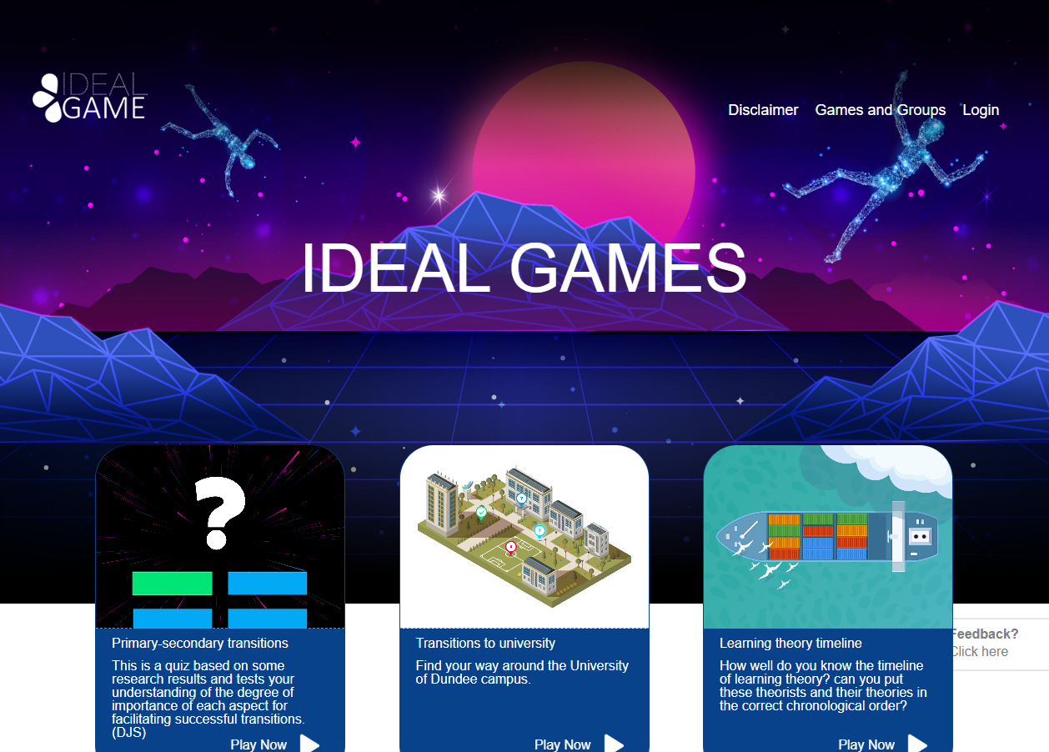
Figure 1: Homepage of IDEAL-GAME Creator
In the right corner on top of the page you can go to Disclaimer, Games and Groups, or Login.
Below you can see three games which were already set up. Don´t worry if you cannot see any games. If you haven´t created any games yet, there will be no games on the website.
In the Disclaimer you can check who is responsible for the website and the IDEAL-GAME Creator.
In Games and Groups you can check which games are available and ready to play.
The first time, the teacher needs to go to Login and create an account for the IDEAL-GAME Creator.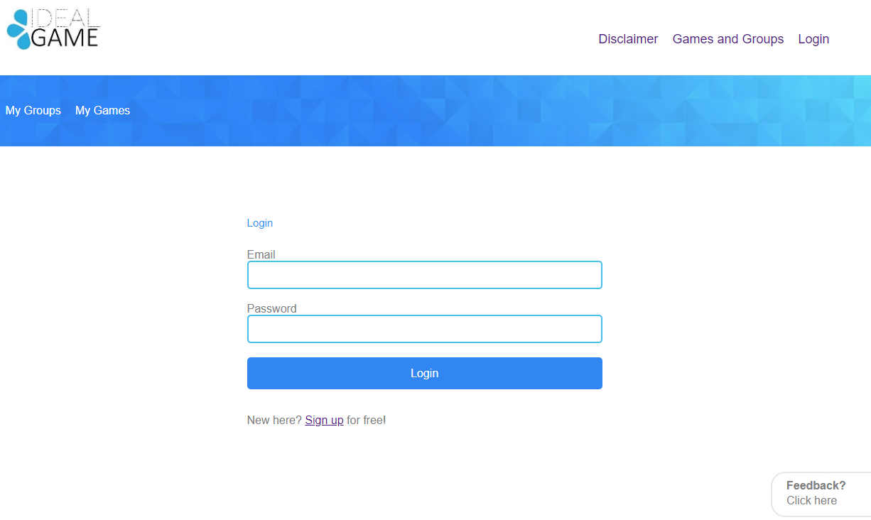
Figure 2: Login of IDEAL-GAME Creator
The teacher can sign up for free by clicking on Sign up and entering an e-mail address and a password. After signing up, the teacher will find an additional area called Control Panel in the top right corner.
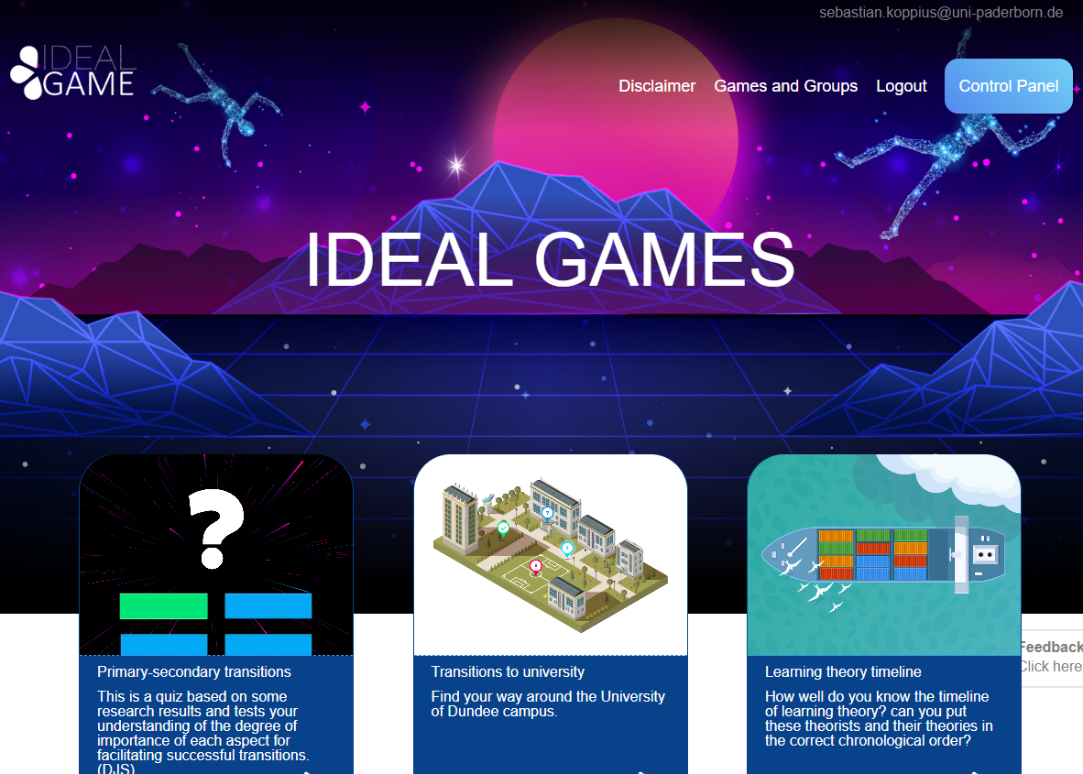
Figure 3: Control Panel of IDEAL-GAME Creator
In the area of Control Panel, the teacher can create a minigame. To do so the teacher has to click on New Game.

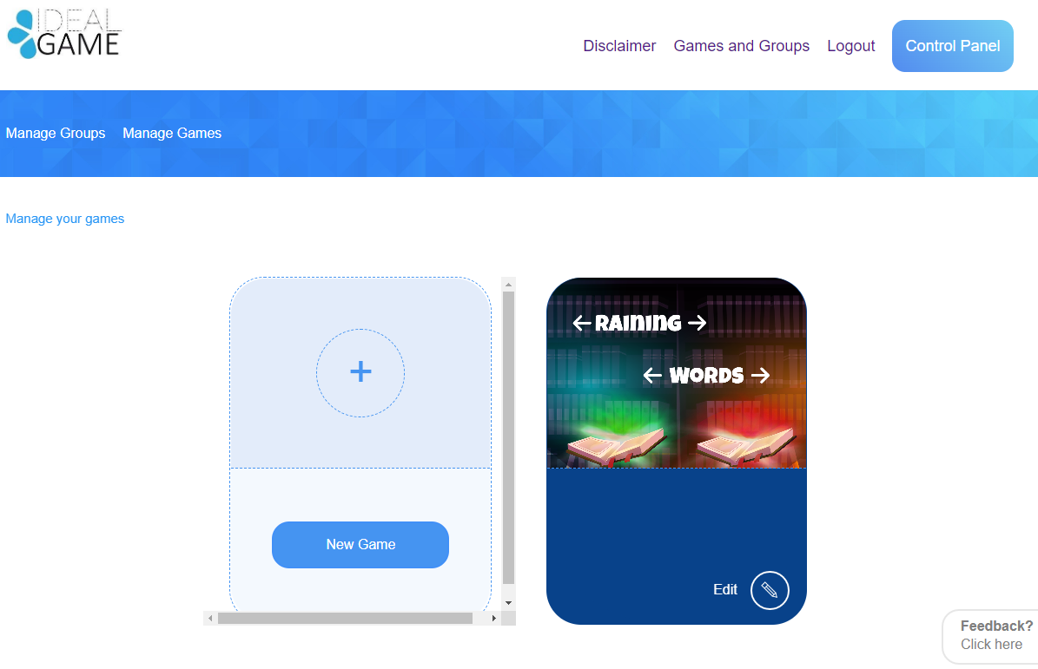
Figure 4: Control Panel - Create New Game of IDEAL-GAME Creator
A new area opens which is called Create game.
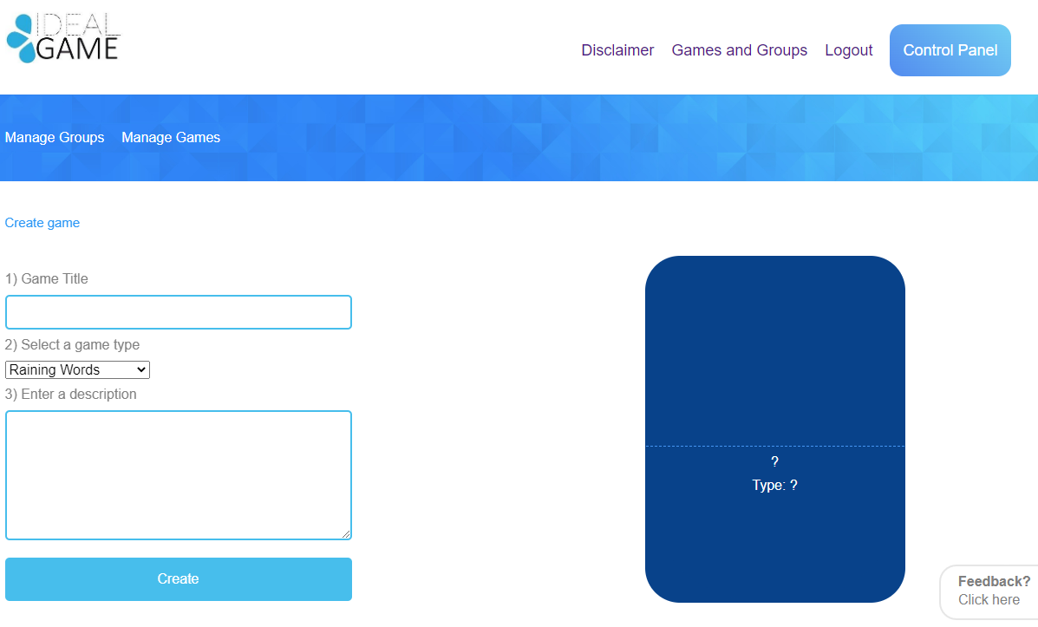
Figure 5: Create game of IDEAL-GAME Creator
Now the teacher can create a game. Starting with a Game Title, Selecting a game type and Entering a description.
Game Title | Choose a catching title for the game.  You can link to the topic which the game is about.
Enter a description | Describe the content of the game in a few sentences.  Here you can link the description to the topic of the game.

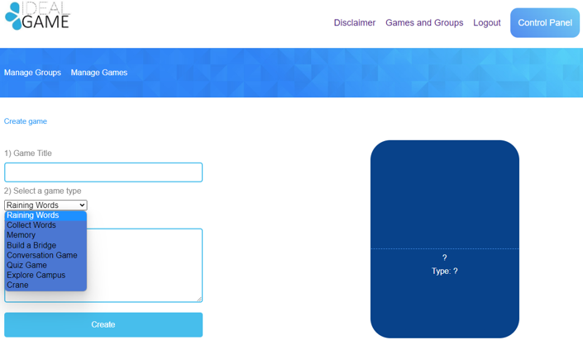
Figure 6: Select a game type of IDEAL-GAME Creator
Select a game type | Choose a game type for this particular game you are about to create. You can choose out of eight games.
Here is a short overview of the games you can choose from. You will find a detailed description in section c (p. 11).
Raining Words | A game of assignment.
Collect Words | A game of assignment.
Memory | A game of assignment of two words/statements.
Build a Bridge | A game for process production.
Conversation Game | Question and answer game.
Quiz Game | Question and answer game with four possible answers.
Explore Campus | A game of assignment of places/buildings.
Crane | A game for text or process production.
When everything has been selected and filled in, click on Create. You will get to the next section, where you have to set the game´s settings in detail. You will find a detailed description in section c (p. 11).
Moreover, there are two areas which are important for the teacher. You can see them in the blue field on the top left. One of them is called Manage Games.
In the area called Manage Games, the teacher can check his/her created games and always edit them by using the pencil symbol.
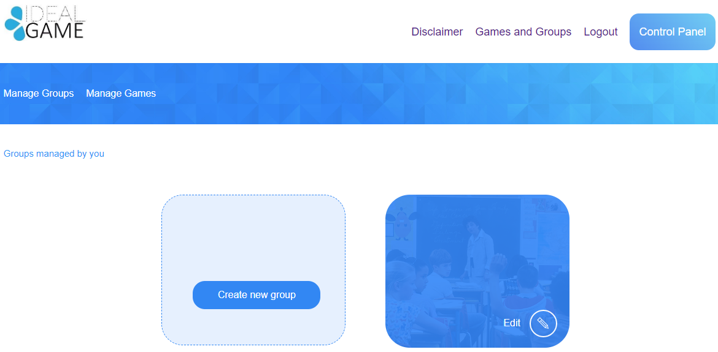
Figure 7: Manage Groups of IDEAL-GAME Creator
The other area is called Manage Groups.
The teacher can create groups in order to organize his/her games. This is useful, if the teacher has more than one class/course. For creating a new group click on Create new group. For editing an existing group click on Edit and the pencil symbol next to it.

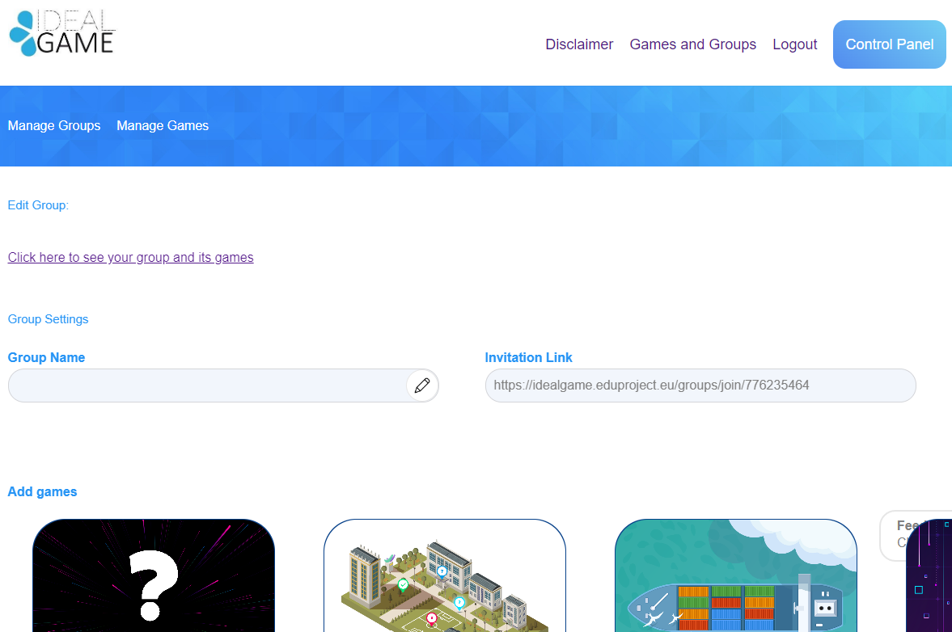
Figure 8: Edit Group (1) of IDEAL-GAME Creator
In the area of Edit Group, the teacher can set the settings of the group.
Group Name | Name the group.  The name could be the name of the class/course/module/seminar/etc.
Invitation Link | The IDEAL-GAME Creator will provide an invitation link for you to send to your students who should be in this group.
Add games | You have to decide which games should be available for the students of this particular group.
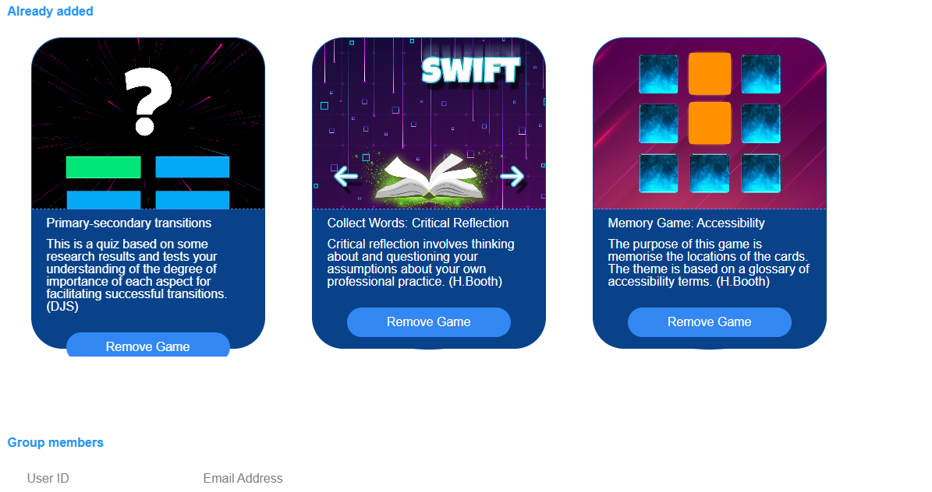
Figure 9: Edit Group (2) of IDEAL-GAME Creator
Further down, you can see all games you Already added to this group. Here you could also remove the game by clicking on Remove Game. You can always come back to the settings and edit the choice of games in the groups.
Lastly, you can see the Group members with their User ID and their Email Address. It provides a good overview of the members in this particular group.
One more important feature is the feedback button.
Figure 10: Feedback Button of IDEAL-GAME Creator
You can see Feedback? Click here all the time. If you choose to use this feature, a new window opens and you can answer some questions about the usability of the IDEAL-GAME Creator.

Back on the homepage, you can go to Games and Groups.
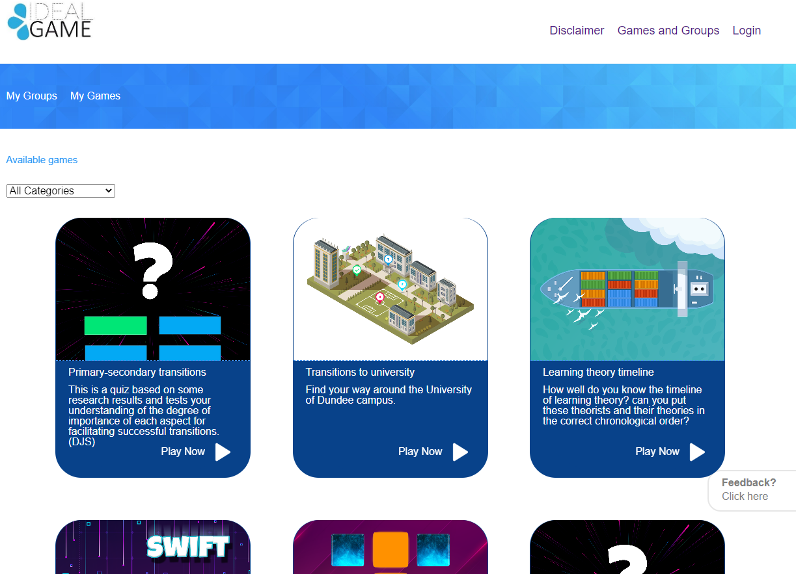
Figure 11: Games and Groups of IDEAL-GAME Creator
Depending on how many games the teacher has created, they will be here in the section of Games and Groups. That is why it says Available games.
Additionally, you can choose a game out of the categories. To do so, open All categories.
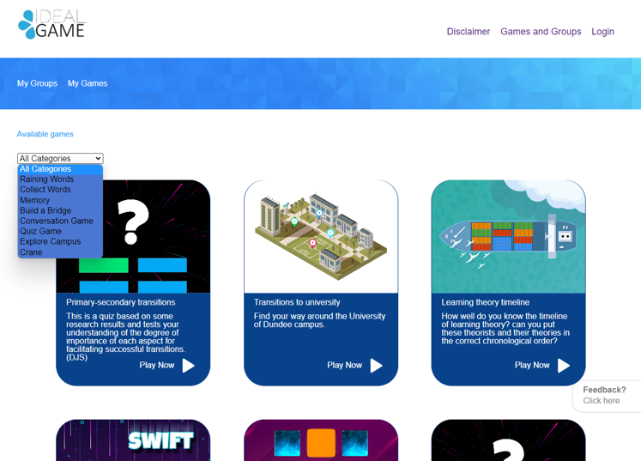
Figure 12: All Categories of IDEAL-GAME Creator
All Categories consists of the games: Raining Words, Collect Words, Memory, Build a Bridge, Conversation Game, Quiz Game, Explore Campus, and Crane.
When the teacher or the student chooses a category, s/he will only see games created in this category.
In the next part you will find each game and its description.

Possible games in detail

Raining Words
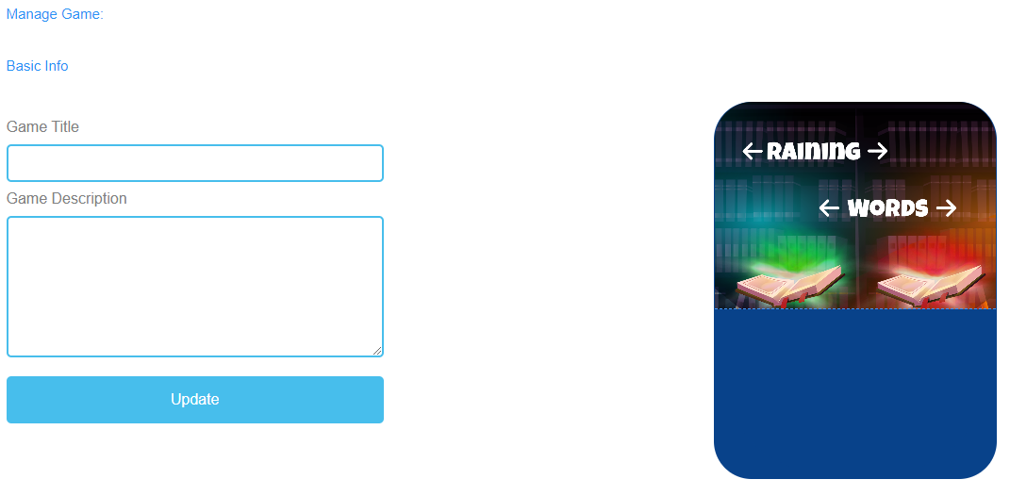
Figure 13: Raining Words, Manage Game

Manage Game
Game Title | Choose a catching title for the game.  You can link it to the topic which the game is about.
Game Description | Describe the content of the game in a few sentences.  Here you can link the description to the topic of the game.
Update | After you have set Game Title and Game Description, you need to press Update to save your input and continue with the settings.

Figure 14: Raining Words, Word Overview (1)
Word Overview | In Word Overview, you can generate words for the game.
Node Text | The Node Text is for the words of the game.  Here you can click Add Node to generate words.

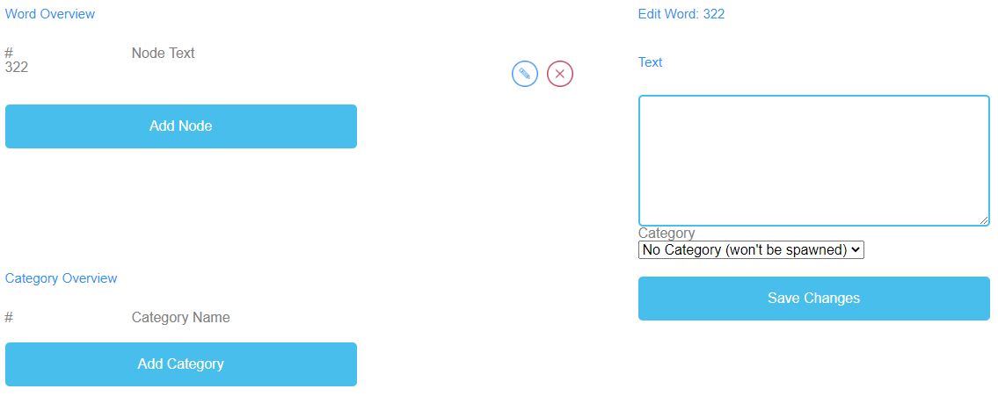
Figure 15: Raining Words, Word Overview (2)

Edit Word | When you click on Add Node a text field opens.  Here you can write down the words.  The number of words is unlimited.  If you have created a Node, you can edit it by clicking on the pencil symbol next to it.  You can delete a Node by clicking on the red cross symbol next to it.
Category | Additionally, you can choose the correct category of the word, if you have already created the categories.
Save Changes | To save the process so far, you have to press Save Changes.

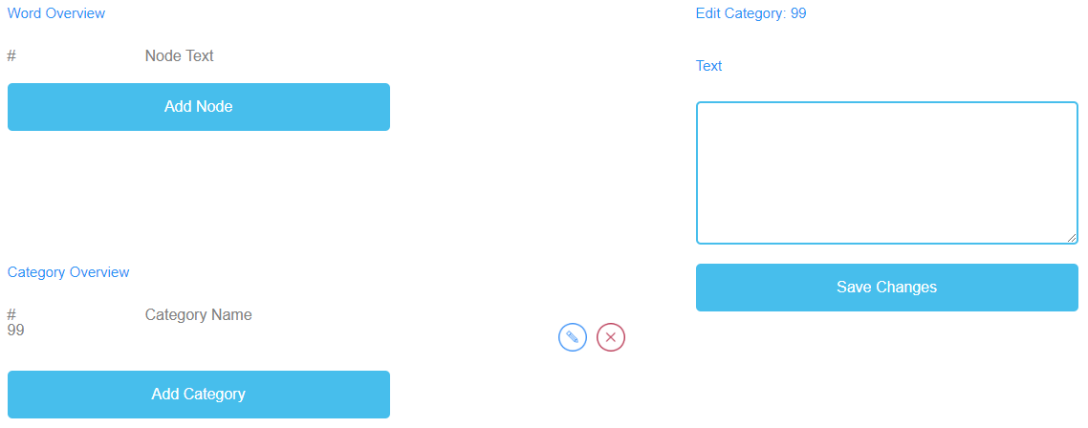
Figure 16: Raining Words, Category Overview

Category Overview | In Category Overview, you can create categories for the game.
Category Name | To create categories, you need to click Add Category.  Choose names for your categories.  You should chose a short and significant category name.  To create a category name, you need to click on Add Category.  A text field will open and you can type in the name of the category.  The number of categories is unlimited, but you should use no more than two because it is much likely of learners having devices with small screens.  If you have created a Category, you can edit it by clicking on the pencil symbol next to it.  You can delete a Category by clicking on the red cross symbol next to it.
Save Changes | To save the process, you need to click on Save Changes.

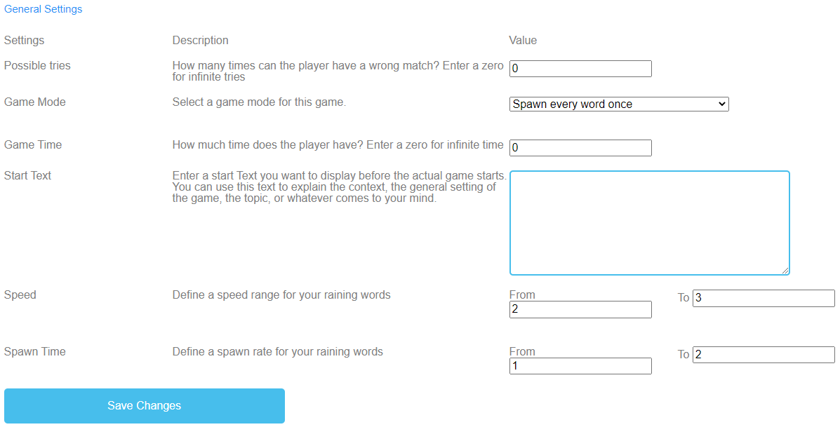
Figure 17: Raining Words, General Settings

General Settings | The next step is to set the general settings of the game.  You can find three columns: Settings, their Description and Value.
Possible tries | Description: How many times can the player have a wrong match? Enter a zero for infinite tries.  Value: Please choose a number of tries for the game. The number zero is for infinite tries.
Game Mode | Description: Select a game mode for this game.  Value: Please choose if either every word only comes once or more than once until the time runs out.
Game Time | Description: How much time does the player have? Enter a zero for infinite time.  Value: Please set a time for the duration of the game. The unit is  in seconds.
Start Text | Description: Enter a start text you want to display right before the actual game starts. You can use this text to explain the context, the general setting of the game, the topic, or whatever comes to your mind.  Value: You can use this text to ask a question or a short explanation of the task.

General Settings
Possible start text | Choose the category in which the word belongs.  Pick the word from above while it comes down and drop it into the matching category book on the ground.
Speed | Description: Define a speed range for your raining words.  Value: From To Please set the duration of the words going down. The unit is in seconds.
Spawn Time | Description: Define a spawn rate for your raining words.  Value: From To Set when new words should come down.. The unit is in seconds.
Save Changes | Please click on Save Changes to save the settings of the game.

Collect Words
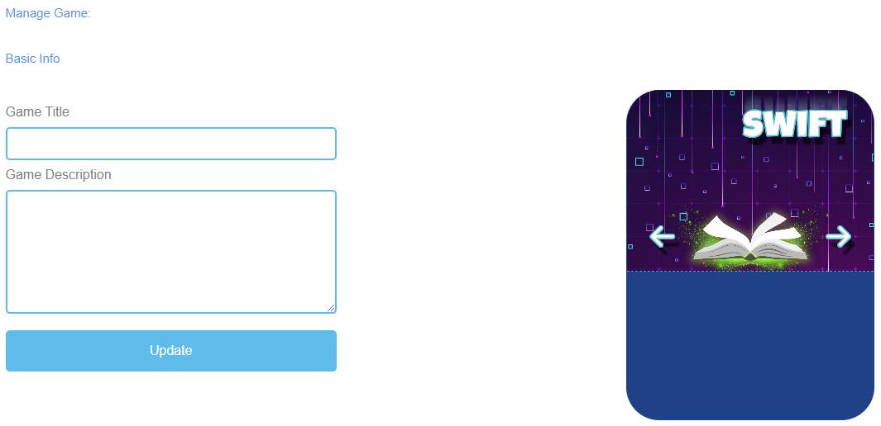
Figure 18: Collect Words, Manage Game

Manage Game
Game Title | Choose a catching title for the game.  You can link it to the topic which the game is about.
Game Description | Describe the content of the game in a few sentences.  Here you can link the description to the topic of the game.
Update | After you have set Game Title and Game Description, you need to press Update to save your input and to continue with the settings.

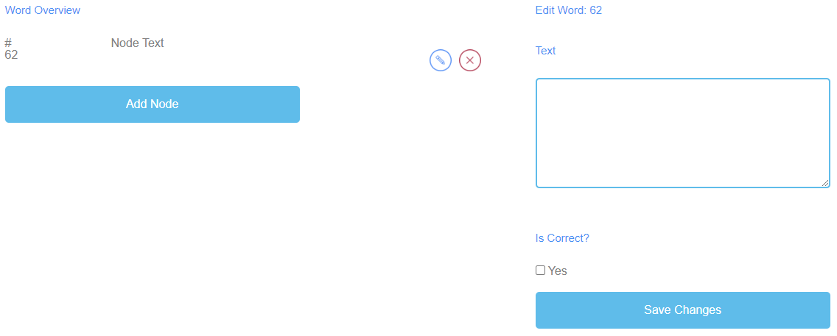
Figure 19: Collect Words, Word Overview

Word Overview | In Word Overview, you can generate words for the game.
Node Text | The Node Text is for the words of the game.  Here you can click Add Node to generate words.  If you have created a Node, you can edit it by clicking on the pencil symbol next to it.  You can delete a Node by clicking on the red cross symbol next to it.
Edit Word | When you click on Add Node a text field opens.  Here you can write down the words.  The number of words is unlimited.
Is correct? | Additionally, you have to decide if the word is correct due to the game.  To do so, you need to tick the box saying Yes, if the word is correct.
Save Changes | After that, please click on Save Changes to save the input.

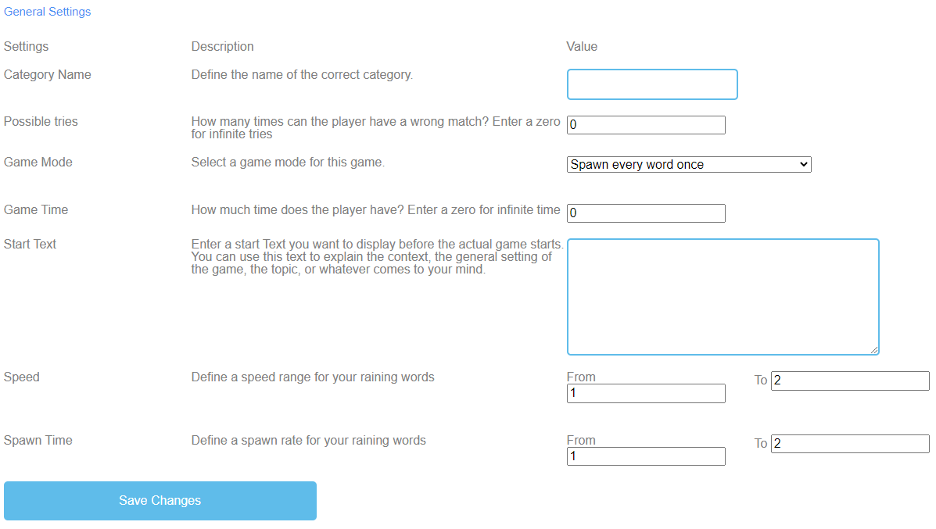
Figure 20: Collect Words, General Settings

General Settings | The next step is to set the general settings of the game.  You can find three columns: Settings, their Description and Value.
Category Name | Description: Define the name of the correct category.  Value: Please fill in a name of the correct category. That is going to be the name of the book on the ground.
Possible tries | Description: How many times can the player have a wrong match? Enter a zero for infinite tries.  Value: Please choose a number of tries for the game. The number zero is for infinite tries.
Game Mode | Description: Select a game mode for this game.  Value: Please choose if either every word only comes once or more than once until the time runs out.
Game Time | Description: How much time does the player have? Enter a zero for infinite time.  Value: Please set a time for the duration of the game. The unit is  in seconds.

General Settings
Start Text | Description: Enter a start text you want to display right before the actual game starts. You can use this text to explain the context, the general setting of the game, the topic, or whatever comes to your mind.  Value: You can use this text to ask a question or a short explanation of the task.
Possible start text | Choose which words belong in the book.
Speed | Description: Define a speed range for the words.  Value: From To Please set the duration of the words coming down. The unit is in seconds.
Spawn Time | Description: Define a spawn rate for your words.  Value: From To Please set the time of words coming next. The unit is in seconds.
Save Changes | Please click on Save Changes to save the settings of the game.

Memory
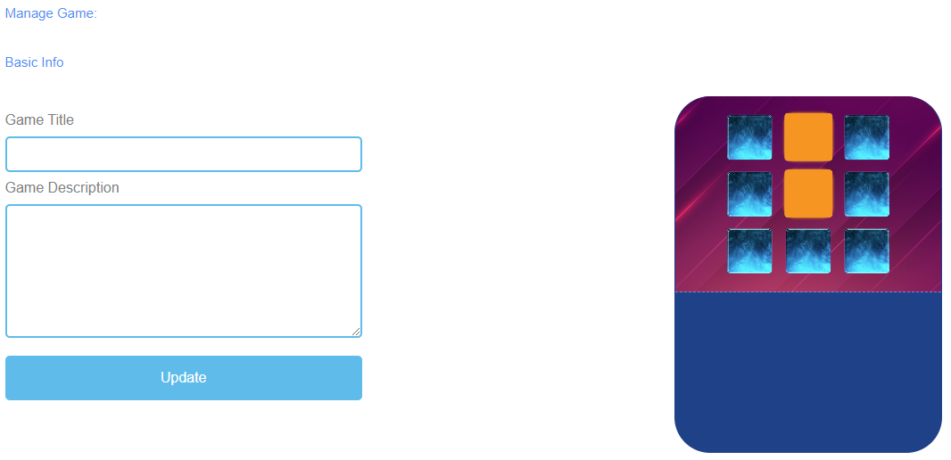
Figure 21: Memory, Manage Game

Manage Game
Game Title | Choose a catching title for the game.  You can link it to the topic which the game is about.
Game Description | Describe the content of the game in a few sentences.  Here you can link the description to the topic of the game.
Update | After you have set Game Title and Game Description, you need to press Update to save your input and to continue with the settings.

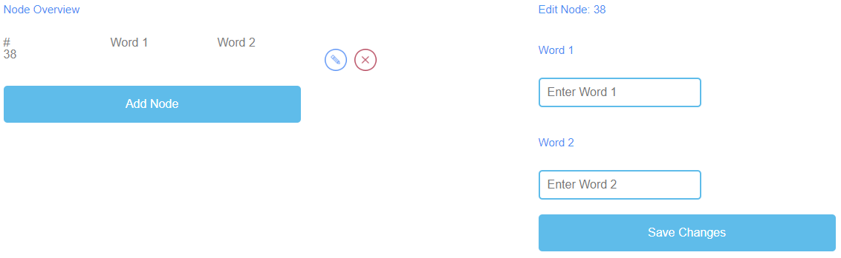
Figure 22: Memory, Node Overview

Node Overview | The Node Overview is for the words of the game.
Word 1  Word 2 | Here you can click Add Node to generate pairing words which are then a memory pair.  You have to enter Word 1 and Word 2.  If you have created a Node, you can edit it by clicking on the pencil symbol next to it.  You can delete a Node by clicking on the red cross symbol next to it.
Save Changes | Please click on Save Changes to save your input.

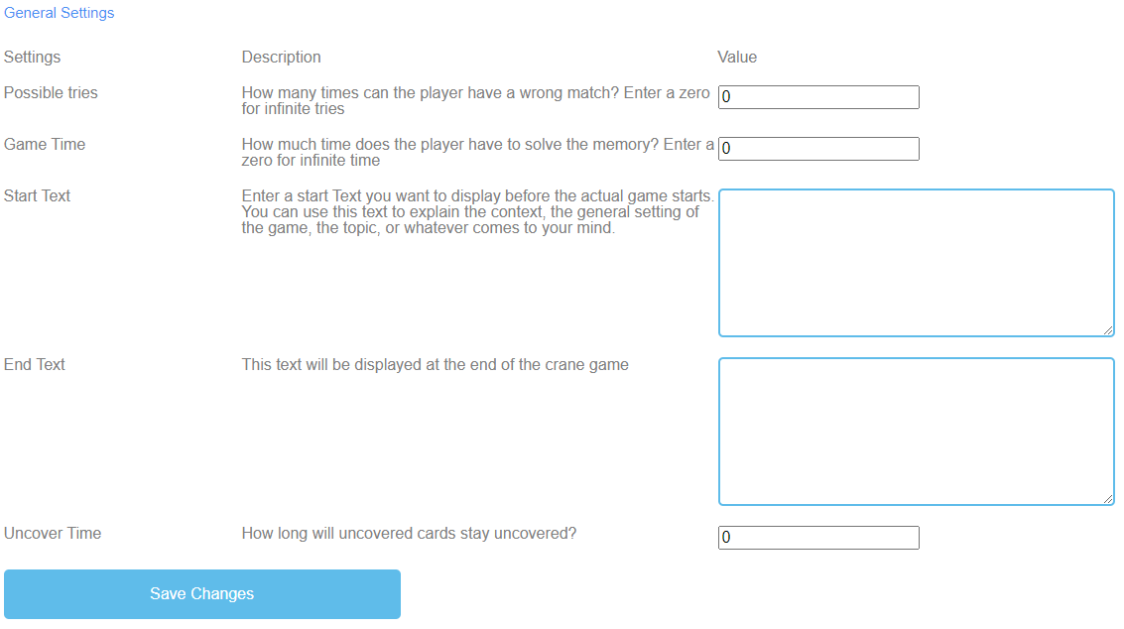
Figure 23: Memory, General Settings

General Settings | The next step is to set the general settings of the game.  You can find three columns: Settings, their Description and Value.
Possible tries | Description: How many times can the player have a wrong match? Enter a zero for infinite tries.  Value: Please choose a number of tries for the game. The number zero is for infinite tries.
Game Time | Description: How much time does the player have? Enter a zero for infinite time.  Value: Please set a time for the duration of the game. The unit is  in seconds.
Start Text | Description: Enter a start text you want to display right before the actual game starts. You can use this text to explain the context, the general setting of the game, the topic, or whatever comes to your mind.  Value: You can use this text to ask a question or a short explanation of the task.
Possible start text | Find the right pairs.

General Settings | The next step is to set the general settings of the game.
End Text | Description: This text will be displayed at the end of the memory game.  Value: You can use this text to congratulate the learner for playing the game. You should motivate the learner to play again.
Uncover Time | Description: How long will uncovered cards stay uncovered?  Value: Please set the time of the uncovered words. The unit is in seconds.
Save Changes | Please click on Save Changes to save the settings of the game.

Build a Bridge
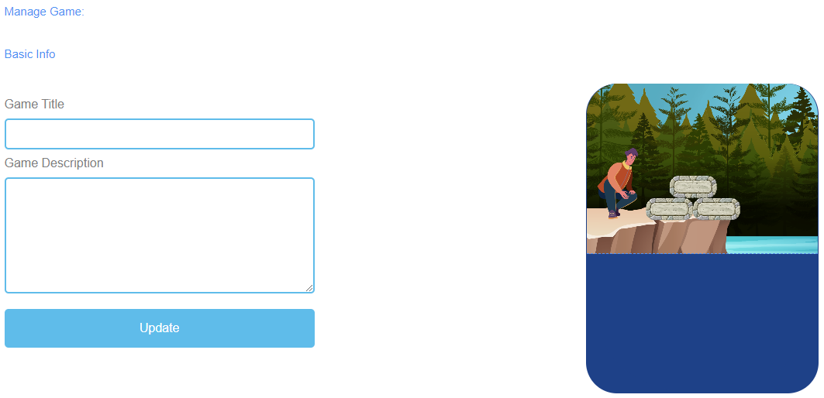
Figure 24: Build a Bridge, Manage Game

Manage Game
Game Title | Choose a catching title for the game.  You can link it to the topic which the game is about.
Game Description | Describe the content of the game in a few sentences.  Here you can link the description to the topic of the game.
Update | After you have set Game Title and Game Description, you need to press Update to save your input and to continue with the settings.

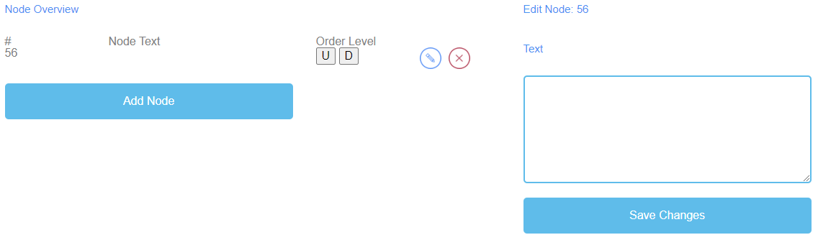
Figure 25: Build a Bridge, Node Overview

Node Overview | The Node Overview is for the words of the game.
Node Text | The Node Text is for the words of the game.  Here you can click Add Node to generate words.  Here you can write down the words in the text field.  The number of words is unlimited.  If you have created a Node, you can edit it by clicking on the pencil symbol next to it.  You can delete a Node by clicking on the red cross symbol next to it.
Order Level | Order Level allows you to set the order of the Nodes as they are then to be arranged as a bridge by the learner.  U stands for up.  D stands for down.  You can see the order in the first column under #.  The first Node should be first in the game, the second is second, etc.
Save Changes | After that, please click on Save Changes to save the input.

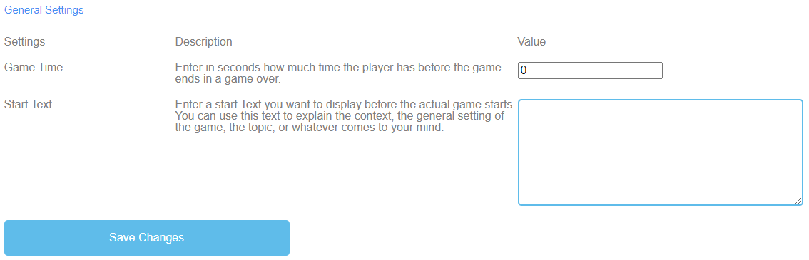
Figure 26: Build a Bridge, General Settings

General Settings | The next step is to set the general settings of the game.  You can find three columns: Settings, their Description and Value.
Game Time | Description: How much time does the player have? Enter a zero for infinite time.  Value: Please set a time for the duration of the game. The unit is  in seconds.
Start Text | Description: Enter a start text you want to display right before the actual game starts. You can use this text to explain the context, the general setting of the game, the topic, or whatever comes to your mind.  Value: You can use this text to ask a question or a short explanation of the task.
Possible start text | Put the words/terms in the right order to build a bridge.
Save Changes | Please click on Save Changes to save the settings of the game.

Conversation Game
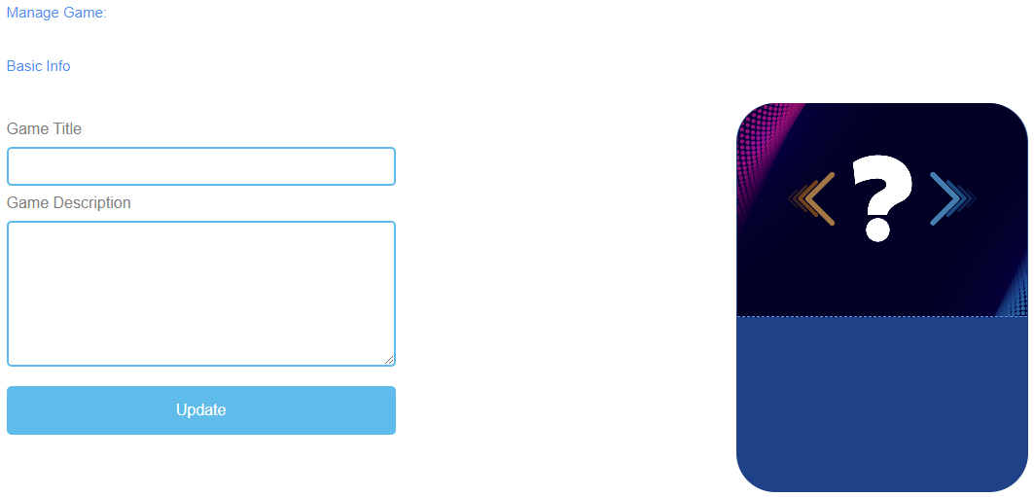
Figure 27: Conversation Game, Manage Game

Manage Game
Game Title | Choose a catching title for the game.  You can link it to the topic which the game is about.
Game Description | Describe the content of the game in a few sentences.  Here you can link the description to the topic of the game.
Update | After you have set Game Title and Game Description, you need to press Update to save your input and continue with the settings.

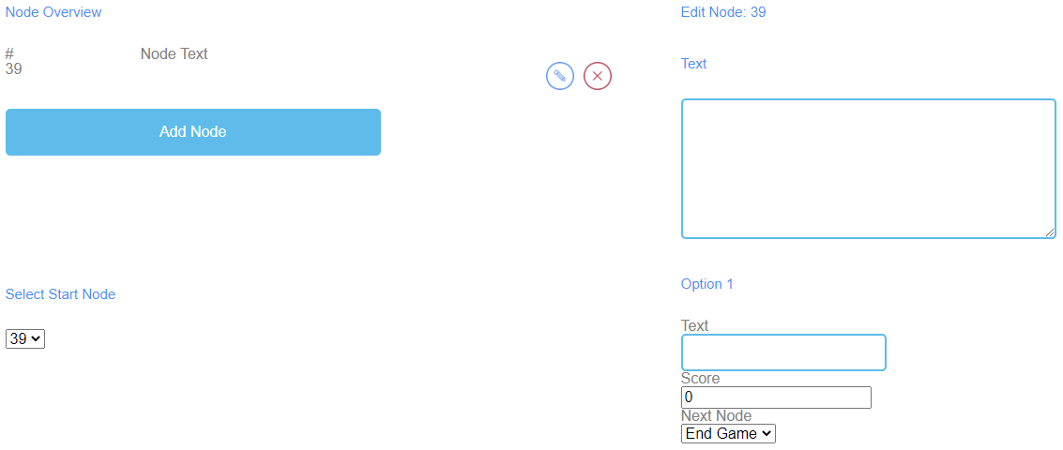
Figure 28: Conversation Game, Node Overview (1)

Figure 29: Conversation Game, Node Overview (2)

Node Overview | The Node Overview is for the words of the game.
Node Text | The Node Text is for the words of the game.  Here you can click Add Node to generate words.  If you have created a Node, you can edit it by clicking on the pencil symbol next to it.  You can delete a Node by clicking on the red cross symbol next to it.
Select Start Node | Choose the number of Node which should start the game.
Edit Node | When you click on Add Node a text field opens.  Here you can write down the words/term.  The number of words is unlimited.

Node Overview
Option 1 and 2 | Option 1 and 2 are the answers to the question/statement.  Fill in the Text field.
Score | You use Score to determine the amount of points earned in the event for a correct and for a wrong answer.
Next Node | Next Node allows you to determine the next word/term.
Save Changes | After that, please click on Save Changes to save the input.

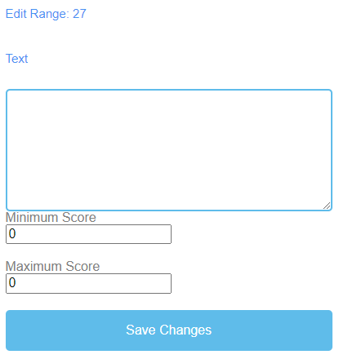
Figure 30: Conversation Game, Result Overview (1)

Figure 31: Conversation Game, Result Overview (2)

Result Overview | You use the Results Overview to determine how the learner did in the game.
Score Range | Use Score Range to set different score ranges of points.  These can account for several points.  Click on Add Range to set a Score Range.
Description | Describe what the achieved score means within the score range.  Formulate the description in the Text field.

Result Overview | You use the Results Overview to determine how the learner did in the game.
Possible Score Range and Description | 0-5 Oh no, that didn´t go so well. Try it again!  15-20 That was great! Keep it up!
Minimum Score | Set the Minimum Score for this Score Range.
Maximum Score | Set the Maximum Score for this Score Range.
Save Changes | Please click on Save Changes to save the settings of the game.

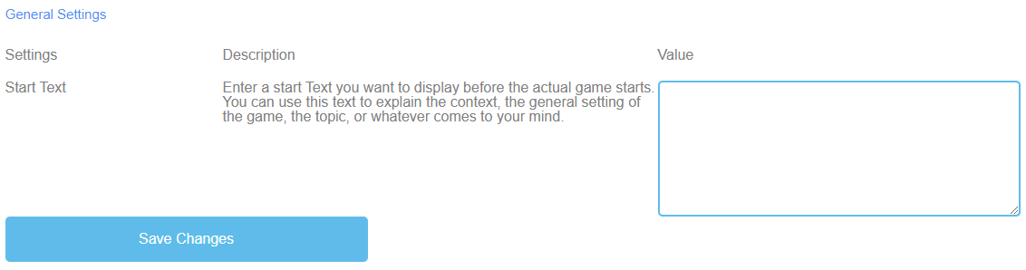
Figure 32: Conversation Game, General Settings

General Settings | The next step is to set the general settings of the game.  You can find three columns: Settings, their Description and Value.
Start Text | Description: Enter a start text you want to display right before the actual game starts. You can use this text to explain the context, the general setting of the game, the topic, or whatever comes to your mind.  Value: You can use this text to ask a question or a short explanation of the task.
Possible start text | Choose the correct answer to the question/statement.
Save Changes | Please click on Save Changes to save the settings of the game.

Quiz Game
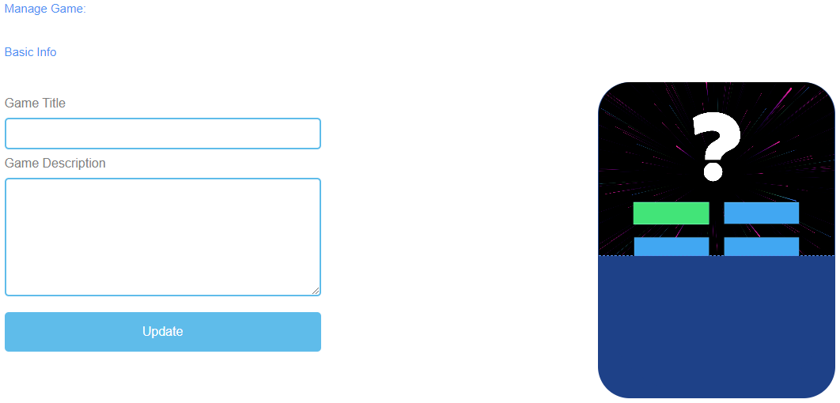
Figure 33: Quiz Game, Manage Game

Manage Game
Game Title | Choose a catching title for the game.  You can link it to the topic which the game is about.
Game Description | Describe the content of the game in a few sentences.  Here you can link the description to the topic of the game.
Update | After you have set Game Title and Game Description, you need to press Update to save your input and continue with the settings.

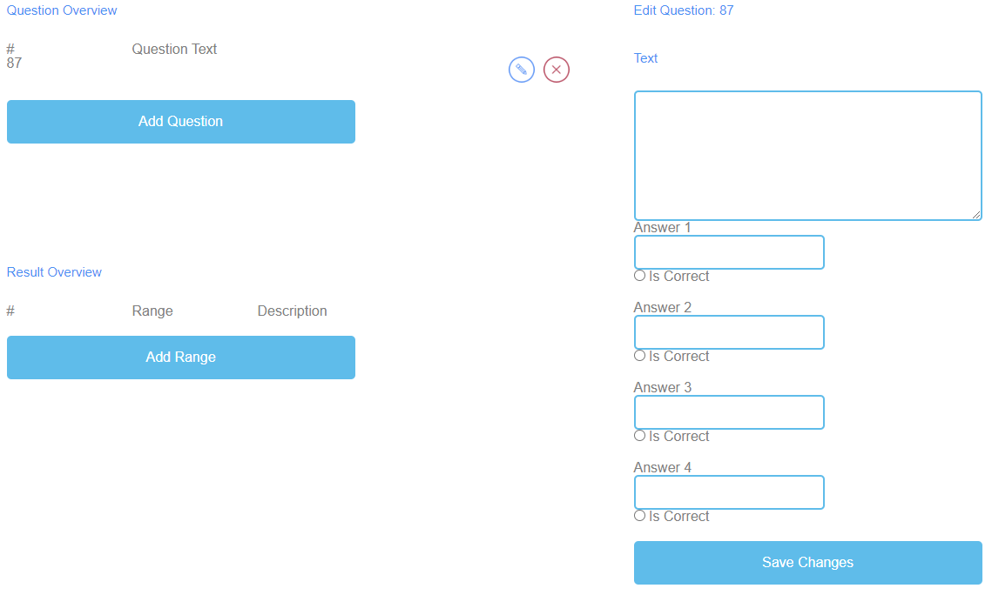
Figure 34: Quiz Game, Question Overview

Question Overview | In the section Questions Overview, you can generate the questions of the game.
Question Text | The Question Text is for the questions of the game.  Here you can click Add Question to generate questions.  If you have created a Question Text, you can edit it by clicking on the pencil symbol next to it.  You can delete a Question Text by clicking on the red cross symbol next to it.
Answer 1-4 | Please provide 4 answers to the question.  One of them should be the right one. If that is the case, you need to tick the box saying Is Correct.
Save Changes | Please click on Save Changes to save the input.

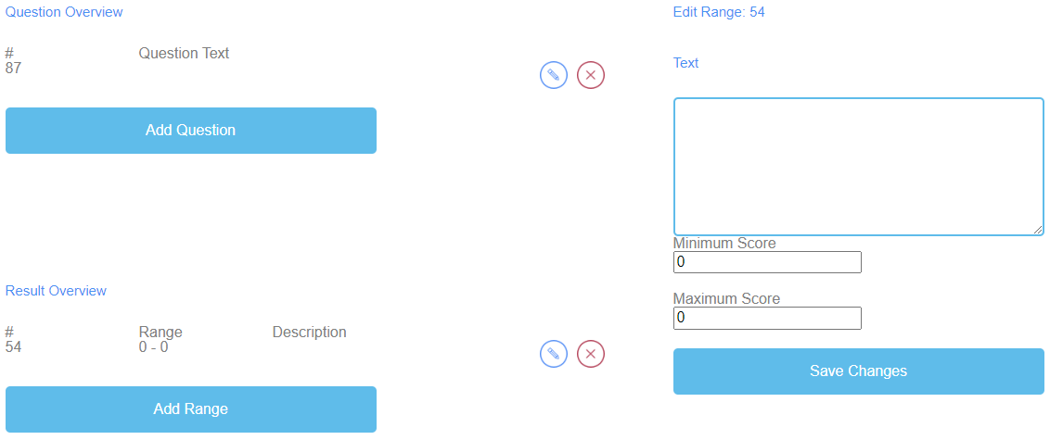
Figure 35: Quiz Game, Result Overview

Result Overview | You use the Results Overview to determine how the learner did in the game.
Score Range | Use Score Range to set different score ranges of points.  These can account for several points.  Click on Add Range to set a Score Range.  If you have created a Score Range, you can edit it by clicking on the pencil symbol next to it.  You can delete a Score Range by clicking on the red cross symbol next to it.
Description | Describe what the achieved score means within the score range.  Formulate the description in the Text field.
Possible Score Range and Description | 0-5 Oh no, that didn´t go so well. Try it again!  15-20 That was great! Keep it up!
Minimum Score | Set the Minimum Score for this Score Range.
Maximum Score | Set the Maximum Score for this Score Range.
Save Changes | Please click on Save Changes to save the settings of the game.

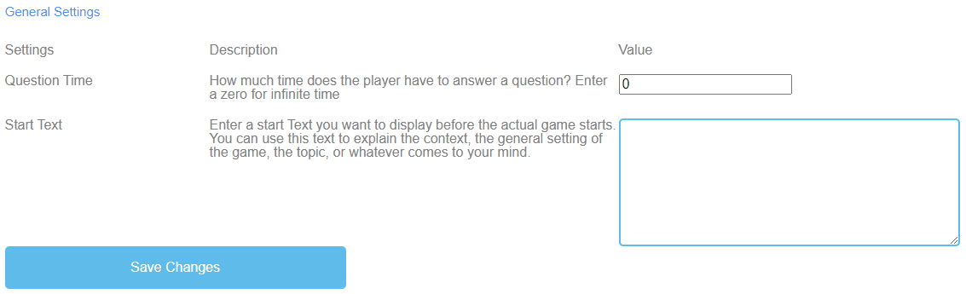
Figure 36: Quiz Game, General Settings

General Settings | The next step is to set the general settings of the game.  You can find three columns: Settings, their Description and Value.
Question Time | Description: How much time does the player have to answer a question? Enter a zero for infinite time.  Value: Please set a time for learner to answer a question. The number zero is for infinite time. The unit is in seconds.
Start Text | Description: Enter a start text you want to display right before the actual game starts. You can use this text to explain the context, the general setting of the game, the topic, or whatever comes to your mind.  Value: You can use this text to ask a question or a short explanation of the task.
Possible start text | Choose the correct answer to the question.
Save Changes | Please click on Save Changes to save the settings of the game.

Explore Campus
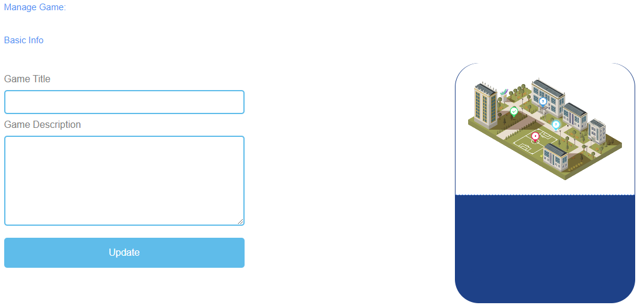
Figure 37: Explore Campus, Manage Game

Manage Game
Game Title | Choose a catching title for the game.  You can link it to the topic which the game is about.
Game Description | Describe the content of the game in a few sentences.  Here you can link the description to the topic of the game.
Update | After you have set Game Title and Game Description, you need to press Update to save your input and continue with the settings.

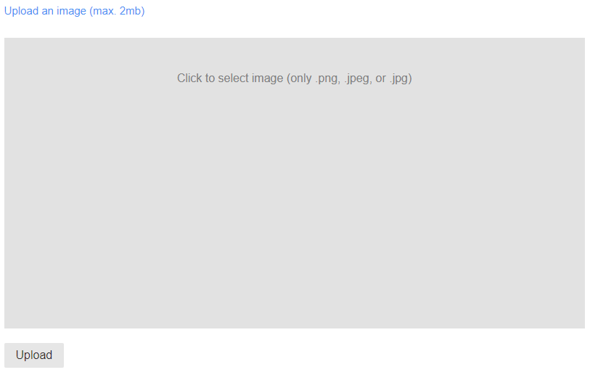
Figure 38: Explore Campus, Upload an image

Upload an image | Choose an image for the game.  Click into the grey field to select an image.  The size of the image is maximum 2 MB.  The image has to be in png, jpeg or jpg format.  Click on Upload to upload the image into the game.

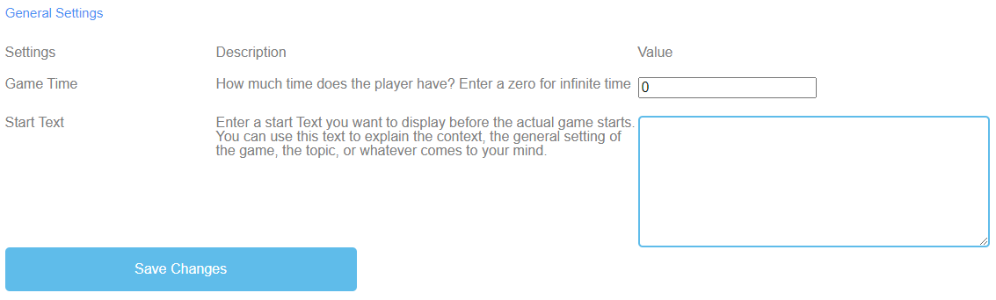
Figure 39: Explore Campus, General Settings

General Settings | The next step is to set the general settings of the game.  You can find three columns: Settings, their Description and Value.
Game Time | Description: How much time does the player have? Enter a zero for infinite time.  Value: Please set a time for the duration of the game. The unit is  in seconds.
Start Text | Description: Enter a start text you want to display right before the actual game starts. You can use this text to explain the context, the general setting of the game, the topic, or whatever comes to your mind.  Value: You can use this text to ask a question or a short explanation of the task.
Possible start text | Fill in the correct names of the buildings.
Save Changes | Please click on Save Changes to save the settings of the game.

Crane
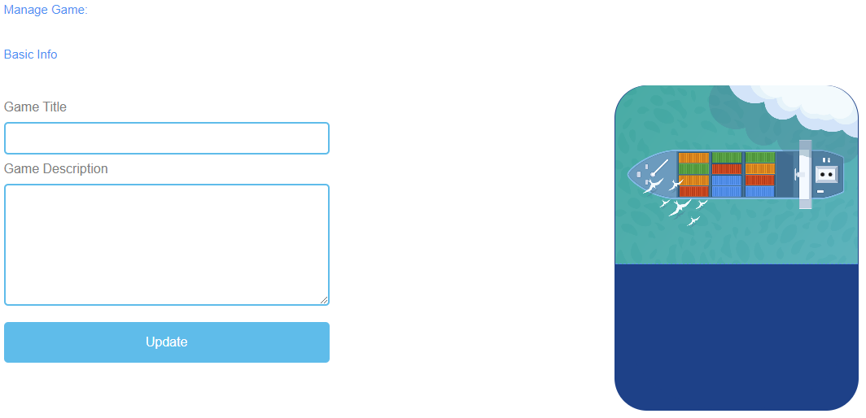
Figure 40: Crane, Manage Game

Manage Game
Game Title | Choose a catching title for the game.  You can link it to the topic which the game is about.
Game Description | Describe the content of the game in a few sentences.  Here you can link the description to the topic of the game.
Update | After you have set Game Title and Game Description, you need to press Update to save your input and continue with the settings.

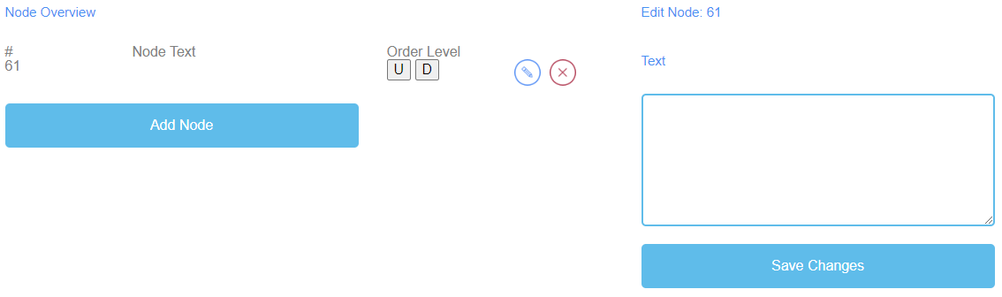
Figure 41: Crane, Node Overview

Node Overview | The Node Overview is for the words of the game.
Node Text | The Node Text is for the words of the game.  Here you can click Add Node to generate words.  If you have created a Node, you can edit it by clicking on the pencil symbol next to it.  You can delete a Node by clicking on the red cross symbol next to it.
Order Level | Order Level allows you to set the order of the Nodes as they are then to be arranged by the learner on the cargo ship.  U stands for up.  D stands for down.  You can see the order in the first column under #.  The first Node should be first in the game, the second is second, etc.
Text | When you click on Add Node a text field opens.  Here you can write down the words.  The number of words is unlimited.
Save Changes | After that, please click on Save Changes to save the input.

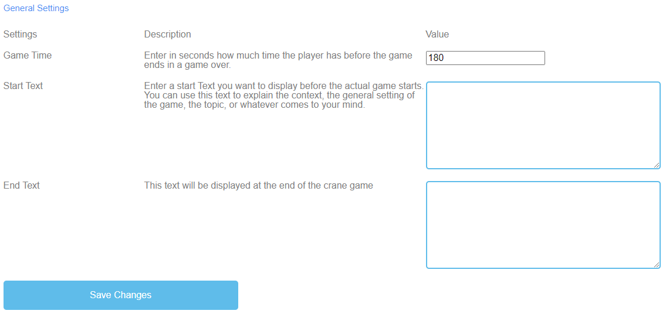
Figure 42: Crane, General Settings

Conclusions
UPB - Marc Beutner
The project IDEAL-GAME could successfully provide a serious game creator tool, which offers the opportunity to create and implement mini serious games. The testing results were very positive and the games could be integrated in different fields of higher education. Moreover, the partners were able to create additional lesson plans as well as learning and teaching resources. In the partner countries both the lecturers and the students could handle the tool and implement it in the learning processes. It was possible to get feedback on the games and to adapt them to the different modules, courses and lectures. The feedback was excellent and strengthens the idea to offer IDEAL-GAME on a broader basis. The lecturers stated that the use of the tool is easy. Moreover, they made clear that it is necessary to test a little bit with the settings for the different game, to get for example an appropriate time for the appearance of terms and items or for the appropriate speed, which has to be adjusted to the specific needs and the lengths of the texts. The learners and students easily got accustomed to the games and could handle it perfectly. Nevertheless, there is always the need to combine the games with other parts of the lectures, modules or courses, because it is always helpful to rethink the content and to provide feedback to the learners, who are keen on getting additional information by the lecturer. They felt motivated and were very interested to work with the different games. Here also the variety of games (a) raining words, (b) collecting words, (c) memory, (d) build a bridge, € conversation game, (f) quiz game, (g) explore campus and (h) the crane game is helpful to have not always the same approaches with the students but to offer a mixture of games within a course to ensure additional motivation and to integrate different perspectives.
The usability test of the Serious Game Creator Tool was successful and the usability of the tool is really good. This means it can be handled easily and the integration of the games in higher education went very well. In total, IDEAL-GAME is an excellent approach and offers mini serious games as OER (open educational resources) as well as the serious game creator tool.

