Marc Beutner / Rasmus Pechuel (Ed.)
  - IDEAL GAME:
  - Improving didactics, education and learning in higher education with the Online Serious Game Creator

IK-Verlag

  - Didactic Handbook for lecturers

The IDEAL-GAME project, addressed in this book, is co-funded by the ERASMUS+ programme of the European Union, The European Commission is not responsible for any uploaded or submitted content. Such content expresses the views of its author(s) only.

Bibliographische Information Der Deutschen Bibliothek

Die Deutsche Bibliothek verzeichnet diese Publikation in der Deutschen Nationalbibliographie; detaillierte bibliographische Daten sind im Internet verfügbar über:
http://dnb.ddb.de abrufbar.

ISBN:
1. Aufl. 2022
© Lehrstuhl Wirtschaftspädagogik II, Universität Paderborn

und
©

Ingenious Knowledge Verlag
Hausanschrift: Friedrich-Karl-Str. 200, 50735 Köln
Telefon: (0221) 16820019
Köln, December 2022
All rights, including partial reprinting, photomechanical reproduction (including microscopy) and evaluation by databases, are reserved.

Content

Introduction 6
Part A - General Information 9
1. Advantages of using mini serious games in lecturers and seminars (UoD) 9
2. The use of mini serious games in blended learning 12
3. The use of mini serious games in flipped classrooms 14
Part B – The IDEAL-GAME project 15
4. The IDEAL-GAME partners 15
5. Main objectives and core aspects of IDEAL-GAME 19
6. Developments of IDEAL-GAME 20
7. The IDEAL-GAME results 22
Part C - The IDEAL-GAME Creator Tool 28
8. IDEAL-GAME Creator -Structure and aims 28
9. How to use the IDEAL-GAME Creator 29
10. Functions of the IDEAL-GAME Creator 31
Part D Pedagogical and Didactic Implementation 33
11. Mini serious games to repeat the topic 33
12. Mini serious games to depth the topic 35
13. Mini serious games for critical evaluation 38
14. Mini serious games for reflection 42
Part E – Concrete examples with material input 45
15. Demonstration of self-executed use of the IDEAL-GAME Creator at UPB, Germany 45
16. Demonstration of self-executed use of the IDEAL-GAME Creator at UoD, UK 55
17. Demonstration of self-executed use of the IDEAL-GAME Creator at UIPT, Romania 73
18. Demonstration of self-executed use of the IDEAL-GAME Creator at WSEI, Poland 103
19. Demonstration of self-executed use of the IDEAL-GAME Creator at UDIMA, Spain 111
20. Conclusions 131

Abbreviations

cf cited from
HE Higher Education
Ibid. abbreviation for the Latin word ibīdem, meaning ´in the same place´
IDEAL-GAME Project -
"Improving didactics, education and learning in higher education
with the Online Serious Game Creator"
IK Ingenious Knowledge GmbH
IO Intellectual Output
IT Information Technology
OER Open Educational Resources
PR Project Result
UDIMA Universidad a distancia de Madrid SA, Spain
UPB University Paderborn, Chair Business and Human Resource Education II Germany
UoD University of Dundee, United Kingdom
UPIT Universitatea din Pitesti, Rumania
WSEI Wysza Szkola Ekonomii i Innowacji w Lublinie, Poland

Introduction
UPB - Marc Beutner
Digitisation and the use of modern media is becoming more and more crucial in Higher Education (HE). Lectures are not only held face-to-face these days. At least since the COVID-19 pandemic but also in the years before, the use of video inputs, online tools like padlets, etc. as well as online synchronous and asynchronous ways of teaching have become a standard in HE. Lecturers use their lectures within modules or courses to support their students when there is a need to acquire knowledge of terms, facts, and concepts. This can be on a basic but also on an advanced level of knowledge acquisition. Blight stated already in the year 2000 that lectures are as effective (Bligh, 2000). Nevertheless, it became pretty clear to Bligh that lectures are not really more effective, than other teaching methods (Bligh, 2000). Moreover Bunce / Flens / Neiles pointed out students cannot pay attention in class for longer periods of time (Bunce / Flens / Neiles 2010, p 1438ff.). This means that motivation of students is an important issue.
Baylor University stated that “lectures worth listening to
- Are organised […]
- Are delivered with Authenticity […]
- Are Accompanied by Guidance and Opportunity for Note-Taking […]
- Invite Questions […]
- Solicit and Act on Feedback […]” (Baylor 2022)
So, it is obvious that with regard to teaching methods in HE there are some more teacher related ones, like the lectures mentioned above or worked examples, and some more student related one, like collaborative or inquiry-based or project-based approaches (see as well at Faculty Center 2022). Many teaching methods in HE refer to specific principles for smart teaching like the one mentioned by Ambrose in 2010, e.g. Goal-directed practice, targeted feedback or self-directed learning. Emerging online environments as younger fields of teaching methods, had influence to educational learning in HE. You can find several students who thrive in this digital supported learning environments. However, you can also find those who become amotivated and who are not engaged any more.
One way to increase students’ motivation within digital learning environments is to focus on serious games. But, usually serious games are rare and do not fit so good to a specific topic or they are not as flexible as the lecturers need them to be. Here, mini-serious games can come into action and this is also the point where our project IDEAL-GAME - Improving didactics, education and learning in higher education with Online Serious Game Creator – has a specific focus with the design and implementation of our Mini-Serious Game Creator that helps to create Mini-Serious Game easily and offers a chance to integrate aspects in our scenarios which are both motivational but also an innovative way of providing knowledge.
Our approach in IDEAL-GAME goes hand in hand with trends towards intensive use of the internet, social media approaches and smart HE teaching solutions. The integration of such types of digital methods offer and create added value to learning and teaching processes and offers high quality services and innovative instruments for HE.
This book is based on the results of the Erasmus+ project IDEAL-GAME which is situated in the EU ERASMUS + programme as a strategic partnership in the field of Higher Education.
Core idea of this project was to address new and innovative ways of learning and teaching in HE to improve teaching and learning in higher education institutions. The project is developing an online tool for creating small or mini serious games for higher education. This means that a game-based learning approach is incorporated in HE.
The partners of the international project IDEAL-GAME foster the quality of Higher Education and also foster lecturers with additional information. Moreover, we broaden the perspectives and ways to deal with digitisation in HE.
In total is becoming clear that digitization in HE is not only digitization of teaching processes but also the change of way of dealing with students at higher education organisations due to new processes and ways of improving academic outcomes. This book should be a guide to lecturers and offers insights in our project. Focussing our tool, the IDEAL-GAME Serious Game Creator goes hand in hand with offering different aspects of teaching and learning in HE. We try to help the reader to establish their own position with regard to the current developments and use of game-based learning approaches in the digital parts of Higher Education.
Personally, I wish you a pleasant journey within our handbook and our ideas and solutions. Enjoy reading this lecturer handbook and remember that it is crucial to focus on your own specific situation. So, we would be happy if you apply our tool but with regard to your own HE-situation and your precise contexts.

Marc Beutner
Paderborn, December 2022
References
Ambrose, Susan A., eds. How Learning Works: Seven Research-based Principles for Smart Teaching. San Francisco, CA: Jossey-Bass, 2010.
Baylor (2022): Effective Lectures. On the Internet: https://www.baylor.edu/atl/index.php?id=965135, Access date: 15.11.2022.
Bligh, D. A. (2000). What’s the use of lectures? San Francisco: Jossey-Bass.
Bunce, D. M., Flens, E. A., & Neiles, K. Y. (2010). How long can students pay attention in class? A study of student attention decline using clickers. Journal of Chemical Education, 87(12), 1438-1443.
Faculty Center (2022): Teaching Methods Overview. On the Internet: https://fctl.ucf.edu/teaching-resources/teaching-strategies/teaching-methods-overview/, Access date: 15.11.2022.

Part A - General Information
UoD – Divya Jindal-Snape / Helen Booth / Derek Robertson

Advantages of using mini serious games in lecturers and seminars (UoD)
Over the years, the use of serious games has increased in higher education across a range of disciplines (Bouki & Economou, 2015; De Gloria, Bellotti, Berta, & Lavagnino, 2014). This means that the university staff need to play multiple roles when using serious games, namely, that of a designer, player, facilitator, motivator and evaluator (Lameras et al., 2017). Lameras and colleagues undertook a literature review and found that ideally game play should be immersive and learner-led.
Serious games can provide lecturers opportunities to create authentic learning situations, including moving from abstract to concrete, that can help develop the students’ problem solving and thinking skills. They have also been found to enhance students’ motivation due to their dynamic nature (Westera, 2019) which allows for active learning. More importantly, they can be applied to a range of subjects (Lameras et al., 2017) and contexts, such as learning French (Krystalli & Arvanitis, 2018). Several studies have reported that majority of university students were positive about the use of serious games. A meta analysis of serious games found evidence of serious games: a. having a positive impact on immersive learning, b. facilitating understanding of concepts, c. enhancing cognitive and affective functioning, d. providing flexibility in time and place of learning, e. improving cross-cultural understanding and collaboration (Zhonggen, 2019).
It has been found that for serious games to engage learners, it is important that the learner finds the play to be enjoyable and fun, with higher levels of enjoyment increasing the level and length of engagement (Younis & Loh, 2010). Therefore, they need to have a good balance of fun and learning, which has led to the use of commercial off-the-shelf (COTS) games instead (e.g., Jindal-Snape, Baird & Miller, 2011; Miller & Robertson, 2010, 2012).
Creation of serious games is time consuming and requires appropriate funding. Therefore, for lecturers to be able to create serious games in HE classrooms can be problematic. Further, the serious games have to be designed to be accessible to everyone as well as meeting the pedagogical principles. De Gloria et al. (2014) have highlighted some other challenges, such as tensions between game features and learning objectives, the suspension of disbelief that is crucial for game play might have a negative impact on learning, and the extrinsic motivation obtained from rewards during game play might stop the learner from developing intrinsic motivation to learn. Further, very few serious games studies have so far robustly evaluated their impact on learning outcomes (Westera, 2019). The IDEAL-GAME project bridges this gap to some extent by providing a mini serious game creator tool to university staff as well as conducting a usability test and evaluation.

References
Bouki, V., & Economou, D. (2015). Using Serious Games in Higher Education: Reclaiming the Learning Time. Workshop Proceedings of the 11th International Conference on Intelligent Environments. doi:10.3233/978-1-61499-530-2-381
De Gloria, A., Bellotti, F., Berta, R., & Lavagnino, E. (2014). Serious Games for education and training. International Journal of Serious Games, 1(1), http://dx.doi.org/10.17083/ijsg.v1i1.11
Jindal-Snape, D., Baird, L., Miller, K. (2011). A longitudinal study to investigate the effectiveness of the Guitar Hero project in supporting transition from P7-S1. Report for LTS. Dundee: University of Dundee.
Krystalli, P., & Arvanitis, P. (2018). EDULEARN18 Proceedings, 10th International Conference on Education and New Learning Technologies, July 2nd-4th, 2018, Palma, Spain.
Lameras, P., Arnab, S., Dunwell, I., Stewart, C., Clarke, S., & Petridis, P. (2017). Essential features of serious games design in higher education: Linking learning attributes to game mechanics. British Journal of Educational Technology, 48(4), 972-994.
Miller, D. J., & Robertson, D. P. (2010). Using a games console in the primary classroom: effects of 'Brain Training' programme on computation and selfesteem. British Journal of Educational Technology, 41(2), 242-255. https://doi.org/10.1111/j.1467-8535.2008.00918.x
Miller, D., & Robertson, D. (2012). Computer game improves primary pupils' arithmetic. (Insights; No. 3). British Educational Research Association. http://www.bera.ac.uk/system/files/Insights%20%20Computer%20Game%20revised%20v3.pdf
Westera, W. (2019). Why and How Serious Games can Become Far More Effective: Accommodating Productive Learning Experiences, Learner Motivation and the Monitoring of Learning Gains. Journal of Educational Technology & Society, 22(1), 59-69.
Younis, B. & Loh, C.S. (2010). Integrating serious games in higher education programs. Paper presented at Academic Colloquium, July 2010: Building Partnership in Teaching Excellence. Ramallah, Palestine.
Zhonggen, Y. (2019). A Meta-Analysis of Use of Serious Games in Education over a Decade. International Journal of Computer Games Technology https://doi.org/10.1155/2019/4797032

The use of mini serious games in blended learning
Blended learning is defined as a combination of face-to-face and online learning (Spanjers, Könings, Leppink, Verstegen, de Jong, Czabanowska & van Merriënboer, 2015). During COVID times teaching and learning moved to mainly online platforms; however, despite the different countries’ lockdowns being over, the human and capital investment in online technologies and pedagogical approaches has meant that most universities have moved to blended learning, albeit to a small or large extent. However, blended learning is not a new concept and research suggests that it is favoured as it can lead to improved learning (Spanjers et al., 2015) as well as enhanced emotional, cognitive and/or behavioural engagement of students (Heilporn & Lakhal, 2021).
As mentioned earlier, serious games are ideal for also enhancing learning and engagement, thereby making them a useful pedagogical strategy within blended learning. In a medical context, for example, Dankbaar (2017) found that when a serious game was used with medical senior trainees (residents) for additional preparation for class in a blended learning environment, it led to development of better cognitive skills as compared to those who only used a course manual as preparation for class. Dunwell, Petridis, Arnab, Protopsaltis, Hendrix and de Freitas (2011) found that serious games worked best within a blended learning approach when they played a core role for exploratory or experiential learning. Others have noted that serious games work better in a blended learning context as it allows for scaffolding of learning (Egenfeldt-Nielsen, 2011) through support from lecturer and peers. Therefore, it is important that serious games are used as part of a holistic pedagogical approach, which considers carefully the core role that they can play, along with providing experiential learning and well-considered scaffolding, for them to be effective in enhancing students’ learning. Within the IDEAL-GAME project, several such games were created within a blended learning approach, such as in-class activities providing the understanding of primary-secondary transitions followed by post-class activity of game play through the scenario and conversations games where students were asked to undertake to support primary-secondary transitions of ‘Alex’, a fictional young person.

References
Dankbaar, M. (2017). Serious games and blended learning; effects on performance and motivation in medical education. Perspectives in Medical Education, 6(1), 58-60. doi: 10.1007/s40037-016-0320-2. PMID: 27975195; PMCID: PMC5285280.
Dunwell, I., Petridis, P. , Arnab, S. , Protopsaltis, A. , Hendrix, M., & de Freitas, S. (2011). Blended game-based learning environments: extending a serious game into a learning content management system. In F. Xhafa and L.Barolli and M. Köppen (Eds). Intelligent Networking and Collaborative Systems (INCoS), 2011 Third International Conference on (pp. 830 – 835). Los Alamitos, CA: IEEE. http://dx.doi.org/10.1109/INCoS.2011.58
Egenfeldt-Nielsen, S. (2011). Beyond edutainment: Exploring the educational potential of computer games. Lulu. com.
Heilporn,G., & Lakhal, S. (2021). Fostering student engagement in blended courses: A qualitative study at the graduate level in a business faculty.The International Journal of Management Education, 19(3) https://doi.org/10.1016/j.ijme.2021.100569
Spanjers, A.E., Könings, K.D., Leppink, J., Verstegen, D.M.L., de Jong,N., Czabanowska, K., & van Merriënboer, J.J.G.(2015). The promised land of blended learning: Quizzes as a moderator. Educational Research Review,15, 59-74.

The use of mini serious games in flipped classrooms
Flipped classrooms involve students reading or listening to lectures at home and engaging in problem solving and discussions in class. A flipped classroom is considered to have many advantages over traditional teaching as they can lead to a. active learning, b. rich discussions, c. learner agency and autonomy, d. learning at their own pace and e. better interaction with staff (Nouri, 2016; Ouchaouka, Omari, Talbi, Moussetad, Amrani & Labriji , 2020). Ouchaouka et al. used a serious game within a flipped approach for a cell biology class and found that the serious game provided opportunities to create multi-tool models which could change the classical approach to university teaching. A recent study, based on a literature review of 92 papers that used serious games in flipped classrooms, found that there was a positive impact, especially on academic performance (Smith, Legaki & Hamari, 2022). Smith et al. also reported that it was primarily for the in-class aspect of flipped classrooms that serious games had been used compared to the out-of-class aspect. This is different from some of the mini serious games created within the IDEAL-GAME project, such as quizzes and scenarios that students were asked to play, either as pre-class or post-class activities.

References
Nouri, J. (2019). The flipped classroom: for active, effective and increased learning especially for low achiever. International Journal of Technology in Higher Education, 13(3), 1-10. DOI 10.1186/s41239-016-0032-z
Ouchaouka, L., Omari, K., Talbi, M., Moussetad, M., Amrani, N., & Labriji, L. (2020). Flipped Classroom and Serious Games as a New Learning Model in Experimental Sciences at the University. 10.1007/978-3-030-40274-7_69.
Smith, A., Legaki, N.Z., & Hamari, J. (2022). Games and gamification in flipped classrooms: A systematic review. 6th International GamiFIN Conference 2022 (GamiFIN 2022), April 26-29 2022, Finland.

Part B – The IDEAL-GAME project
UPB / UPIT
Marc Beutner / Georgeta Chirlesan / Alexandru Dan Toma

The IDEAL-GAME partners
“Improving didactics, education and learning in Higher Education with Online Serious Game Creator” [acronym IDEAL-GAME] is a project financed by the Erasmus+ Programme of the European Union – a Strategic Partnership for Higher Education, and has the reference number 2020-1-DE01-KA203-005682. It is situated under Key Action 2 - Cooperation for innovation and the exchange of good practices.
The project is implemented by a consortium of 6 partner-organisations from 5 European countries: Germany, Romania, Poland, United Kingdom and Spain. This consortium gathers five public and non-public universities and one IT company providing educational resources.
More precisely the IDEAL-GAME partners are:
Universität Paderborn (UPB) (Germany) is the project coordinator. Universität Paderborn is the University for the Information Society. Its strong foundation in computer science and its applications, as well as the importance of IT for a growing number of disciplines, are the pillars for this claim. Its mission includes a strong international and cultural presence, since the information society is decidedly global and should not remain a purely intellectual undertaking. The university orchestra, the drama group, and more than 70 different sports, are some of the important university activities that help characterize academic life here in Paderborn.
The five faculties cover a broad range of courses of study in the arts and humanities, business studies, natural sciences, and engineering. Universität Paderborn offers 63 degree programs at bachelor and master level.
With over 20,300 students, 255 professors and a library that is open 350 days a year, the compact campus of the university provides a friendly, green, connected environment with excellent services for student life.
For more information please visit: https://www.uni-paderborn.de/en/university
Ingenious Knowledge (IK) (Germany) prides itself in its ability to deliver cutting edge IT solutions and innovative approaches in education. They design and provide e-Tools (e.g., a system to analyse interests and skills as a basis for better orientation), serious games which includes advanced didactical concepts with tightly integrated mixtures of learning/training content and fun, new learning approaches technology-based and projects and services for career orientation.
For more information please visit: https://www.ingeniousknowledge.com/?id=1
Universitatea din Pitești (UPIT) (Romania) is a comprehensive and multidimensional state university that undertakes the mission of education and research, by achieving the modern university's trinomial: education - research - community services, as follows:
Professional development at the undergraduate and postgraduate level and in the concept of lifelong learning, for the purpose of personal development, insertion of graduates into the labor market, satisfying the socio-economic environment's needs of competences and adaptability to permanent changes.
Generating and transferring knowledge through fundamental and applicative scientific research, development, innovation and technology transfer, individual and collective creation, relevant and meaningful at the regional, national and international level.
Promoting and developing partnerships at the local, regional and national level in order to involve the University in solving community problems and increasing visibility and prestige.
With 6 faculties and over 10.000 students enrolled in study programmes at Bachelor, Master and Doctoral levels, the UPIT’s educational offer is a very generous one, with branches opened in the areas of interest in the region.
For more information please visit: www.upit.ro
Wyzsza Szkola Ekonomii i Innowacji w Lublinie (WSEI) (Poland) is the largest non-public university in eastern Poland, known for its practical preparation for the profession and extensive cooperation with enterprises. Enjoying significant prestige, being a leader in terms of preparing graduates and receiving the highest awards for education for the needs of the labour market, WSEI has 22 years of existence, 40.000 graduates and 9.000 of students and listeners. The mission of WSEI is to prepare the highly qualified professionals, who will be able to meet European standards and who then reinforce the human resources potential and enhance the capacity of local government institutions in terms of public finance management, strategic planning or absorption and management of EU funds. In the context of economic development of the region those mentioned areas of activities are the key challenges that the public and private sector is to face in the next few years.
For more information please visit: https://rekrutacja.wsei.lublin.pl/en/
University of Dundee (UoD) (United Kingdom) was founded in 1881. Nowadays, its core purpose is to transform lives, working locally and globally through the creation, sharing, and application of knowledge. The university is organised into ten schools. In addition, all of these schools have associated research centres or units. Through the University of Dundee Strategy 2022-27, the university aims to develop itself as a place where they can each grow their abilities, where people come to be stretched, to contribute, and to have positive impact on the world.
For more information please visit: https://www.dundee.ac.uk/
Universidad a Distancia de Madrid SA (UDIMA) (Spain) is the first private online university in Spain. Its methodology is based on online training, making use of the latest information and communication technologies. In this way, it contributes to the fact that, despite the distances, the student feels accompanied by the teacher and his classmates at all times. Not surprisingly, the idea of being ´the closest university´ to the student throughout the learning process circulates in its DNA. The campus and main headquarters of the University are located in the Madrid town of Collado Villalba. UDIMA has 5 faculties and also affiliated centres. UDIMA is a private Higher Education institution whose specific purposes are the following:
Train and provide access to university education and the continuity of studies to all those people qualified to pursue higher studies in accordance with State legislation.
Improve educational methods based on information and communication technologies (ICT).
Promote the use of ICT using the most suitable online distance learning techniques and experiences, as well as testing new educational models at the service of students and also of universities, institutions and companies with which collaboration agreements and programs are established. methodological support.
Contribute with all the means at its disposal to the construction of a more just, supportive, peaceful and democratic society.
Prioritize the development of human dignity and the implementation of effective equality between women and men, particularly through the elimination of all discrimination based on sex. For more information please visit: https://www.udima.es/es/la-udima.html
References
IK (2022): Information on Ingenious Knowledge GmbH. On the Internet: https://www.ingeniousknowledge.com/?id=1, Access date: 25.11.2022.
UoD (2022): Information on the University of Dundee. On the Internet: https://www.dundee.ac.uk/, Access date: 25.11.2022.
UDIMA (2022): Information on the Universidad a Distancia de Madrid SA. On the Internet: https://www.udima.es/es/la-udima.html, Access date: 25.11.2022.
UPB (2022): Information on the University Paderborn / Universität Paderborn. On the Internet: https://www.uni-paderborn.de/en/university, Access date: 25.11.2022.
UPIT (2022): Information on the University Pitesti / Universitatea din Pitești. On the Internet: www.upit.ro, Access date: 25.11.2022.
WSEI (2022): Information on Wyzsza Szkola Ekonomii i Innowacji w Lublinie. On the Internet: https://rekrutacja.wsei.lublin.pl/en/, Access date: 25.11.2022.

Main objectives and core aspects of IDEAL-GAME
IDEAL-GAME is an ambitious project that aims to support the process of learning in Higher Education institutions in a modern and innovative manner that implies the use of serious, intelligent and fascinating games. These games are in fact digital tools especially designed to improve the processes of understanding, memorizing and thoroughgoing study and also to reduce stress during these intellectual activities.
The additional OERs (Open Educational Resources) provided by the IDEAL-GAME project are addressed to different specialists - like teachers, trainers, researchers, students, technicians and youth employees, working in a vast field of activities.
The project objectives are to design an Online Serious Game Creator and create, test and evaluate Mini OER Serious Games within learning scenarios. The project envisages to improve didactics, education and learning in Higher Education with Online Serious Game Creator.
Thus, the main goal of IDEAL-GAME is to create a flexible tool that can be used to design module-based serious games that promote student with digital learning, improves student activity and also incorporate a motivational game-based learning approach that can be combined with a flipped-classroom concept.

References
Beutner, M. (2022): IDEAL-GAME. Website. Aims and objectives. Paderborn 2022. Retrieved from the Internet: https://ideal-game.eduproject.eu/. Access date: 01.08.2022.

Developments of IDEAL-GAME
The project IDEAL-GAME is embedded in the improvement of the quality of lectures in Higher Education and addresses study programmes and study modules in many fields. The idea is to activate the students and let them take part in a flipped classroom approach with the use of serious games in the online phases, where the learners prepare lessons and learn new aspects, concepts and theories in self-directed learning online and come back to the lesson to reflect and discuss on the learned topics and use the face-to-face learning times to deepen knowledge and compare understanding and positions.
A flipped classroom is an instructional strategy and a type of blended learning that reverses the traditional learning environment by delivering instructional content, often online, outside of the classroom. It moves activities, including those that may have traditionally been considered homework, into the classroom. In a flipped classroom, students watch online lectures, collaborate in online discussions, or carry out research at home while engaging in concepts in the classroom with the guidance of a mentor.
Here, in IDEAL-GAME project, we combine the flipped classroom with serious games to motivate the students, to support their learning and introduce them to new ways of learning. So, we combine game-based learning approaches with the flipped classroom. This fits to the needs of modern students who are looking for more reflection (own study 2017 and 2018) and are used to new information technology in their daily lives.
In the studies of 2017 and 2018 conducted with 140 students, 86 % of the students wanted to integrate more eLearning in their study programmes and 81% stated that a flipped classroom approach would be an appropriate way to learn in Higher Education. 78% stated that this happens not so often at university and 93% stated that it should be used more often in lectures. 83% of the participants wanted to integrate game-based learning approaches in the study programmes and 79% wanted to do this via Serious Games. At the same time 98% of the students stated that there are no Serious Games in their study programme.
In interviews with 10 lecturers the same description was transported. They said that the core problem is that no adequate small serious games are available and that the design takes too much time or is beyond their skills.
This is where the project IDEAL-GAME steps in. The project aims to design an Online Serious Game Creator and create, test and evaluate Mini OER Serious Games within learning scenarios.
Developments of the IDEAL-GAME project followed the foreseen work plan and have been achieved based on five envisaged outputs that are described under the next section below: research on learning with serious games in Higher Education; Game Creator Tool; Serious Games and learning materials; Handbooks; Policy Paper and Layman`s Report.

References
Beutner, M. (2022): IDEAL-GAME. Website. Aims and objectives. Paderborn 2022. Retrieved from the Internet: https://ideal-game.eduproject.eu/. Access date: 01.08.2022.

The IDEAL-GAME results
As a challenging project, IDEAL-GAME develops and delivers a set of 5 comprehensive results. The project’s outcomes consist of:
- O1: IDEAL-GAME - Research on learning with serious games in Higher Education
- O2: IDEAL-GAME - Creator Tool Development
- O3: IDEAL-GAME - OER Development of Serious Games and learning materials and implementation
- O4: IDEAL-GAME - Development of Books
- O5: IDEAL-GAME - Policy Paper and Layman`s Report

O1: IDEAL-GAME - Research on learning with serious games in Higher Education
The research conducted in all partner countries has:
- gathered information on the use of Serious Games in Higher Education and its pedagogical approaches to date;
- collected information on the present status of currently used ways for actively engaging learners in lectures and motivating students;
- highlighted information on didactic approaches and current use of IT and digital environments in Higher Education;
- identified data on the use of flipped classrooms and the opportunities and challenges concerning the use of mini-Serious Games in lectures and study modules as well as on current experiences and future perspectives in Higher Education;
- collected and presented examples of best practice learning and teaching resources.
The research was conducted in two ways: on the one hand, desk-based research was undertaken through literature review; on the other hand, field-based data was acquired through an online survey questionnaire applied to at least 100 participants in each partner country.
The questionnaire consisted of open and closed parts and addresses four thematic sections: general information; environment resources and appropriate media in Higher Education; estimations about digitisation / e-learning/ flipped classrooms/ (Mini) Serious Games in Higher Education; opportunities and challenges.
Based on the findings from desk- and field-based research, a comprehensive report has been elaborated and it is accessible on project platform at https://ideal-game.eduproject.eu/?page_id=16 . The report was the basis for the IDEAL-GAME Creator Tool design and for the selection of the necessary mini-Serious Games, including additional OER worksheets and topics, as well as ensuring the fit to the target groups.
The report supported thus the development of the other outcomes of the project, as it has informed the creation, testing and evaluation of Mini OER Serious Games within learning scenarios.
O2: IDEAL-GAME - Creator Tool Development
The development of the IDEAL-GAME Creator represented the second phase of the project. The tool itself is the most important result of the project. After design and development of the tool, a usability survey with at least 70 users per partner country was implemented (Lecturers and also students in Higher Education), in order to improve our IDEAL-GAME Creator.
The tool is created as a browser tool and its improved final version is made available for free, in all project languages, at https://ideal-game.eduproject.eu/?page_id=16
This tool offers the chance to create different types of small serious games which can be integrated in modules and lectures, e.g.:
- serious games for learning professional and subject related vocabulary
- serious games for assignment of corresponding facts and terms
- serious games which focus on process flows
- competitive serious games to enhance learning
- Puzzle Games to get in contact with models and theories etc.
The tool is designed in a way that the small serious games can be adapted to different scientific disciplines and fields, individually. It can be used for modules and lectures and can be equipped by the users with different content. Thus, the tool is - as intended - a flexible one that can be used to design module-based serious games.
O3: IDEAL-GAME - OER Development of Serious Games and learning materials and implementation
Using the IDEAL-GAME Tool the partners created different Serious Games for their modules and lectures. Moreover, they developed learning materials which can be used hand in hand with the Serious Games. The partners created learning scenarios in which the games will be embedded. In addition to the innovative Serious Games, the innovative element was to combine the games with materials to provide a flipped classroom approach. Here, the learners became active, learned new aspects at home with the games and additional materials, and within the face-to-face lectures the focus was set on discussion, reflection and deepening the knowledge as well as using it in realistic contexts.
The Serious Games and the material have been all created according to the OER standards of EU-StORe and will be rated in the EU-StORe Tool as well to create a broader perspective and get to a broad audience. The pedagogical and didactical elements within the additional learning materials (Power-Point-Presentations, Texts, Graphics and Audios) have been designed according to the criteria: activation of students, providing different perspectives, clarity, structure, reflection elements, feedback possibilities and assessment.
Minimum 10 mini-Serious Games have been created by each project partner by using the IDEAL-GAME Creator too. The games are accessible free from project platform at https://ideal-game.eduproject.eu/?page_id=16
O4: IDEAL-GAME - Development of Books
To make sure that the use of the game design tool (IDEAL-GAME Creator Tool) is understandable and easy and also that the didactical concepts are made available, understandable and usable by the users - lectures, Professors, Assistants and also to the students – three different manuals have been developed:
Didactical handbook for lecturers: provides future measure creators (lecturers in Higher Education) with the knowledge that is necessary to create the curriculum behind the game-creating tool and how the tool can be integrated in the planning of learning situations and lesson plans. It offers overviews and examples of teaching scenarios and focusses on learning outcomes matrixes. Moreover, it offers didactical materials and resources. In addition to that, curriculum and learning outcomes matrix-blueprints are provided, that lecturers only need to fill in. Core idea is to guide lecturers in a way that they can create a sound structure on which the later measure will be based and where they integrate the use of the IDEAL-GAME tool.
Handbook for lecturers: offers a short guide how to use the tool and the different Serious Game formats provided with the tool. Choosing the contents for the Games is only one part of planning a certain lecture, module or course and their preparation is also only a first part of the creation process. The serious Games have to be part of a whole didactical setting. And also flipped classroom approaches have to be explained. And the handbook for lecturers provides lecturers with the knowledge and the skills to deal with the tool itself.
Handbook for students: offers students a short guide how to use the games and the different formats provided with the tool, as well as the learning scenarios.
These handbooks are intended to represent useful guides for the project users, suggesting different ways of optimizing learning results for the learners, ways of motivating those who had bad experiences with learning expectations, methods for working with them, and more.
O5: IDEAL-GAME - Policy Paper and Layman`s Report
Policy Paper and Layman’s Report are documents elaborated by the project consortium towards the end of the project lifetime.
Policy Paper presents recommendations for Higher Education providers and European policy makers on the use of the IDEAL-GAME tool and the Serious Games as well as flipped classroom approaches. Additional facts and results from the surveys and the testing evaluation are also included.
The Policy Paper considers the following three key issues:
  - the importance of Serious Games and innovative motivating learning and teaching resources for higher education
  - the importance of a common European approach on Flipped Classroom designs in higher educational with regard to ECTS regulation and acceptance of modules from other European universities
  - the professionalisation of lecturers with regard to the IDEAL-GAME tool
and unfolds a structure built on the topics below:
- EXECUTIVE SUMMARY
- STATEMENT OF THE PROBLEM
- OBJECTIVES OF THE IDEAL-GAME PROJECT
- CURRENT POLICIES
- IDEAL-GAME PROJECT OPTIONS
- RECOMMENDATIONS FOR A COURSE OF ACTION
- REFERENCES
The policy paper thus considers why a change of policy approach might be relevant as well as emphasizes on the policy options available and the pros and cons of each option. It recommends a course of action based on the experiences and lessons learned in the course of the IDEAL-GAME project.
Layman’s Report includes all the basic information from the whole project, being a mirror of the project and its outstanding achievements.
The document has a simple structure:
- OVERVIEW OF THE IDEAL-GAME PROJECT
- THE FLIPPED CLASSROOM APPROACH
- INNOVATIVE FORMS OF HIGHER EDUCATION
- THE IDEAL-GAME TOOL
- MINI SERIOUS GAME EXAMPLES AND HOW TO USE THEM
- INSIGHTS IN THE IDEAL-GAME LEARNING MATERIALS
- TESTIMONIALS FROM BENEFICIARIES
- CONCLUSIONS AND RECOMMENDATIONS
and it is rendered in language easy to understand by anyone.
Both documents – the Policy Paper and the Layman’s Report – are available on project website at https://ideal-game.eduproject.eu/?page_id=16
All in all, within the IDEAL-GAME project the following results are provided:
(a) the online IDEAL-GAME Serious Game Creator tool
(b) more than 50 Serious Games created with the creator tool of IDEAL-GAME provided on the online platform
(c) a flipped classroom concept for higher education modules and courses for the integration of Serious Games
(d) Collection of best practice teaching resources (OER)
(e) Research report on the use of Serious Games in higher education
(f) a IDEAL-GAME Policy Paper with recommendations to school education, policy makers and teachers
(g) the IDEAL-GAME website with information on the project and links to the Creator tool and the Serious Games
(h) the IDEAL-GAME dissemination material (flyer, poster, newsletter, social media, marketing material, leaflets etc.)
(i) the IDEAL-GAME didactical handbook for lecturers
(j) the IDEAL-GAME tool handbook for lecturers
(k) the IDEAL-GAME handbook for students
(l) the IDEAL-GAME video presentation of the tool

References
IDEAL-GAME Website (2022): IDEAL-GAME. Website. On the Internet: https://ideal-game.eduproject.eu/?page_id=16, Access date: 15.11.2022.

Part C - The IDEAL-GAME Creator Tool
UPB / IK
Marc Beutner / Tim Kreuzberg / Rasmus Pechuel

IDEAL-GAME Creator -Structure and aims
One of the main elements of the IDEAL-GAME project is the IDEAL-GAME Creator. All systems are composed of parts and connections and so is also the IDEAL-GAME Creator. These structures are arrangements and an organisation of interrelated elements. In IDEAL-GAME we decided to provide a flat structure which is easy to overview and has not so many hierarchical levels. To run the Mini-Serious Games we need both a development structure and an implementation structure. With regard to the development structure
The aim of this Creator tool is to provide an easy opportunity to design mini serious games which can be used in educational settings, especially with regard to higher education. A sub-aim of the tool is s to offer an easy-to-use browser environment in which a number of mini-serious games can be selected and adapted to one's own needs and one´s courses as well as learning / teaching modules. Under the website https://idealgame.eduproject.eu/ the project partners offer under the Games and Groups a mode to manage the games, while on the top level of the website all open serious games are displayed. While managing the game you can also create your own groups where you have the possibility to address a specific group of people or students like the one who participate in a lecture or study module in higher education. The editor for the games offers the user specific information with regard to the information needed by the game which should be created. Therefore, the editor steers you directly through the development process and asks step by step for additional information. A game can also be used by different groups, which offers the chance to prepare game not only for one course environment but for several ones. The major goal is to enhance the quality of learning and teaching. For the lecturer the IDEAL-GAME Creator tool offers a support system of improve modern and innovative lecturing and the Mini-Serious Games help the learners to achieve their learning aims. So, the Creator tool has both, an effect to improvement of teaching as well as an effect on the improvement of learning with an activation approach which put the learner in the centre of the action.

How to use the IDEAL-Game Creator
In this short chapter, we would like to provide an short overview about (a) how to create an account, (b) what to do when you forgot the password, (c) how to manage the account, (d) how to find available games, (e) how to play the games, (f) how to see groups and (g) how to create games and groups.

Create account
Both creators and players create an account in the same way. With an account it is possible to be a creator and a player at the same time.
Use the following link to get to the registration:
https://idealgame.eduproject.eu/account/signup
You can also directly access the registration by visiting the main page, clicking “Login”, and then clicking the “Sign up” button in the login view.
Please make sure to use a valid email address, as you will have to verify the email address provided.

Forgot password
If you forgot your password, there is a button to recover your account in the login form. This will send you an email with a new password which can be changed again later in the account management.

Manage account
You can access the account management when you are logged in by clicking on your email address in the top right corner of the screen. This will lead you to the account management, in which you can change your email address, change your password, or delete your account.

See available games as a player
To see all available games from the public selection and the groups you have joined at once, click on the “Games and Groups” menu item and then “My Games” in the submenu. This will lead you directly to the games overview.
Creators can additionally see the games they created here.
To see all available games within a group you have joined, click on the “Games and Groups” menu item and then “My Groups” in the submenu. Select a group to see its details. Here you can see the games that are available within the group.

Play games as a player
Select one of the games from the overview or in your group to get to the play view.

See groups as a player
To see all available games within a group you have joined, click on the “Games and Groups” menu item and then “My Groups” in the submenu. Select a group to see its details.

Create games as a creator
Click the “Control Panel” menu item to get to the creator interface. Now click “Manage Games”. Here you can see the games you already created and you can create new games. For more information regarding game creation, read “A Step by Step Guide to the IDEAL-GAME Creator”.

Create groups as a creator
Click the “Control Panel” menu item to get to the creator interface. Now click “Manage Groups”. Here you can see the groups you already created and you can create new groups.

Functions of the IDEAL-Game Creator
As we provide a short overview where to find the elements in the IDEAL-GAME Creator, we will now have short look at the functions, with regard to (a) general functions, (b) the differentiation of public and private games, (c) the available game types and the (d) groups under IDEAL-GAME.

General Functionality
The IDEAL-GAME Creator offers all the functionality that is needed to make simple games in a short time and publish collections of games for internal groups of other registered users. It also comes with a wide range of example games that can be used as reference for own ideas in terms of configuration, to see how specific game types work, or to be used as a standalone game for specific topics in different areas.

Public and Private Games
While there are public games which are showcased in the general game overview and can be used in groups by everybody, normal users can only create private games. This has the reason that we want to make sure that this environment remains safe to use and that the showcased games are appropriate.
If you think that your game is a great addition to the public games, send us an email:
idealgame@ingeniousknowledge.com

Availability of Game Types
When creating your own games users can chose between seven different game types.
Raining Words | A game of assignment.
Collect Words | A game of assignment.
Memory | A game of assignment of two words/statements.
Build a Bridge | A game for process production.
Conversation Game | Question and answer game.
Quiz Game | Question and answer game with four possible answers.
Explore Campus | A game of assignment of places/buildings.
Crane | A game for text or process production.

Due to the risk of copyright infringements the following game is not available for normal user accounts, but only after request for specific permissions.
Explore Campus | A game of assignment of places/buildings.

Groups
Groups are the standard way for normal users to share the game with others. There is no limit in the number of groups that can be created, the amount of games that can be assigned, and the number of users that can be invited. However, keep in mind that users need to create an account to join groups. Groups can be joined through an invitation link provided by the group author.

Part D Pedagogical and Didactic Implementation

Mini serious games to repeat the topic
UoD – Divya Jindal-Snape / Helen Booth / Derek Robertson
Repetition of a topic is considered to enhance learning. The logic behind that is that when you first experience something new, you might be so caught up in the experience that you might not learn from it. This is especially seen in the context of early years learning with topics repeated till young children have learned and mastered them, e.g., learning languages. Bruner (2000) cites his friend to highlight that repetition is the first principle of all learning. He argues that good teachers create a lesson plan that allows for repetition and return to the topic because it can deepen the learning quickly. The reason for this depth in learning is that students can then discover at their own pace, have opportunities to reflect and gain clarity of thought.

Despite its advantages, repetition can be boring and lead to disengagement. Bruner (2000) suggests that to stop it from becoming boring a good balance has to be achieved, which is only possible if one focusses on learning rather than teaching. It can be argued that using a mini serious game means that the same topic can be repeated but it can be more engaging as a different pedagogical approach and a new lens are used. Further, it is possible to explain the abstract, theoretical aspects during a lecture, with students playing mini serious games to then apply that knowledge to authentic scenarios to progress in the game. This has been seen to be particularly important when learning clinical skills or in the context of learning to fly a plane. Mini serious games can therefore be used to create repetitive learning of topics both before class, in-class and post-class activities, but by providing novel scenarios and opportunities to explore the topics.

References
Bruner, R.F. (2001). Repetition is the first principaln of all learning. Accessed from (20) (PDF) Repetition is the First Principle of All Learning (researchgate.net)

Mini serious games to depth the topic
UPIT - Georgeta Chirlesan / Alexandru Dan Toma
Game-Based Learning (GBL) is an approach through which different specific problem scenarios can be arranged in a play context (Ebner/Holzinger 2007, p. 873ff.). It specifically refers to the use of computer games with educational value or software application that exploit games for enhancing learning within various domains (Ariffin / Oxley / Sulaiman 2014, p. 20ff.). Within this framework, Serious Games (SGs) are promoted as an excellent tool for supporting both formal and non-formal learning for adults since they are often closer simulations of real-life experiences in which students have to cope with immersive and realistic problem-solving settings (Connolly / Boyle / MacArthur / Haineyb / Boyle 2012).
Serious Games are digital tools especially designed to improve the processes of understanding, memorizing and thoroughgoing study and also to reduce stress during these intellectual activities. They are designed in a way that can be individually adapted to different scientific disciplines and field and can be equipped by the users with different content. Their goals are to promote student with digital learning, improve student intellectual activity and also incorporate a motivational game-based learning approach that can be combined with a Flipped-Classroom concept or other best practice learning and teaching resources (Michael / Chen 2006).
Serious Games to depth the topic are especially designed to consolidate the basic knowledge of the students about a certain topic, to involve them in activities and tasks aimed at the improvement of knowledge and thinking skills, and to repeatedly recall them learning experiences engagingly (Wu / Bin Chiou /Kao / Alex Hu / Huang 2012). To achieve these goals, Mini-Serious Games to depth the topic developed using the IDEAL-GAME Creator Tool [6] are based on a Pedagogical and Didactical Implementation Strategy that pursues the following objectives (Ross / Ellipse / Freeman 2004]:
Consolidation and systematization of the knowledge already acquired through a synthesis of the main topics of the subject, ranked according to their degree of complexity and on the basis of intrinsic and essential links;
Integrating this knowledge into the system of previously acquired knowledge by fitting it into a more comprehensive structure than the context in which it was originally taught;
Preparation for the summative assessment exam / test of acquired knowledge in a way that can evaluate both the degree of preparation of the students and the effectiveness of the learning program;
Anticipating the context for teaching and learning new knowledge, to be taught in detail in future courses, by introducing new clues and problem-situations.
Moreover, the Serious Games to depth the topic improve learning skills of the students, focusing mainly on their Critical Thinking, a pervasive characteristic of human beings that makes them able to generate judgments based on analysis, interpretation, evaluation, and inference. By developing their critical thinking skills, Serious Games of this type help students to clarify and analyse the meaning of arguments, evaluate evidence, judge whether a conclusion can follow from certain premises, justify one or more conclusions based on certain premises (McDonald 2017, p. 76ff.).
Critical Thinking contribute essentially to the formation of the 21st century skills, which indicates those skills that human beings need to expertly possess to be a successful worker, a good citizen and to fully realize them as persons in the contemporary context, whose traits require new and adequate behaviours and abilities (Qian / Clark 2016, p. 50ff.). Three sets of skills, consistent with the core 21st century central themes, can be distinguished: learning and creative innovation skills; information, media and technology skills; life and career skills. Regarding them, Critical Thinking and Problem-Solving are described as the “new basics of 21st century learning” (Trilling / Fadel 2009) and concern the ability to solve problems based on conscious manipulation of one’s reasoning paths and knowledge contents. In this regard, Serious Games to depth the topic act as an effective environment conducive to the development of the 21st century skills, which are absolutely necessary to find innovative solutions to the challenges raised by our century [Romero, M. Usart and M. Ott 2015, p 148ff and Qian / Clark 2016, p. 50ff.).

References
Ariffin, M. M. / Oxley, A. / Sulaiman, S. (2014): Evaluating game-based learning effectiveness in higher education, Procedia-Social and Behavioural Sciences, 123, 20-27, 2014
Connolly, T. M. / Boyle, E. A. / MacArthur, E. W. / Hainey, T. / Boyle, J.M. (2012): A systematic literature review of empirical evidence on computer games and serious games, Computers & Education, 59(2), 661–686, 2012. https://doi.org/10.1016/j.compedu.2012
Ebner, M. / Holzinger, A. (2007): Successful implementation of user-centered game-based learning in higher education: An example from civil engineering, Computer & Education, Vol. 49, Nr. 3, pp. 873–890, 2007. https://doi.org/10.1016/j.compedu.2005.11.026
IDEAL-GAME Creator Tool online on https://idealgame.eduproject.eu
McDonald, S. D. (2017): Enhanced Critical Thinking skills through Problem-Solving Games in secondary schools, Interdisciplinary Journal of E-Learning & Learning Objects, 13, 79–96, 2017. https://doi.org/10.28945/3711
Michael, D. R. / Chen, S. L. (2006): Serious Games: games that educate, train and inform, Thomson Course Technology PTR, Boston, MA, 2006. https://doi.org/10.1021/la104669k
Qian, M / Clark, K. R. (2016); Game-based learning and 21st century skills: A review of recent research, Computers in Human Behavior, 63: 50-58, 2016 https://doi.org/10.1016/j.chb.2016.05.023
Romero, M. / Usart, M. / Ott, M. (2015): Can serious games contribute to developing and sustaining 21st century skills?, Games and Culture, 10(2), 148-177, 2015 https://doi.org/10.1177/1555412014548919
Ross, P.H. / Ellipse, M.W. / Freeman, H.E. (2004). Evaluation: A systematic approach (7th ed.). Thousand Oaks: Sage. ISBN 978-0-7619-0894-4
Trilling, B. / Fadel, C. (2009): 21st century skills: Learning for life in our times. San Francisco, CA, US: Jossey-Bass, 2009
Wu, W. H. / Bin Chiou, W. / Kao, H. Y. / Alex Hu, C. H. / Huang, S. H. (2012): Re-exploring game-assisted learning research: The perspective of learning theoretical bases, Computers & Education, 59(4), 1153-1161, 2012. https://doi.org/10.1016/j.compedu.2012.05.003

Mini serious games for critical evaluation
WSEI - Edyta Wiśniewska, Robert Porzak
The quality of the knowledge and skills acquired by the student using serious games is comparable to the competences acquired through learning with classical teaching methods, and often even better (Beutner and Pechuel, 2011; Wang and Huang, 2021). In some applications, the use of serious games can be particularly valuable, especially in technical, economic, natural and medical subjects, as well as in language learning (Beutner et al., 2016; Beutner and Pechuel, 2019; Pranantha et al., 2012). However, a positive evaluation of the usefulness of serious games is different from the usefulness of serious games in the critical evaluation of students' progress (Bellotti et al., 2013). Knowledge of the overall effectiveness of serious games can support the critical evaluation of individual or group learning outcomes. It is worth mentioning here that not in every case learning outcomes gained using serious games need to be included in critical evaluation, nevertheless it is always possible.
The use of serious games in critical evaluation can be based on similar mechanisms as their use in the learning process. Some of the natural characteristics of serious games even fit perfectly into critical evaluation. The student-engaging gamification mechanism is in practice a part of critical evaluation by itself. Scoring and comparisons between students, as well as performance comparisons between successive measurements, are usually easy to achieve in serious games. Such properties of serious games allow them to be used across the full spectrum of critical evaluation. An example would be serious games used to evaluate cognitive training (Lumsden et al., 2016). The use of serious games in critical evaluation can invoke database mechanisms and rankings against reference groups built into the games. It is also possible to collect data from serious games for such evaluation procedures conducted outside the system of the serious game. Typical methods useful for analysing data are statistical and graphical functions of spreadsheets such as Open Calc or Excel. Analysing learning outcomes is also possible in open licence statistical packages like R or PSPP (Porzak, 2004).
Serious games enable not only critical evaluation conducted by the lecturer, but also critical self-evaluation performed by the student himself. Critical self-evaluation can provide the student with valuable insights into their progress in mastering a skill taught or knowledge gained (Pannese et al., 2013). It can be considered that encouraging students to conduct critical self-evaluation is one practical way to extend the applications of serious games. Measuring progress tends to be a motivating factor for further engagement, especially in long-term courses (Kapp et al., 2019). The data source for critical self-evaluation can be both the results obtained in the game itself and logging data (Westera et al., 2014).

References
Bellotti, F., Kapralos, B., Lee, K., Moreno-Ger, P., Berta, R., 2013. Assessment in and of Serious Games: An Overview. Advances in Human-Computer Interaction 2013, 136864. https://doi.org/10.1155/2013/136864
Beutner, M., Pechuel, R., 2019. Mountains of Absolutely Terrifying Height (MATH) – Creating a Serious Games through Design-Based Research, in: Graziano, K. (Ed.), Proceedings of Society for Information Technology & Teacher Education International Conference 2019. Association for the Advancement of Computing in Education (AACE), Las Vegas, NV, United States, pp. 2134–2140.
Beutner, M., Pechuel, R., 2011. Paderborn Vocational Education Concept (PVEC) for Serious Games and “The Fair Project” – Exploring the Potential of Serious Games to Create Authentic Work Situations in Vocational Education and Training, in: Ho, C., Lin, M.-F.G. (Eds.), Proceedings of E-Learn: World Conference on E-Learning in Corporate, Government, Healthcare, and Higher Education 2011. Association for the Advancement of Computing in Education (AACE), Honolulu, Hawaii, USA, pp. 575–580.
Beutner, M., Teine, M., Gebbe, M., Fortmann, L.M., 2016. NetEnquiry--A Competitive Mobile Learning Approach for the Banking Sector. International Association for Development of the Information Society.
Kapp, F., Spangenberger, P., Kruse, L., Narciss, S., 2019. Investigating changes in self-evaluation of technical competences in the serious game Serena Supergreen: Findings, challenges and lessons learned. Metacognition and Learning 14, 387–411. https://doi.org/10.1007/s11409-019-09209-4
Lumsden, J., Edwards, E.A., Lawrence, N.S., Coyle, D., Munafò, M.R., 2016. Gamification of Cognitive Assessment and Cognitive Training: A Systematic Review of Applications and Efficacy. JMIR Serious Games 4, e11. https://doi.org/10.2196/games.5888
Pannese, L., Prilla, M., Ascolese, A., Morosini, D., 2013. Serious Games for Reflective Learning: Experiences from the MIRROR Project [WWW Document]. Cases on Digital Game-Based Learning: Methods, Models, and Strategies. https://doi.org/10.4018/978-1-4666-2848-9.ch023
Porzak, R., 2004. Wykorzystanie pakietów statystycznych do analizy zgromadzonego materiału diagnostycznego, in: Gaś, Z. (Ed.), Badanie zapotrzebowania na profilaktykę w szkole. Fundacja “Masz Szansę,” Lublin, pp. 239–259.
Pranantha, D., Bellotti, F., Berta, R., Gloria, A.D., 2012. A Format of Serious Games for Higher Technology Education Topics: A Case Study in a Digital Electronic System Course. 2012 IEEE 12th International Conference on Advanced Learning Technologies 13–17.
Wang, C., Huang, L., 2021. A Systematic Review of Serious Games for Collaborative Learning: Theoretical Framework, Game Mechanic and Efficiency Assessment. International journal of emerging technologies in learning 16, 88–105. https://doi.org/10.3991/ijet.v16i06.18495
Westera, W., Nadolski, R., Hummel, H., 2014. Serious Gaming Analytics: What Students´ Log Files Tell Us about Gaming and Learning. Int. J. Serious Games 1, 35–50.

Mini serious games for reflection
UDIMA - Silvia Prieto Preboste / Guillermo Abia Palomo
Serious games have a technopedagogical purpose (Carvalho, 2017) based both on the problems to be solved and on clearly defined learning objectives (Susi et al., 2007).
Active methodologies arise with the aim of improving student involvement, motivation and learning. Among them, we will focus on serious games for reflection, which are those games created with predefined learning objectives (Véliz, 2016). Through them, students can work on specific content in a meaningful way, due to the enormous attraction that games generate, while at the same time developing executive functions and soft skills, which are fundamental for training.
Games stimulate the brain and increase the capacity for resolution encompassed in the so-called executive functions (Shapoval et al., 2022). Similarly, playing games facilitates decision-making, improves cognitive function and helps to develop new skills applicable to real life.
Serious games are especially useful for education and training. Rather than just offering traditional static paper-based or online courses, their integration into the classroom and corresponding online educational activities can provide an immersive and engaging environment where players "learn by doing" (Véliz, 2016).
This kind of serious game is thought-provoking because the players act and learn from their own mistakes in a controlled environment. This trial-and-error approach supports learning well and is also able to enhance teamwork, social leadership skills and collaboration.
Moreover, serious games can motivate reflection and be integrated into all areas of the educational process (Pannese et al., 2013). In this community of researchers and practitioners, several authoring tools are already available for teachers to develop their own games.
The mechanics of the proposed games allow a formidable immersion of the player in the scene, feeling part of a framework in which he/she can know the consequences of mistakes and successes, learning without altering reality, since it is only a training in a simulated environment.
In turn, factors such as multimodality and interactivity, as well as the motivation encouraged by the play activity itself, or its power to generate emotions, have an important effect on learning in general, and on the development of competences in particular.
The natural human predisposition towards competition and play is used to make certain tasks less boring and, thanks to these methods, they become more dynamic and effective.
The game itself teaches. Behind every game created for reflection provides a series of learning both in terms of content and values, tolerance to frustration, memorisation of rules, strategies to win, anticipation of the possible actions of the other player, etc. (Véliz, 2016). Any game develops essential skills such as observation, probability, speed, empathy, intuition, risk-taking and decision-making.
When the student plays the serious game, he/she will be able to analyse the number of successes obtained in the game, reflecting on the number of error and successes.
The trial-and-error methodology together with decision-making promotes the knowledge that actions generate consequences on the environment to enable the learner to reflect on learning and to infer such decisions to the real world.

References
Carvalho, C.V., Rodríguez, M.C., Nistal, M.L., Hromin, M., Bianchi, A., Heidmann, O., Tsalapatas, H., & Metin, A. (2018). Using video games to promote engineering careers. The International Journal of Engineering Education, 34(2), 388-399. http://bit.ly/3qjVwET
Pannese, Lucia & Prilla, Michael & Ascolese, Antonio & Morosini, D. (2013). Serious Games for Reflective Learning: Experiences from the MIRROR Project. 10.4018/978-1-4666-2848-9.ch023.
Shapoval, S., Gimeno-Santos, M., Mendez Zorrilla, A., Garcia-Zapirain, B., Guerra-Balic, M., Signo-Miguel, S., & Bruna-Rabassa, O. (2022). Serious Games for Executive Functions Training for Adults with Intellectual Disability: Overview. International journal of environmental research and public health,19(18), 11369. https://doi.org/10.3390/ijerph191811369
Susi, T., Johannesson, M. and Backlund, P. (2007) Serious games: An overview. Elearning, vol. 73, no. 10, p. 28, 2007.
Véliz, F. (2016) Los Juegos Serios / Serious Game para formar y Gamificación. [Página de Linkedin] . Recuperado 2 de Diciembre de 2022 de https://www.linkedin.com/pulse/los-juegos-serios-serious-game-para-formar-y-felipe-v%C3%A9liz-h-/

Part E – Concrete examples with material input

Demonstration of self-executed use of the IDEAL-GAME Creator at UPB, Germany
In the following you find the lesson plans prepared by University Paderborn – UPB:

University of Paderborn
Department: Business and Human Resource Education
Learning Scenarios and Games

Lesson Plan 1

Author / Teacher: Sebastian Koppius
Course / Subject: Vocational Education / Human Resource Management
Level: Bachelor, future VET teachers in the field of economic and economic students in the field of Human Resource Management, 7 credits.
Topic: Recruiting
Prerequisite skills or knowledge: The students should ideally have taken part in a job interview themselves. The ability to change perspectives is also very valuable.

Learning Outcomes
- Identifying typical interview mistakes
- The ability to empathize with others
- Analysis of interview errors
- Designing error avoidance strategies

Time required for pre-class activity: None
Time required for in-class activity: 2h
Time required for post-class activity: 1h

- In-class activities
- The class is divided into two groups,
  - one group plays the mini serious game called: Perspective Recruiter: Interview mistakes_UPB1
  - and the other group plays the mini serious game called: Perspective Applicant: Interview mistakes_UPB2

- Afterwards, the players record their solutions: "What are typical mistakes made by recruiters and applicants" on a flipchart / sheet / board and add their own experiences.
- The class discusses the results.
- Full class activity: Then the class watches the video together: Here, further sources of error are named and old sources of error are recognized: https://www.youtube.com/watch?v=OO1adq6gpak
- Finally, the students think about error avoidance strategies in small groups.

- Post-class activities

Homework: Each student writes a short abstract about the common mistakes during a job interview. This abstract is part of the class portfolio

- Evaluation and Assessment

Formative assessment: Students are prepared to either accompany the recruiting process themselves in the HR department or to help shape the school-to-work transition of their students from a teacher's perspective. The next seminar session builds on the thematic structuring of the interview.
Summative assessment: The assessment of mistakes during the interview and the development of strategies to avoid them is important both from a personal point of view for the students and for professional development.
University of Paderborn
Department: Business and Human Resource Education
Learning Scenarios and Games

Lesson Plan 2
Author / Teacher: Sebastian Koppius
Level: Bachelor, future VET teachers in the field of economic and economic students in the field of Human Resource Management, 7 credits.
Topic: Recruiting
Prerequisite skills or knowledge: The students should ideally have taken part in a job interview themselves. The ability to change perspectives is also very valuable.

Learning outcomes
- Identify the different stages of a job interview.
- can put the phases of the interview in the right order
- Can assess at which points what is expected in terms of content.
- Reflect on whether one's own job interviews also took place in the same way.
- Reflect for whom such phases are helpful

Time required for pre-class activity: None
Time required for in-class activity: 1h
Time required for post-class activity: None

    - In-class activities
- The lecturer presents the different phases of the thematic structuring of the job interview according to Udo Stopp from 1975.
- The slides are faded out and the students try to put the knowledge they have learned in the right order with the help of the mini game: “The bridge to a successful job interview_UPB03”
- Small group discussion: Reflection on whether the approach is still up to date.
- Small group: Collect suggestions for improvement.
- Full class discussion: The individual improvements are presented and a new order is created.
- It is reflected what benefit the design of a thematic structuring can have for the recruiter.

- Post-class activities

Homework: Each student summarizes his or her personal thematic structuring in terms of content and adds

- Evaluation and Assessment

Formative assessment: Students are prepared to either accompany the recruiting process themselves in the HR department or to help shape the school-to-work transition of their students from a teacher's perspective. The next seminar session builds on the thematic structuring of the interview.

Summative assessment: The assessment of mistakes during the interview and the development of strategies to avoid them is important both from a personal point of view for the students and for professional development.

University of Paderborn
Department: Business and Human Resource Education
Learning Scenarios and Games

Lesson Plan 3

Author / Teacher: Marc Beutner
Course / Subject: Learning theories and competence development
Level: Future Teacher, VET, 10 credits
Theme: Deepening of competences
Prerequisite skills or knowledge None

Learning outcomes
- understand the competences according to Erpenbeck & Heyse, professional competence, methodological competence, social competence and personal competence
- analyze the skills and abilities behind the competences
- analyze complex situations with regard to the promoted competences

Time required for pre-class activity: 1h
Time required for in-class activity: 1h
Time required for post-class activity: None

- Student’s new material (before class)
Reading before class, journal article https://www.kodekonzept.com/wissensressourcen/kode-kompetenzatlas/

In-class activities

- The class is divided into 4 groups.
  - One group deals in depth with professional competence
  - One group deals in depth with methodological competence
  - One group deals in depth with social competence
  - And the last group deals in depth with personal competence
- The groups present their results to the class.
- The results are recorded collaboratively.

- At the end of the lesson, the students play the game: The Competence Matching Game - UPB4 and check themselves whether they have correctly assigned the skills and abilities to the competence model according to Erpenbeck & Heyse.

- Post-class activities
Homework: Every student who could not solve the mini serious game correctly on the first try, tries again at home.

- Evaluation and Assessment
Feedback and grading of assignment.

University of Paderborn
Department: Business and Human Resource Education
Learning Scenarios and Games

Lesson Plan 4
Author / Teacher: Marc Beutner
Course / Subject: Learning theories and competence development
Level: Future Teacher, VET, 10 credits
Theme: Deepening of competences
Prerequisite skills or knowledge None

Learning Outcomes
- An understanding of different learning theories
- In depth analysis of constructivism

Time required for pre-class activity: 1h
Time required for in-class activity: 2h
Time required for post-class activity: 1h

- Student’s new material (before class)
  - Reading before class, journal article https://www.researchgate.net/publication/345224426_Theories_of_Pedagogy

- In-class activities
- The lecturer introduces the learning theories with their representatives.
- The students take notes
- The lecturer then asks students to report on constructivism.
- This is followed by 3 short presentations on constructivism.
- In this context, particular attention is paid to Wolfgang's Klaki Legitimation of Teaching Content.
- The students assess the necessity

- Post-class activities
Homework: The students have the opportunity to try out the following games for consolidation and revision purposes: Master of Constructivism - UPB5, Master of Constructivism_UPB6, The great Creator_UPB7, Theory of Learning_UPB8, The Klafki Crane_UPB9

University of Paderborn
Department: Business and Human Resource Education
Learning Scenarios and Games

Lesson Plan 5
Author / Teacher: Marc Beutner
Course / Subject: Media didactics
Level: Future Teacher, VET, 8 credits
Theme: Usability, Webdesign, Wertheimer’s Design Laws
Prerequisite skills or knowledge None

Learning Outcomes
- An understanding of website development especially blogs
- Recognizes the mechanisms of usability
- They increasingly deal with Wertheimer's design laws and are able to distinguish design laws from others.
- Transfer of web design to the design of school materials

Time required for pre-class activity: 20 minutes
Time required for in-class activity: 2h
Time required for post-class activity: 20 minutes

      - Student’s new material (before class)
Students familiarize themselves individually with the blog creation site: https://www.blogger.com/u/0/onboarding

    - In-class activities

- You will get together in small groups (3-4 students per group).
- The students create a blog about the digital changes in school classrooms in Germany.
  - The content is known to the students from the previous events.
- After one hour, there is a cut and there is an impulse lecture about Wertheimer's design laws.
- The students pay close attention and take notes.
- Afterwards, the students revise their blog and apply Wertheimer's design laws.

- Post-class activities
As homework, everyone works on the game: Beware of the Design Traps - UPB9 . The game, as a repetition for the common abbreviations in media didactics called: The Diversity of Media Abbreviations_UPB10, is also given as homework.

3. Evaluation and Assessment
In the next course, the students assess each other's blog creation in terms of content and usability using a checklist.

Demonstration of self-executed use of the IDEAL-GAME Creator at UoD, UK
In the following you find the lesson plans prepared by University of Dundee – UoD:

University of Dundee
Learning Scenarios and Games

Lesson Plan 1

Author / Teacher: Divya Jindal-Snape
Course / Subject: Research Methods
Level: Masters, teacher education or social work students, 30 credits.
Topic: Research Ethics

Prerequisite skills or knowledge (connect to prior lesson): Students should have prior understanding of research methods and methods of data collection so that they can understand the context of research ethics.

Learning Outcomes
1. An understanding of the code of research ethics of your organisation and
professional bodies
2. Ability to contextualise a real life ethical issue within your context
3. Ability to conduct research in an ethical manner
4. A clear understanding and ability to resolve any tensions/dilemmas between
research ethics and your professional ethics

Time required for pre-class activity: None
Time required for in-class activity: 2h
Time required for post-class activity: 1h
- In-class activities
- Discussion of what research ethics are and their importance.
- Small group activity: Two different research ethics scenarios and case studies per small group for discussion.
- Full class activity: Each small group to present their views of the scenarios and what would be ethical in those contexts. Other groups to provide their views and discussion in which the lecturer will take the role of critical friend to challenge and problematise their solutions as relevant.

- Post-class activities
Homework: Each student to undertake the quiz and read the university’s research ethics code of practice and application procedure https://www.dundee.ac.uk/research/governance-policy/ethicsprocedures/ethics/applicationandguidancematerials/

- Evaluation and Assessment
Formative assessment: of the understanding of research ethics will be through the research ethics application which will be reviewed by the research ethics panel.
Summative assessment: of the consideration of research ethics and its write up in their dissertation.

University of Dundee
Learning Scenarios and Games

Lesson Plan 2

Author / Teacher: Divya Jindal-Snape
Course / Subject: Teaching across the curriculum
Level: Undergraduate, year 4, 20 credits
Theme: Primary-secondary transitions

Prerequisite skills or knowledge (connect to prior lesson): None

Learning outcomes
- To understand the conceptualisation of primary-secondary transitions
- To understand the impact of primary-secondary transitions on children and young people
- To understand their role as a student teacher and future teacher in supporting children/young people experiencing primary-secondary transitions
- To use research-informed practice

Time required for pre-class activity: 1h
Time required for in-class activity: 3h
Time required for post-class activity: 1h

    - Student’s new material (before class)
Reading before class, journal article
https://bera-journals.onlinelibrary.wiley.com/doi/abs/10.1002/berj.3561

    - In-class activities

- Small group discussion: reflecting on their experience of primary-secondary transitions, what it meant to them, what were they feeling
- Full class discussion: small groups feeding back to full class, leading to discussion of conceptualisation of primary-secondary transitions, potential impact on the child/young person based on their own experience and the journal article they had read as pre-class activity
- Role play: scenario provided (based on the class discussion) of two students on their first day of secondary school, they are feeling lost and ask an older student for help. The older student starts making fun of them. The class to participate in strategies that can be used by the new students to deal with that older student and finding their way to the right classroom.
- Small group discussion: reflecting again on their own transitions, who supported them during primary-secondary transitions, what planning and preparation helped them during transitions
- Full class discussion about transitions practice and support systems

- Post-class activities

Homework: Each student to undertake the game conversation scenarios with a fictional child ‘Alex’. Write brief notes for their rationale for their chosen narrative and any other possible conversations that they might have with students on school placement and/or in future as classroom teachers.

- Evaluation and Assessment

Feedback and grading of assignment.

University of Dundee
Learning Scenarios and Games

Lesson Plan 3

Author / Teacher: Divya Jindal-Snape
Course / Subject: Teaching across the curriculum
Level: Undergraduate, year 4, 20 credits
Theme: Primary-secondary transitions

Prerequisite skills or knowledge (connect to prior lesson): Knowledge gained through previous lesson (Lesson 2)

Learning outcomes
- To understand the conceptualisation of primary-secondary transitions
- To understand the impact of primary-secondary transitions on children and young people
- To understand their role as a student teacher and future teacher in supporting children/young people experiencing primary-secondary transitions
- To use research-informed practice

Time required for pre-class activity: 1h
Time required for in-class activity: 2h
Time required for post-class activity: 1h

- Student’s new material (before class)
Reading before class, journal article https://berajournals.onlinelibrary.wiley.com/doi/abs/10.1002/rev3.3197

In-class activities

- Small group discussion: their response to the mini serious game (Lesson plan 2) and rationale for the options they chose
- Small group discussion: key points from the journal article they had read which summarised 96 primary-secondary articles
- Full class discussion: small groups feeding back key points to full class, what surprised them or was as expected in the results of the journal article

- Post-class activities
Homework: Each student to undertake the quiz about primary-secondary transitions research. To revisit any notes taken in class and journal article to understand the outcome of the quiz.

- Evaluation and Assessment
Feedback and grading of assignment.

University of Dundee
Learning Scenarios and Games
Lesson Plan 4

Author / Teacher: Divya Jindal-Snape
Course / Subject: Not relevant, induction activity
Level: First year students, UG, PG
Theme: Induction to University of Dundee

Prerequisite skills or knowledge (connect to prior lesson): None

Learning outcomes
- To find their way around campus
- To familiarise them with the purpose of each building and space, as well as the service provided there
- To make friends with at least one student

Time required for pre-class activity: None
Time required for in-class activity: 1h
Time required for post-class activity: None

    - Student’s new material (before class)
None

    - In-class activities
- Paired activity: The students will be asked to access the Campus Game on their devices.
- Paired activity: Physically go to those buildings and spaces. On the door of each building is a QR code that provides additional information about them. When they scan the QR code they will be able to collect a point. After scanning all the QR codes to return to the building where the induction activity had started. Can be made competitive by rewarding those getting the correct information in the shortest amount of time.

- Post-class activities

None

- Evaluation and Assessment

None

University of Dundee
Learning Scenarios and Games
Lesson Plan 5

Author / Teacher: Helen Booth
Course / Subject: Research Methods

Level: Masters, teacher education, community education, educational psychology or social work students, 30 credits.

Topic: Research paradigms and frameworks

Prerequisite skills or knowledge (connect to prior lesson): An understanding of different types of research from undergraduate study.

Learning Outcomes
- An understanding of the research paradigms and philosophical approaches
- Understanding of the rationale for using different paradigms and approaches

Time required for pre-class activity: 1h
Time required for in-class activity: 2h
Time required for post-class activity: 1h

- Student’s new material (before class)
  - Reading before class, journal article 230830204.pdf (core.ac.uk)

- In-class activities

- Small group activity: Discussion of what research paradigms and approaches are based on their reading of the journal article.
- Small group activity: Discussion of positionality and their preferred research paradigm or approach, including their rationale for choosing it.

- Post-class activities

Homework: Each student to undertake the quiz on research paradigms for self-assessment and undertake further reading if not clear.

- Evaluation and Assessment

Summative assessment: of their dissertation which will include a section on the paradigm/approach they have used and the rationale behind it.

University of Dundee
Learning Scenarios and Games
Lesson Plan 6 (related to two games)

Author / Teacher: Derek Robertson
Course / Subject: Pedagogy
Level: Masters, teacher education students, 30 credits.
Topic: Learning Theories

Prerequisite skills or knowledge (connect to prior lesson): Students should have prior understanding of research methods and methods of data collection so that they can understand the context of research ethics.

Learning Outcomes
- An understanding of different learning theories
- Ability to identify different learning theorists

Time required for pre-class activity: 20 minutes
Time required for in-class activity: 2h
Time required for post-class activity: None

      - Student’s new material (before class)
Watch this video https://www.youtube.com/watch?v=QcpwEoW1uY8

2. In-class activities
- Small group activity: Discussion of pedagogy and learning theories based on their learning from the video.
- Pairs: Undertake the word rain game and discuss with peer any issues emerging from incorrect answers.
- Pairs: Swap partners and undertake the crane game about theorists and chronological listing of learning theorists.

3. Evaluation and Assessment
Summative assessment: of the understanding of learning theories and theorists through assignment for pedagogy module.

University of Dundee
Learning Scenarios and Games
Lesson Plan 7

Author / Teacher: Helen Booth
Course / Subject: Accessibility of technology
Level: Undergraduate, computing students, 20 credits.
Topic: Web/digital accessibility

Prerequisite skills or knowledge (connect to prior lesson): None

Learning Outcomes
- An understanding of digital inclusion
- Knowledge of related legislation and good practice
- Ability to create digital resources that are accessible and inclusive.

Time required for pre-class activity: none
Time required for in-class activity: 2h
Time required for post-class activity: 1h

- In-class activities
- Small group activity: One scenario and case study per small group for discussion. The scenarios will be based on barriers to web/digital accessibility, what the consequences might be and how they might remove those barriers.
- Full class activity: Each small group to present their views of the scenarios and what their role would be in enhancing accessibility. Other groups to provide their views and discussion in which the lecturer will take the role of critical friend to challenge and problematise their solutions as relevant.
- In pairs, students will undertake the memory game to familiarise themselves with key terms related to accessibility and inclusion.
- The pairs will be assigned one to two key terms and asked to find out what they mean.
- Full class activity: feedback and knowledge sharing about the key terms.

- Post-class activities

Homework: Students will be assigned to small groups and asked to find real cases where legal action was taken due to inaccessibility of website/digital material.

- Evaluation and Assessment
Summative assessment: assignment related to developing a framework of good practice in which they will be asked to focus on at least two key terms/aspects and create guidance.
Lesson Plan 8

Author / Teacher: Helen Booth
Course / Subject: Professional Development
Level: Undergraduate Year 1,
Topic: Reflective Practice, 20 credits

Prerequisite skills or knowledge (connect to prior lesson): None

Learning Outcomes
- 1.An understanding of the processes involved in undertaking reflective practice
- 2.Undertaking a self-assessment to identify development needs as a professional

Time required for pre-class activity: none
Time required for in-class activity: 1h
Time required for post-class activity: ongoing over the year

- In-class activities
- Individual activity: Use the flip chart paper to draw and map their learning journey and decision to choose their particular profession.
- Using the word collection game, reflect on yourself and what you need to develop to become a professional.
- In small groups: Share any reflections that you are happy to share with others. Other students in the group to take the role of critical friend and ask supportive and challenging questions to make that student reflect deeper though questions such as ‘what, why do you think that is and so what’.

- Post-class activities

Homework: Students will be asked to keep reflective journals throughout their studies and to use the game as need be to remind themselves of the questions to ask themselves.

- Evaluation and Assessment
No assessment. They will be encouraged to use their reflective journal when discussing their professional practice with their advisor of studies and placement supervisor.

University of Dundee
Learning Scenarios and Games
Lesson Plan 9

Author / Teacher: Derek Robertson
Course / Subject: Psychology in Professional Practice
Level: Combined module with Teacher education, social work, community education, educational psychology and nursing students, Undergraduate, Year 1, 10 credits
Topic: Maslow’s hierarchy of needs

Prerequisite skills or knowledge (connect to prior lesson): None

Learning Outcomes
- 1.An understanding of Maslow’s hierarchy of needs
- 2.An understanding of how that relates to the needs of children they will work with

Time required for pre-class activity: none
Time required for in-class activity: 1h
Time required for post-class activity: 2h

- In-class activities
- Small group activity: Each group will be given one case study each of children living in difficult circumstances, e.g., who is living in poverty, experiencing domestic abuse, secure and stable family. They will be asked to discuss what their case study child’s needs might be and why.
- Small group activity: Each small group will then be given another scenario to add to their case study of the child’s wellbeing. They will be asked to consider the facilitators and barriers for their case study child.
- They will then be asked to play the bridge game about Maslow’s hierarchy followed by a discussion about how that maps to their discussions about each case study child.

- Post-class activities

Homework: Students will be asked to remain in their small group and asked to create a plan or framework to ensure the child’s wellbeing. What would their role be as a teacher, social worker, health care worker, community education worker or educational psychologist in supporting their case study child’s attainment and wellbeing, underpinning this with Maslow’s hierarchy of needs?

- Evaluation and Assessment
Formative assessment: Presentation of their plan and framework to their peers in the next class; followed by self-assessment and peer-assessment.

Demonstration of self-executed use of the IDEAL-GAME Creator at UIPT, Romania
In the following you find the lesson plans prepared by University of Pitesti– UPIT:

University of Pitesti
Learning Scenarios and Games
Lesson Plan 1

Author / Teacher: Ana Maria Nicolescu
Course / Subject: Protecting the nature
Level (ISCED, difficulty): ISCED: 6, medium
Theme: Sustainable Development

Prerequisite skills or knowledge (connect to prior lesson): Students must have basic knowledge about green energy and the importance of protecting nature through conscious and committed actions.

Time required for pre-class activity: 1h
Time required for in-class activity: 2h
Time required for post-class activity: 1h

Story, canvas, challenges for student (optional, motivational):

Data collected from students help us to see how familiar they are with the 17 goals and the concept of sustainable development in general. It also helps us measure students' interest in protecting nature, as well as their attitude towards green energy. After going through the theoretical materials and after the class discussions, the students will become more aware of the importance of the previous concepts.

- Student’s new material (before class)

Please see:
General intro:https://sdgs.un.org/goals

Green energy: https://www.youtube.com/watch?v=Ms--0d7Oh0s

Protecting the nature: https://www.youtube.com/watch?v=RzJPvMo9QNw

- In-class activities

- Discussion of theoretical aspects related to sustainable development and green energy, focusing on the benefits they bring to nature and people.
- Group play: Sustainable Development Quiz (IDEAL-GAME Creator)
- Discussion game results, playing in forum.
- Homework:
  - To re-read the theoretical aspects, if they gave wrong answers to the questions;
  - Answer how to verify one of randomly assigned questions.

- Post-class activities

Homework: Each student will have to choose one of the 17 goals to reinterpret through a drawing.

- Evaluation and Assessment

Feedback on results, grades for answers.

University of Pitesti
Learning Scenarios and Games
Lesson Plan 2

Author / Teacher: Adriana Gabriela Schiopu
Course / Subject: Construction of materials structure according to the elements in the composition
Level (ISCED, difficulty): ISCED: 6, medium
Theme: Engineering of materials

Prerequisite skills or knowledge (connect to prior lesson): Students must have basic knowledge about the crystal and molecular structures and how build any kind of crystal or molecular structure.

Time required for pre-class activity: 1h
Time required for in-class activity: 2h
Time required for post-class activity: 1h

Story, canvas, challenges for student (optional, motivational):

Data collected from students help us to see how familiar they are with 7 crystallographic systems, atomic boundaries, kind of cell structures. After going through the theoretical materials and after the class discussions, the students will become more aware of the importance of the previous concepts.

    - Student’s new material (before class)

Please see:
The 7 Crystal Systems:
https://www.youtube.com/watch?v=11Ng8CJNE7Y

Crystallography:
https://www.youtube.com/watch?v=WuclTFbINq4

Unit Cell Chemistry Simple Cubic, Body Centered Cubic, Face Centered Cubic Crystal Lattice Structure
https://www.youtube.com/watch?v=HCWwRh5CXYU

    - In-class activities

- Discussion of theoretical aspects related to crystal structure, unit cell,
- Group play: Determination of crystal structure Quiz (IDEAL-GAME Creator)
- Discussion game results, playing in forum.
- Homework:
  - To re-read the theoretical aspects, if they gave wrong answers to the questions;
  - Answer how to verify one of randomly assigned questions.

- Post-class activities

Homework: Each student will have to choose one crystal structure and reinterpret through a drawing.

- Evaluation and Assessment
Feedback on results, grades for answers.
University of Pitesti
Learning Scenarios and Games
Lesson Plan 3

Author / Teacher: Adriana Gabriela Schiopu
Course / Subject: Determination of materials behavior
Level (ISCED, difficulty): ISCED: 6, medium
Theme: Engineering of materials

Prerequisite skills or knowledge (connect to prior lesson): Students must have basic knowledge about the properties of materials: ferrous alloys (steels, cast irons), nonferrous alloys, ceramic materials (oxides, nitrides, carbides), polymer materials (PVC, PET, PE).

Time required for pre-class activity: 1h
Time required for in-class activity: 2h
Time required for post-class activity: 1h

Story, canvas, challenges for student (optional, motivational):

Data collected from students help us to see how familiar they are with are mechanicals properties: hardness, resilience, resistance at traction, elongation a with technological properties: hardening, weldability (calculus of equivalent carbon).
After going through the theoretical materials and after the class discussions, the students will become more aware of the importance of the previous concepts.

      - Student’s new material (before class)

Please see:
What materials and objects are made of?
https://www.youtube.com/watch?v=B8EQCS5ZGwg

Materials properties.
https://www.youtube.com/watch?v=340MmuY_osY

Sorting materials into groups:
https://www.youtube.com/watch?v=og9Gyhzm_XA

      - In-class activities
- Discussion of theoretical aspects related to class of materials and properties
- Group play: Determination of materials behavior Quiz (IDEAL-GAME Creator)
- Discussion game results, playing in forum.
- Homework:
  - To re-read the theoretical aspects, if they gave wrong answers to the questions;
  - Answer how to verify one of randomly assigned questions.

    - Post-class activities
Homework: Each student will have to choose one property and reinterpret through a drawing.

    - Evaluation and Assessment
Feedback on results, grades for answers.

University of Pitesti
Learning Scenarios and Games
Lesson Plan 4

Author / Teacher: Adriana Gabriela Schiopu
Course / Subject: Microscopic analysis of ferrous alloys
Level (ISCED, difficulty): ISCED: 6, medium
Theme: Engineering of materials

Prerequisite skills or knowledge (connect to prior lesson): Students must have basic knowledge about the solidification, phase transformation, ferrous alloys, structure, classification of alloys and microscopic analysis techniques.

Time required for pre-class activity: 1h
Time required for in-class activity: 2h
Time required for post-class activity: 1h

Story, canvas, challenges for student (optional, motivational):

Data collected from students help us to see how familiar they are with ferrous alloys, solidification, phase transformation, metallographic structure. After going through the theoretical materials and after the class discussions, the students will become more aware of the importance of the previous concepts.

    - Student’s new material (before class)

Please see:

Ferrous and non-ferrous alloys:
https://www.youtube.com/watch?v=IiBgHQ5D-3Y

The different phase of steel:
https://www.youtube.com/watch?v=-YIGjX-jcMo

Microscopic technique:
https://www.youtube.com/watch?v=UuHofNW40Yw

    - In-class activities

- Discussion of theoretical aspects related to structure and ferrous alloys;
- Group play: Microscopic analysis of ferrous alloys Quiz (IDEAL-GAME Creator)
- Discussion game results, playing in forum.
- Homework:
  - To re-read the theoretical aspects, if they gave wrong answers to the questions;
  - Answer how to verify one of randomly assigned questions.

      - Post-class activities

Homework: Each student will have to choose one class of ferrous alloy and reinterpret the structure through a drawing.

      - Evaluation and Assessment
Feedback on results, grades for answers.

University of Pitesti
Learning Scenarios and Games
Lesson Plan 5

Author / Teacher: Viorel Nicolae
Course / Subject: Vehicles manufacturing Automotive manufacturing
Level (ISCED, difficulty): ISCED: 6, medium
Theme: Automotive manufacturing

Prerequisite skills or knowledge (connect to prior lesson): Students must have basic knowledge about the main processing operations running in a vehicle manufacturing factory.

Time required for pre-class activity: 1h
Time required for in-class activity: 2h
Time required for post-class activity: 1h

Story, canvas, challenges for student (optional, motivational):

Data collected from students help us to see how familiar they are with the main aspects of the processing operations running in a vehicle manufacturing factory. After going through the theoretical materials and after the class discussions, the students will become more aware of the importance of the previous concepts.

    - Student’s new material (before class)

Please see:
Crankshaft manufacturing:
https://www.youtube.com/watch?v=MRlnwacph3I

Plane grinding:
https://www.youtube.com/watch?v=CsTbWAu0k-o

Engine block manufacturing
https://www.youtube.com/watch?v=hJkwUVSpNPw

Piston manufacturing
https://www.youtube.com/watch?v=oteRRECMeSo

    - In-class activities
- Discussion of theoretical aspects related to process manufacturing of vehicles
- Group play: Solving the quiz related to vehicle manufacturing process (IDEAL-GAME Creator)
- Discussion game results, playing in forum.
- Homework:
  - To re-read the theoretical aspects, if they gave wrong answers to the questions;
  - Answer how to verify one of randomly assigned questions.

    - Post-class activities
Homework: Each student will have to choose one manufacturing process and to establish the proper succession of the operations.

    - Evaluation and Assessment
Feedback on results, grades for answers.

University of Pitesti
Learning Scenarios and Games
Lesson Plan 6

Author / Teacher: Viorel Nicolae
Course / Subject: Solving crisis situations
Level (ISCED, difficulty): ISCED: 6, medium
Theme: Sustainable development

Prerequisite skills or knowledge (connect to prior lesson): Students must have basic knowledge about the main threats that can endanger the activity of an enterprise.

Time required for pre-class activity: 1h
Time required for in-class activity: 2h
Time required for post-class activity: 1h

Story, canvas, challenges for student (optional, motivational):

Data collected from students help us to see how familiar they are with the main aspects of the threats that can endanger the activity of an enterprise. After going through the theoretical materials and after the class discussions, the students will become more aware of the importance of the previous concepts.

- Student’s new material (before class)

Please see:
What to do after the earthquake:
https://www.youtube.com/watch?v=SmklQjGAr20

What to do after the flood:
https://www.youtube.com/watch?v=GjrRinJgBp4

Reducing the risk of landslides:
https://www.youtube.com/watch?v=zl6EwTrJxCc

- In-class activities
- Discussion of theoretical aspects related to crisis situation that could affect the company’s activities
- Group play: Solving the quiz related to solving crisis situations (IDEAL-GAME Creator)
- Discussion game results, playing in forum.
- Homework:
  - To re-read the theoretical aspects, if they gave wrong answers to the questions;
  - Answer how to verify one of randomly assigned questions.

    - Post-class activities
Homework: Each student will have to choose one crisis situation and to analyze every detail of it.

    - Evaluation and Assessment
Feedback on results, grades for answers.

University of Pitesti
Learning Scenarios and Games
Lesson Plan 7

Author / Teacher: Viorel Nicolae
Course / Subject: Solutions for quality problems
Level (ISCED, difficulty): ISCED: 6, medium
Theme: Manufacturing

Prerequisite skills or knowledge (connect to prior lesson): Students must have basic knowledge about the quality issues that appear in the activity of an enterprise.

Time required for pre-class activity: 1h
Time required for in-class activity: 2h
Time required for post-class activity: 1h

Story, canvas, challenges for student (optional, motivational):

Data collected from students help us to see how familiar they are with the main aspects of the quality issues that appear in the activity of an enterprise. After going through the theoretical materials and after the class discussions, the students will become more aware of the importance of the previous concepts.

    - Student’s new material (before class)

Please see:

Quality documents:
https://www.youtube.com/watch?v=0qKJ71iMHN4

Separate sequential and parallel operations:
https://www.youtube.com/watch?v=6LFBZL7RfRY

Tips to achieve zero defects quality:
https://www.youtube.com/watch?v=6LFBZL7RfRY

    - In-class activities
- Discussion of theoretical aspects related to quality problems that could affect the company’s activities
- Group play: Solving the quiz related to solutions to quality problems (IDEAL-GAME Creator)
- Discussion game results, playing in forum.
- Homework:
  - To re-read the theoretical aspects, if they gave wrong answers to the questions;
  - Answer how to verify one of randomly assigned questions.

    - Post-class activities
Homework: Each student will have to choose one quality problem and to analyze every detail of it.

    - Evaluation and Assessment
Feedback on results, grades for answers.

University of Pitesti
Learning Scenarios and Games
Lesson Plan 8

Author / Teacher: Alexandru Dan TOMA
Course / Subject: Differences between leadership and management within an organization
Level (ISCED, difficulty): ISCED: 6, medium
Theme: Human Resources Management

Prerequisite skills or knowledge (connect to prior lesson): Students must have basic knowledge about what are the leader skills and respectively the manager skills in order to rule an organization as well as possible. Also, they must have knowledge about the relation between the leadership and the management and about ways to improve this relation in order to optimally use the human resources of an organization.

Time required for pre-class activity: 1h
Time required for in-class activity: 2h
Time required for post-class activity: 1h

Story, canvas, challenges for student (optional, motivational):

Data collected from students help us to see how familiar they are with the requirements to become a capable leader or manager, the concepts of leadership and management of an organization and the methods to optimally use its human resources. After going through the theoretical materials and after the class discussions, the students will become more aware of the importance of the previous concepts.

      - Student’s new material (before class)
Please see:

Leadership explained
https://www.youtube.com/watch?v=V3VYtT4Fw2g

The definition of Management
https://www.youtube.com/watch?v=H58V2Z0CBaA

Differences between Leadership and Management
https://www.youtube.com/watch?v=mhkLc0HEtR0

      - In-class activities
- Discussion of theoretical aspects related to the leader and the manager of an organization and their concerns about human resources.
- Group play: Leader versus Manager - Quiz Game (IDEAL-GAME Creator)
- Discussion game results, playing in forum.
- Homework:
  - To re-read the theoretical aspects, if the students gave wrong answers to the questions;
  - Answer how to verify one of randomly assigned questions.

- Post-class activities
Homework: Each student will apply the notions learned to a possible scenario of a crisis situation that may occur within a company as: strikes, salary or staff reductions, national or global economic crisis, bankruptcy, natural disasters, etc.

- Evaluation and Assessment
Feedback on results, grades for answers.

University of Pitesti
Learning Scenarios and Games
Lesson Plan 9

Author / Teacher: Alexandru Dan TOMA
Course / Subject: Abraham Maslow`s Theory of the Hierarchy of Needs or the Pyramid of Needs
Level (ISCED, difficulty): ISCED: 6, medium
Theme: Human Resources Management

Prerequisite skills or knowledge (connect to prior lesson): Students must have basic knowledge about human needs as they are classified in the Theory of the Hierarchy of Needs or the Pyramid of Needs elaborated by Abraham Maslow. According to this theory, the students must know to group the human needs in the ascending order of their importance to the individual and also to specify what type they are: Existential, Relational or Grow (personal development) needs. This classification is known as the ERG code of the Pyramid of Needs.

Time required for pre-class activity: 1h
Time required for in-class activity: 2h
Time required for post-class activity: 1h

Story, canvas, challenges for student (optional, motivational):

Data collected from students help us to see how familiar they are with the human needs arranged and coded in the ascending order of their importance to the individual, as they are classified in the Theory of the Hierarchy of Needs or the Pyramid of Needs elaborated by Abraham Maslow. After going through the theoretical materials and after the class discussions, the students will become more aware of the importance of the previous concepts.

    - Student’s new material (before class)
Please see:

Abraham Maslow`s Hierarchy of Needs explained
https://www.youtube.com/watch?v=y1WdqcONLHY

Motivation Theory - Maslow`s Hierarchy of Needs (business level)
https://www.youtube.com/watch?v=3St5OoLYTJ0

Motivation – Contemporary Theories (Maslow`s Hierarchy of Needs for 21th Century)
https://www.youtube.com/watch?v=UUCpQsS_aGs

    - In-class activities

- Discussion of theoretical aspects related to strong point of Maslow's theory, which is the principle of hierarchy of human needs related to their importance to the individual. It expresses that a higher-level need does not arise as motivation unless the lower one has been satisfied. If in the meantime the satisfaction of a need from a lower level is in danger, it becomes dominant again. So, Abraham Maslow developed a motivational theory explaining how individuals progress through the hierarchy of human needs.
- Group play: Maslow's Pyramid of Human Needs – Build a Bridge Game / Crane Game (IDEAL-GAME Creator)
- Discussion game results, playing in forum.
- Homework:
  - To re-read the theoretical aspects, if the students gave wrong answers to the questions;
  - Answer how to verify one of randomly assigned questions.

      - Post-class activities

Homework: Each student will apply the notions learned to a possible scenario of a crisis situation that may occur within the professional life of an individual (employee of an organization) as: strikes, salary or staff reductions, national or global economic crisis, bankruptcy, etc.

      - Evaluation and Assessment

Feedback on results, grades for answers.

University of Pitesti
Learning Scenarios and Games
Lesson Plan 10

Author / Teacher: Alexandru Dan TOMA
Course / Subject: Types of Energy
Level (ISCED, difficulty): ISCED: 6, medium
Theme: General Physics and Chemistry

Prerequisite skills or knowledge (connect to prior lesson): Students must have basic knowledge about the main types of energy involved in various physical and chemical phenomenon, both encountered in natural events and in everyday life.

Time required for pre-class activity: 1h
Time required for in-class activity: 2h
Time required for post-class activity: 1h

Story, canvas, challenges for student (optional, motivational):

Data collected from students help us to see how familiar they are with the main types of energy defined in general courses of Physics and Chemistry and what is their capacity to recognize the type of energy involved in various phenomenon. After going through the theoretical materials and after the class discussions, the students will become more aware of the importance of the previous concepts.

    - Student’s new material (before class)

Please see:
Types of energy overview (Energy in Physics)
https://www.youtube.com/watch?v=yLeoRtb5jxI

What is chemical energy? (Energy in Chemistry)
https://www.youtube.com/watch?v=hFmKIpXceqY

10 forms of energy (Energy in Physics and Chemistry)
https://www.youtube.com/watch?v=E3MnZ-bj1Iw

    - In-class activities
- Discussion of theoretical aspects related to definitions and classification of the main types of energy defined in general courses of Physics and Chemistry. Discussion of practical aspects related to what type of energy/types of energies is/are involved in various physical and chemical phenomenon.
- Group play: Types of Energy - Quiz Game / Raining Words Game (IDEAL-GAME Creator)
- Discussion game results, playing in forum.
- Homework:
  - To re-read the theoretical aspects, if the students gave wrong answers to the questions;
  - Answer how to verify one of randomly assigned questions.

    - Post-class activities
Homework: Each student will apply the notions learned to specify what type of energy is involved in 10 physical or chemical phenomenon personally encountered in natural events and in everyday life.

    - Evaluation and Assessment
Feedback on results, grades for answers.

University of Pitesti
Learning Scenarios and Games
Lesson Plan 11
Author / Teacher: Alexandru Dan TOMA
Course / Subject: Characteristics of the photon
Level (ISCED, difficulty): ISCED: 6, medium
Theme: Quantum Physics

Prerequisite skills or knowledge (connect to prior lesson): Students must have basic knowledge about the Theory of Special Relativity and the Corpuscular Theory of Light, from which it follows the characteristics of the photon and their expressions as formulas.

Time required for pre-class activity: 1h
Time required for in-class activity: 2h
Time required for post-class activity: 1h

Story, canvas, challenges for student (optional, motivational):

Data collected from students help us to see how familiar they are with the main notions about the corpuscular nature of light and the characteristics of the corpuscle of light, named photon. After going through the theoretical materials and after the class discussions, the students will become more aware of the importance of the previous concepts.

    - Student’s new material (before class)

Please see:

Theory of Special Relativity
https://www.youtube.com/watch?v=UHj2b6lZA-U

Corpuscular Theory of Light
https://www.youtube.com/watch?v=3T8T7u2-aVY

Characteristics of the photon
https://www.youtube.com/watch?v=pnh6HK77EXA

    - In-class activities

- Discussion of theoretical aspects related to the Theory of Special Relativity, elaborated by Albert Einstein, and the Corpuscular Theory of Light, elaborated by Max Plank and completed by Albert Einstein, from which it follows the characteristics of the photon (speed in vacuum, speed in a transparent material environment, wavelength, energy, impulse, motion mass, rest mass, electric charge) and their expressions as formulas.
- Group play: Characteristics of the photon - Memory Game (IDEAL-GAME Creator)
- Discussion game results, playing in forum.
- Homework:
  - To re-read the theoretical aspects, if the students gave wrong answers to the questions;
  - Answer how to verify one of randomly assigned questions.

    - Post-class activities
Homework: Each student will apply the notions learned to define the characteristics of the photon and to specify their expressions as formulas.

    - Evaluation and Assessment
Feedback on results, grades for answers.

University of Pitesti
Learning Scenarios and Games
Lesson Plan 12

Author / Teacher: Alexandru Dan TOMA
Course / Subject: Corpuscular nature of light
Level (ISCED, difficulty): ISCED: 6, medium
Theme: Quantum Physics

Prerequisite skills or knowledge (connect to prior lesson): Students must have basic knowledge about the Corpuscular Theory of Light and the physical phenomena involving the corpuscular nature of light, as distribution of the spectral intensity of the thermal radiation, external photoelectric effect and Compton effect.

Time required for pre-class activity: 1h
Time required for in-class activity: 2h
Time required for post-class activity: 1h

Story, canvas, challenges for student (optional, motivational):

Data collected from students help us to see how familiar they are with the main notions about the corpuscular nature of light and the physical phenomena in which this aspect is manifested. After going through the theoretical materials and after the class discussions, the students will become more aware of the importance of the previous concepts.

    - Student’s new material (before class)

Please see:
Corpuscular Theory of Light
https://www.youtube.com/watch?v=3T8T7u2-aVY

Plank`s distribution of the spectral intensity of the thermal radiation
https://www.youtube.com/watch?v=7hxYGaegxAM

Einstein`s photoelectric equation
https://www.youtube.com/watch?v=O0wchw_Mi30

External photoelectric effect – Experimental Demonstration
https://www.youtube.com/watch?v=UHj2b6lZA-U

What is Compton Scattering?
https://www.youtube.com/watch?v=rGy7nsC8O_Y

Compton effect – Experimental Demonstration
https://www.youtube.com/watch?v=vvDy2aA4eVU

    - In-class activities

      - Discussion of theoretical aspects related to the Corpuscular Theory of Light, elaborated by Max Plank and completed by Albert Einstein, and the physical phenomena involving the corpuscular nature of light as: distribution of the spectral intensity of the thermal radiation, external photoelectric effect and Compton effect. Discussion of experimental aspects related to these phenomena, the laws that govern them and their expressions as formulas.
      - Group play: Corpuscular nature of light - Memory Game (IDEAL-GAME Creator)
      - Discussion game results, playing in forum.
d) Homework:
- To re-read the theoretical aspects, if the students gave wrong answers to the questions;
- Answer how to verify one of randomly assigned questions.

    - Post-class activities

Homework: Each student will apply the notions learned to define the 3 studied physical phenomena involving the corpuscular nature of light and to specify the laws that govern them and their expressions as formulas.

    - Evaluation and Assessment

Feedback on results, grades for answers.

University of Pitesti
Learning Scenarios and Games
Lesson Plan 13

Author / Teacher: Alexandru Dan TOMA
Course / Subject: Undulating nature of microparticles
Level (ISCED, difficulty): ISCED: 6, medium
Theme: Quantum Physics

Prerequisite skills or knowledge (connect to prior lesson): Students must have basic knowledge about the hypotheses and physical phenomena involving the undulating nature of microparticles, as de Broglie`s hypothesis, Davisson & Germer experiment on electron diffraction on single crystal atomic lattices, Bragg`s law related to this experiment and Heisenberg's uncertainty principle for an atomic particle.

Time required for pre-class activity: 1h
Time required for in-class activity: 2h
Time required for post-class activity: 1h

Story, canvas, challenges for student (optional, motivational):

Data collected from students help us to see how familiar they are with the main notions about the undulating nature of microparticles and the physical phenomena in which this aspect is manifested. After going through the theoretical materials and after the class discussions, the students will become more aware of the importance of the previous concepts.

1. Student’s new material (before class)

Please see:
Louis de Broglie`s hypothesis
https://www.youtube.com/watch?v=n-tM6y_1lkU

Davisson & Germer experiment – Verification of the de Broglie`s hypothesis
https://www.youtube.com/watch?v=Ho7K27B_Uu8

Bragg`s law related to Davisson & Germer experiment
https://www.youtube.com/watch?v=uvHc9etFt-A

Heisenberg's uncertainty principle
https://www.youtube.com/watch?v=Fw6dI7cguCg

2.In-class activities
- Discussion of theoretical aspects related to the hypotheses and physical phenomena involving the undulating nature of microparticles, as: Louis de Broglie`s hypothesis, Davisson & Germer experiment on electron diffraction on single crystal atomic lattices, Bragg`s law related to this experiment and Heisenberg's uncertainty principle for an atomic particle. Discussion of experimental aspects related to these phenomena, the laws that govern them and their expressions as formulas.
- Group play: Undulating nature of microparticles - Memory Game (IDEAL-GAME Creator)
- Discussion game results, playing in forum.
- Homework:
  - To re-read the theoretical aspects, if the students gave wrong answers to the questions;
  - Answer how to verify one of randomly assigned questions.

    - Post-class activities

Homework: Each student will apply the notions learned to define 3 studied physical phenomena involving the undulating nature of microparticles and to specify the laws that govern them and their expressions as formulas.

    - Evaluation and Assessment

Feedback on results, grades for answers.

Demonstration of self-executed use of the IDEAL-GAME Creator at WSEI, Poland
In the following you find the lesson plans prepared by University of Economics and Innovation in Lublin – WSEI:

University of Economics and Innovation in Lublin
Learning Scenarios and Games
Lesson Plan 1
Author / Teacher: Robert Porzak
Course / Subject: Statistics
Level (ISCED, difficulty): ISCED: 6, medium
Theme: Statistical Test Selection – comparing groups (part 1)

Prerequisite skills or knowledge (connect to prior lesson): student should have had at least one basic methodology of quantitative social research and statistics courses, ensuring understanding of basic terms and concept of statistics.

Time required for pre-class activity: 1h
Time required for in-class activity: 2h
Time required for post-class activity: 1h

Story, canvas, challenges for student (optional, motivational):
Data collected from students can let us understand relation between sex, education level, age, religiosity, intelligence, school grades and sexual permissiveness, marijuana use, transgender and cancel culture attitudes. How to learn, what are conclusions? How to select the right statistical test to verify results?

1. Student’s new material (before class)
Please see:
- General intro:
https://towardsdatascience.com/statistical-testing-understanding-how-to-select-the-best-test-for-your-data-52141c305168
- Bivariate Analysis & Comparing Groups:
https://www.youtube.com/watch?v=gX6DpTrkoKA
- Test selector:
https://methods.sagepub.com/which-stats-test

2. In-class activities
a) Discussion, if attitudes toward sex really differ between women and men and how to prove it.
b) Presentation of IDEAL-GAMES.
c) Group play: Statistical Match 2 https://idealgames.eduproject.eu/user/game/77
d) Discussion game results, playing in forum.
e) Homework:
a. play one time each of Statistical Match 1 – 7;
b. answer how to verify one of randomly assigned questions.
3. Post-class activities
Doing homework, recording collected sum of points and proposed test.
4. Evaluation and Assessment
Feedback on results, grades for answers.

University of Economics and Innovation in Lublin
Learning Scenarios and Games
Lesson Plan 2

Author / Teacher: Robert Porzak
Course / Subject: Statistics
Level (ISCED, difficulty): ISCED: 6, medium
Theme: Statistical Test Selection – comparing groups (part 2)

Prerequisite skills or knowledge (connect to prior lesson): student should have had at least one basic methodology of quantitative social research and statistics courses, ensuring understanding of basic terms and concept of statistics.

Time required for pre-class activity: 1h
Time required for in-class activity: 2h
Time required for post-class activity: 1h

Story, canvas, challenges for student (optional, motivational):

Data collected from students can let us understand relation between sex, education level, age, religiosity, intelligence, school grades and sexual permissiveness, marijuana use, transgender and cancel culture attitudes. How to learn, what are conclusions? How to select the right statistical test to verify results?

- Student’s new material (before class)

Please see:
General intro:
https://towardsdatascience.com/statistical-testing-understanding-how-to-select-the-best-test-for-your-data-52141c305168

Multiple Groups Comparison:
https://www.youtube.com/watch?v=dYdTqoamI3Q
https://www.ncbi.nlm.nih.gov/pmc/articles/PMC7720730/

Test selector:
https://methods.sagepub.com/which-stats-test

- In-class activities

- Discussion, if attitudes toward marijuana use really differ between persons with different education level and how to prove it.
- Group play: Statistical Match 9 https://idealgames.eduproject.eu/user/game/84
- Discussion game results, playing in forum.
- Homework:
  - play one time each of Statistical Match 8 – 16;
  - answer how to verify one of randomly assigned questions.

- Post-class activities

Doing homework, recording collected sum of points and proposed test.

- Evaluation and Assessment
Feedback on results, grades for answers.
University of Economics and Innovation in Lublin
Learning Scenarios and Games
Lesson Plan 3

Author / Teacher: Robert Porzak
Course / Subject: Statistics
Level (ISCED, difficulty): ISCED: 6, medium
Theme: Statistical Test Selection – correlations

Prerequisite skills or knowledge (connect to prior lesson): student should have had at least one basic methodology of quantitative social research and statistics courses, ensuring understanding of basic terms and concept of statistics.

Time required for pre-class activity: 1h
Time required for in-class activity: 2h
Time required for post-class activity: 1h

Story, canvas, challenges for student (optional, motivational):

Data collected from students can let us understand relation between sex, education level, age, religiosity, intelligence, school grades and sexual permissiveness, marijuana use, transgender and cancel culture attitudes. How to learn, what are conclusions? How to select the right statistical test to verify results?

- Student’s new material (before class)

Please see:
General intro:
https://towardsdatascience.com/statistical-testing-understanding-how-to-select-the-best-test-for-your-data-52141c305168

Correlations:
https://www.statisticshowto.com/probability-and-statistics/correlation-coefficient-formula/

Test selector:
https://methods.sagepub.com/which-stats-test

- In-class activities

- Discussion, if sexual permissiveness is really correlated with school grades and how to prove it.
- Group play: Statistical Match 18 https://idealgames.eduproject.eu/user/game/93
- Discussion game results, playing in forum.
- Homework:
  - play one time each of Statistical Match 17 – 20;
  - answer how to verify one of randomly assigned questions.

- Post-class activities
Doing homework, recording collected sum of points and proposed test.

- Evaluation and Assessment
Feedback on results, grades for answers.

University of Economics and Innovation in Lublin
Learning Scenarios and Games
Lesson Plan 5

Author / Teacher: Robert Porzak
Course / Subject: Statistics
Level (ISCED, difficulty): ISCED: 6, medium
Theme: Statistical Test Selection – regressions

Prerequisite skills or knowledge (connect to prior lesson): student should have had at least one basic methodology of quantitative social research and statistics courses, ensuring understanding of basic terms and concept of statistics.

Time required for pre-class activity: 1h
Time required for in-class activity: 2h
Time required for post-class activity: 1h

Story, canvas, challenges for student (optional, motivational):

Data collected from students can let us understand relation between sex, education level, age, religiosity, intelligence, school grades and sexual permissiveness, marijuana use, transgender and cancel culture attitudes. How to learn, what are conclusions? How to select the right statistical test to verify results?

- Student’s new material (before class)
Please see:

General intro:
https://towardsdatascience.com/statistical-testing-understanding-how-to-select-the-best-test-for-your-data-52141c305168

Regressions:
https://www.youtube.com/watch?v=xTpHD5WLuoA

Test selector:
https://methods.sagepub.com/which-stats-test

- In-class activities
- Discussion, if marijuana use attitudes depends on age, intelligence, and cancel culture attitudes and how to prove it.
- Group play: Statistical Match 22 https://idealgames.eduproject.eu/user/game/93
- Discussion game results, playing in forum.
- Homework:
  - play one time each of Statistical Match 21 – 25;
  - answer how to verify one of randomly assigned questions.

- Post-class activities
Doing homework, recording collected sum of points and proposed test.

- Evaluation and Assessment
Feedback on results, grades for answers.

Demonstration of self-executed use of the IDEAL-GAME Creator at UDIMA, Spain
In the following you find the lesson plans prepared by Madrid Open University – UDIMA:

Madrid Open University
Learning Scenarios and Games
Lesson Plan 1

Social Media or Social Bookmarking - UDIMA1

Type: Raining words.
Subject: Information and Communication Technologies, Marketing and Advertising.
Theme: Social Media or Social Bookmarking.
Target group: This game would be appropriate for high school or college students, as a unit review.
Game description: Choose which group each term belongs to.

Learning aim: With this game, students will be able to learn to differentiate the platforms that belong to Social Media and those that are Social Bookmarking. For example, they will understand if a platform like “Facebook” is Social Media or Social Bookmarking.
It is intended to achieve especially the activation of the students and the clarity to differentiate similar concepts.

Didactical implementation:
1. Resources:
The What, Why, & How of Social Bookmarking: https://acortar.link/pjtyhk
Social Media: Definition, Effects, and List of Top Apps: https://acortar.link/9xiRFE

2. Development of the learning activity
- Presentation of the IDEAL-GAME: https://idealgame.eduproject.eu/play?game=5
- Play the game and discussion of the results
- Invite students to play the game as many times as they need to review the concepts presented.

3. Assessment
As long as it is a mini serious game to repeat the topic, the student is allowed to carry out a self-assessment.

Madrid Open University
Learning Scenarios and Games
Lesson Plan 2

Computer software terms - UDIMA2

Type: raining words.
Subject: Information and Communication Technologies, basic computing, and any software subject.
Theme: Software and Computer Technology.
Target group: It may be appropriate for high school or college students.
Game description: To which program does each term best correspond?

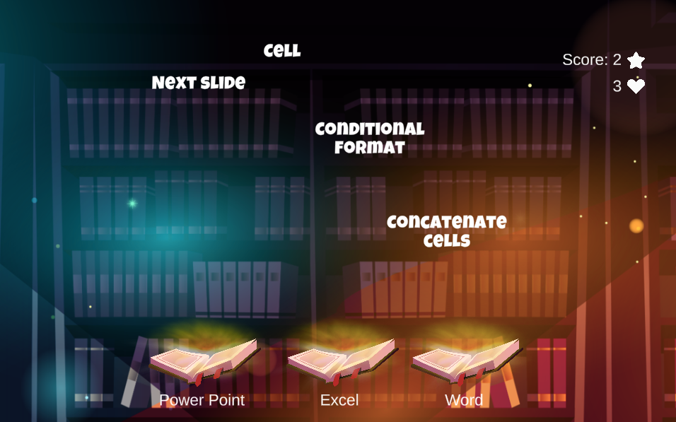

Learning aim: With this game, students should be clear about what the different Microsoft office packages are for: Excel, PowerPoint, and Word.
They will be raining terms that must match one of the three programs, in each case the one that best suits. For example, if the terms are relative to cells or functions, we will know that it refers to Excel.
In this case, the player will have 3 lives, so they can fail at most 3 times before ending the game early.
With the game it is intended to achieve especially the activation of the students, the clarity to differentiate concepts and structure the contents well according to the program to which it refers.

Didactical implementation:
1. Resources:
Learn Microsoft Office 2019: A comprehensive guide to getting started with Word, Power Point, Excel, Access, and Outlook. https://acortar.link/RvXVc3
2. Development of the learning activity
- Presentation of the IDEAL-GAME: https://idealgame.eduproject.eu/play?game=84
- Play the game and discussion of the results.
- Invite students to play the game as an introduction to these software programs or as a refresher.

3. Assessment
As long as it is a mini serious game to repeat the topic, the student is allowed to carry out a self-assessment.

Madrid Open University
Learning Scenarios and Games
Lesson Plan 3

Computer software terms - UDIMA3

Type: Swift.
Subject: English.
Theme: English learners, levels A2 and B1.
Target group: It may be appropriate for primary school, college, or university, depending on the level of English being taught. It could be used as a unit review and to prepare for an exam.
Game description: Hunt only irregular verbs in English.

Learning aim: On this occasion, the objective of the game is to differentiate the irregular verbs from the regular ones, "hunting" only the irregular verbs that appear.
It is a game to practice learning English, specifically a basic aspect such as differentiating irregular verbs, those in which the past simple and the participle are not built by adding "-ed" at the end.
The game is intended to achieve above all the activation of the students and the clarity to differentiate concepts.
Didactical implementation:
1. Resources:
Learn English - British Council: https://learnenglish.britishcouncil.org/grammar/english-grammar-reference/irregular-verbs
English page: https://www.englishpage.com/irregularverbs/irregularverbs.html

2. Development of the learning activity
- Presentation of the IDEAL-GAME: https://idealgame.eduproject.eu/play?game=22
- Play the game and review the most conflicting verbs.
- Invite students to play the game as many times as they need to review the concepts presented.

3. Assessment
As long as it is a mini serious game to repeat the topic, the student is allowed to carry out a self-assessment. It can be used to review before the exam.

Madrid Open University
Learning Scenarios and Games
Lesson Plan 4

Computer software terms - UDIMA4

Type: Swift
Subject: Calculus or basic mathematics, or any subject that aims to improve mathematical speed, concentration, and basic calculations.
Theme: Calculus, Mathematics, and Concentration.
Target group: It can be appropriate for primary, secondary, or university students.
Game description: Capture only the correct equations for 2 minutes.
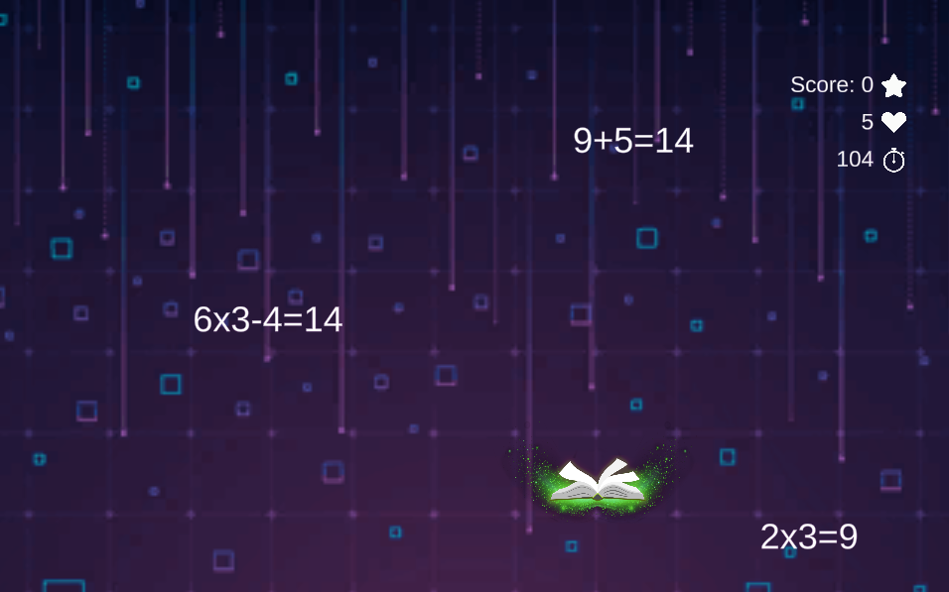

Learning aim: In this game, the player must be very attentive for 2 minutes to do simple mathematical operations (most of them) and capture the correct ones. The wrong ones have to be let go.
The player has 5 lives, therefore, if he fails the calculations 5 times, he will be eliminated. At the end of the time or being eliminated, the player will know the score achieved to be able to beat it in future attempts.
The objective of the game is above all to achieve the activation of the students, elements of reflection regarding concentration for several minutes, and assessment.

Didactical implementation:
1. Resources:
Teaching Primary Mathematics: https://acortar.link/XQr0Tf

2. Development of the learning activity
- Presentation of the IDEAL-GAME: https://idealgame.eduproject.eu/play?game=86
- Play the game and discuss the results of concentration and difficulty.
- Invite students to play the game as many times as needed to get better at quickly calculating basic maths operations and strengthen their concentration.

3. Assessment
As an additional activity to train the basic calculation speed and concentration of the student.
It can be used as class dynamics, to evaluate the level of mathematical calculation in real time in a class. At the end, students can share their grades to get a global idea.

Madrid Open University
Learning Scenarios and Games
Lesson Plan 5

Technology quiz - UDIMA5

Type: Quiz game.
Subject: Information and Communication Technologies, basic computing, any software subject or technology in general.
Theme: Technology.
Target group: It may be appropriate for high school or college students.
Game description: Answer the following questions.

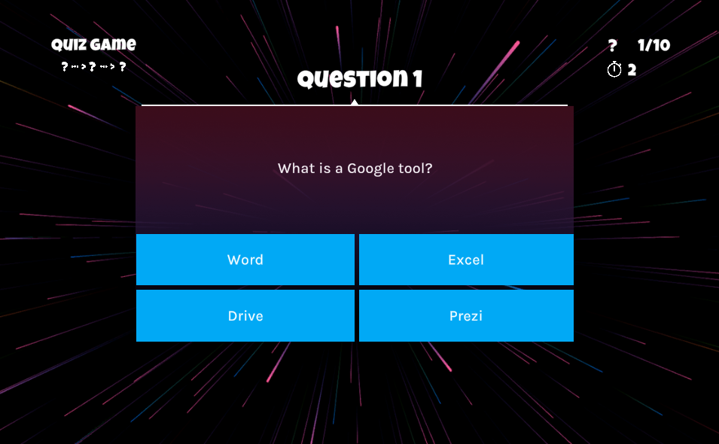

Learning aim: This game is a traditional quiz, where questions are asked and 4 possible answer options are given, of which only one is correct.
There are 10 questions in total, on topics related to new technologies, software, and office tools.
The aim of the game is above all to activate the students and structure the content well according to what is being asked, assessment, and different feedback possibilities.

Didactical implementation:
1. Resources:
Integrating Technology in the Classroom: Tools to Meet the Need of Every Student: https://acortar.link/jbi0EL
Information and Communication Technology: computerized information and electronic technology: https://acortar.link/SlzvxM

2. Development of the learning activity
- Presentation of the IDEAL-GAME: https://idealgame.eduproject.eu/play?game=24
- Play the game and share the results of the test with the rest of the class.
- Once done, the student will know the answers. He can do it again to strengthen his knowledge or as a review.

3. Assessment
As an introduction to these technologies or as a general review. It can be used as class dynamics, to evaluate the level of general knowledge of the students.
It can be used by the teacher at the beginning of the course to assess the general level of the students or as an icebreaker in an initial class.

Madrid Open University
Learning Scenarios and Games
Lesson Plan 6

Technology quiz. Final set - UDIMA6

Type: Conversation game.
Subject: Information and Communication Technologies, basic computing, any software subject or technology in general.
Theme: Technology.
Target group: This would be appropriate for high school or college students, as a unit review.
Game description: Answer the questions correctly until you reach the end. Pay attention because a failure will make you start over.

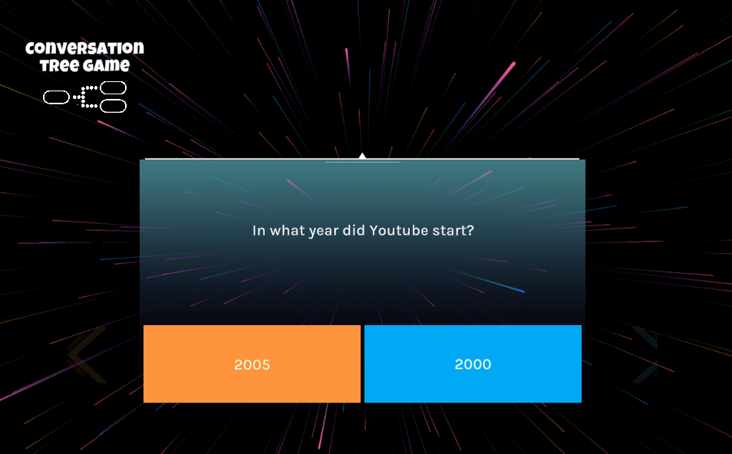

Learning aim: This game emulates a quiz, where a question is asked and there are two possible answers. If you get it right, you go on to the next question, but if you fail, the game ends.
The goal is for the player to get all the questions right and pass all 7 levels, but if he gets any wrong, he would have to start over.
Therefore, there are 7 questions in total, on topics related to new technologies, software, general knowledge about new technologies, and the Internet.
At the end of the last question, the player will get the score they have achieved and personalized feedback, depending on how they have done.
The aim of the game is above all to activate the students and structure the content well according to what is being asked, assessment, and different feedback possibilities.

Didactical implementation:
1. Resources:
Foundations of Web Technology: https://acortar.link/Pah5qH

2. Development of the learning activity
- Presentation of the IDEAL-GAME: https://idealgame.eduproject.eu/play?game=85
- Play the game and share the results of the test with the rest of the class.
- Multiple attempts can be made until all questions are answered correctly. You can do it again to reinforce knowledge or as a review.

3. Assessment
As an introduction to a class on technology or as a fun activity related to technology. It can be used as a class dynamic, to assess the level of general knowledge of the students.
It can be used by the teacher at the beginning of the course to assess the general level of the students or as an icebreaker in an initial class.

Madrid Open University
Learning Scenarios and Games
Lesson Plan 7

Social networks - UDIMA7

Type: Memory.
Subject: Information and Communication Technologies, Marketing and Advertising.
Theme: Social networks.
Target group: This game would be appropriate for elementary or high school students.
Game description: Search and memorize the pairs of social networks.

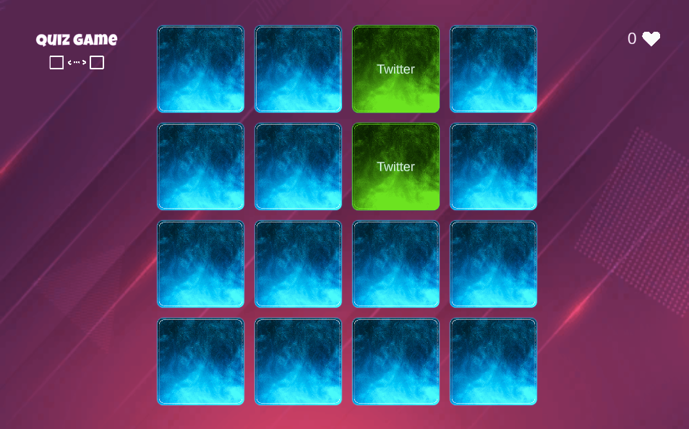

Learning aim: This game aims to discover cards with different social networks and make pairs, memorizing the place they occupied when discovered.
The objective of the game is to clarify and get elements of reflection and memory on the already uncovered networks.

Didactical implementation:
1. Resources:
- Beginner Guide of Social Media Marketing: Use Facebook, Twitter, Pinterest, Instagram, Linkedin and Google Plus for Business Growth. - Matthew Roy
- Social Media Marketing - Ultimate User Guide to Facebook, Instagram, YouTube, Blogging, Twitter, LinkedIn, TikTok, Pinterest. - Adidas Wilson

2. Development of the learning activity
- Presentation of the IDEAL-GAME: https://idealgame.eduproject.eu/play?game=4
- Play the game and discussion of the results. Reflection of the result of each one.
- Invite students to play the game as many times as they need to review the concepts presented.

3. Assessment
As long as it is a mini serious game to repeat the topic, the student is allowed to carry out a self-assessment.
It could be used as an introduction to technologies or as an extra activity to sharpen memory.

Madrid Open University
Learning Scenarios and Games
Lesson Plan 8

Speedy Noah's Ark - UDIMA8

Type: Crane.
Subject: Natural sciences.
Theme: Zoology.
Target group: This game may be appropriate for high school or college students.
Game description: Rank these animals from fastest to slowest. Hurry up, you only have 1 minute!

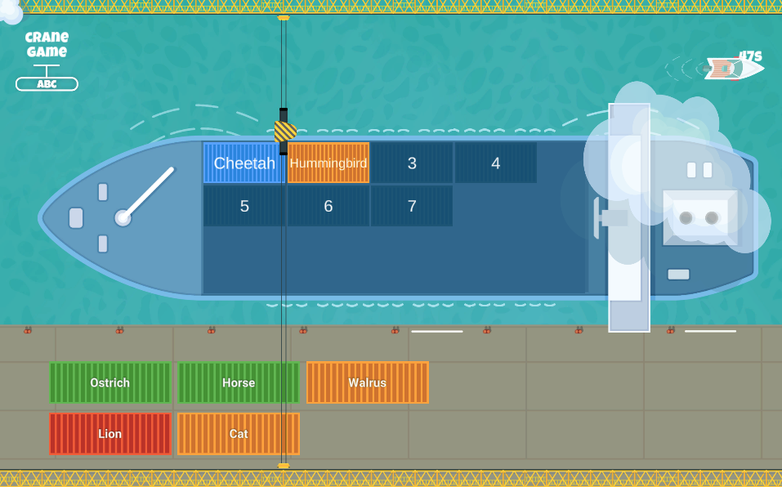

Learning aim: This game aims to place the animals in order, depending on their speed. If any animal is ordered in an incorrect position, it must be ordered again, before the end of the 1-minute time.
The objective of the game is above all to activate the students, structure the content well according to what is asked, and reflect on the options to get the correct order on time.

Didactical implementation:
1. Resources:
Vertebrates: Comparative Anatomy, Function, Evolution: https://acortar.link/8UTBQQ

2. Development of the learning activity
- Presentation of the IDEAL-GAME: https://idealgame.eduproject.eu/play?game=89
- Play the game and discussion of the results.
- Invite students to play the game as many times as they need to review the concepts presented.

3. Assessment
As long as it is a mini serious game to repeat the topic, the student is allowed to carry out a self-assessment.
It could be used as an introduction to natural science, or as an extra activity.
It can be used as a starting point to reflect on and order other animals in class.

Madrid Open University
Learning Scenarios and Games
Lesson Plan 9

Social networks chronology - UDIMA9

Type: Build a bridge.
Subject: Information and Communication Technologies, Marketing, Advertising, and Community Management.
Theme: Social Networks.
Target group: It may be appropriate for high school or college students.
Game description: Sort these social networks by launch date, from oldest to newest.

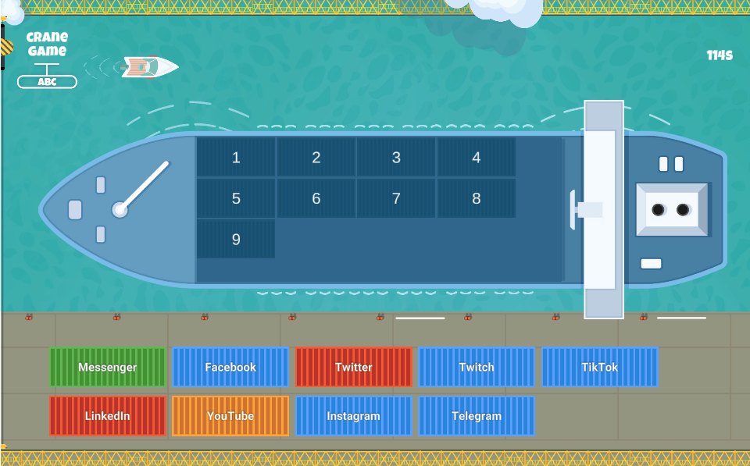

Learning aim: Students have 2 minutes. The nets in their correct position will stay and the rest will have to be put back. In this game, the player must order the applications and social networks that are proposed, according to the release date. In this way the bridge will resist, if any piece is poorly arranged, the bridge will fall and the player will have lost.
The student must think and choose if an application like Linkedin is before or after another like YouTube.
To assign the order and check if it is correct, the player will have a maximum of 2 minutes, before checking if the chosen order is correct.
The objective of the game is above all to activate the students, structure the content well according to what is asked, and reflect on the options to get the correct order on time or successive attempts.

Didactical implementation:
1. Resources:
Social Media Marketing 2020 Mastery. How to Create a Brand. Become a Skilled Influencer on Twitter, Facebook, Youtube, and Instagram: Personal Branding & Digital Networking Strategies. - Brandon J. Artley

2. Development of the learning activity
- Presentation of the IDEAL-GAME: https://idealgame.eduproject.eu/play?game=43
- Play the game and discussion of the results.
- Discuss in class how networks have evolved and what changes they have had from the first to the last to be launched.
- Invite students to play the game as many times as they need to review the concepts presented.

3. Assessment
As long as it is a mini serious game to repeat the topic, the student is allowed to carry out a self-assessment.
It could be used as an introduction to the technology, or as an extra activity.

Madrid Open University
Learning Scenarios and Games
Lesson Plan 10

Human evolution bridge - UDIMA10

Type: Build a bridge.
Subject: Natural sciences, ancient history, or similar.
Theme: Human evolution.
Target group: It may be appropriate for elementary or high school students.
Game description: Order the homos of the hominization process, from oldest to most recent.
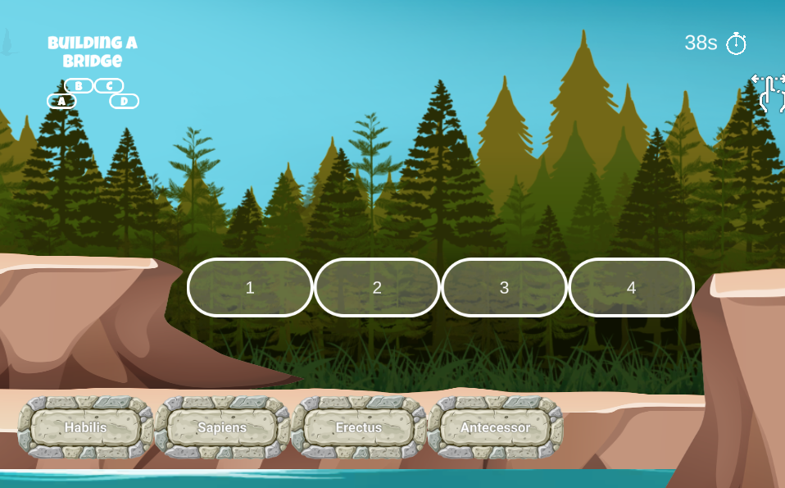
Learning aim: In this game, the player must order some phases of human evolution, choosing which was before and which was after. In this way the bridge will resist, if any piece is poorly arranged, the bridge will fall and the player will have lost.
To assign the order and check if it is correct, the player will have a maximum of 1 minute, before checking if the chosen order is correct.
The objective of the game is above all to activate the students, to clarify the different phases of human evolution, to structure these phases well to know which was before and which was after and to reflect on the options to get the correct order on time or successive attempts.

Didactical implementation:
1. Resources:
Human Evolution: A Very Short Introduction: https://acortar.link/LTOMlR
A Story of Us: A New Look at Human Evolution: https://acortar.link/Br2S2U

2. Development of the learning activity
- Presentation of the IDEAL-GAME: https://idealgame.eduproject.eu/play?game=87
- Play the game and discussion of the results.
- Expand the list with other evolutionary phases, following the dynamics proposed in the game.
- Invite students to play the game as many times as they need to review the concepts presented.

3. Assessment
As long as it is a mini serious game to repeat the topic, the student is allowed to carry out a self-assessment.
It could be used as an introduction to natural science, or as an extra activity to open the topic in class.

Conclusions
UPB - Marc Beutner
The project IDEAL-GAME could successfully provide a serious game creator tool, which offers the opportunity to create and implement mini serious games. The testing results were very positive and the games could be integrated in different fields of higher education. Moreover, the partners were able to create additional lesson plans as well as learning and teaching resources. In the partner countries both the lecturers and the students could handle the tool and implement it in the learning processes. It was possible to get feedback on the games and to adapt them to the different modules, courses and lectures. The feedback was excellent and strengthens the idea to offer IDEAL-GAME on a broader basis. The lecturers stated that the use of the tool is easy. Moreover, they made clear that it is necessary to test a little bit with the settings for the different game, to get for example an appropriate time for the appearance of terms and items or for the appropriate speed, which has to be adjusted to the specific needs and the lengths of the texts. The learners and students easily got accustomed to the games and could handle it perfectly. Nevertheless, there is always the need to combine the games with other parts of the lectures, modules or courses, because it is always helpful to rethink the content and to provide feedback to the learners, who are keen on getting additional information by the lecturer. They felt motivated and were very interested to work with the different games. Here also the variety of games (a) raining words, (b) collecting words, (c) memory, (d) build a bridge, € conversation game, (f) quiz game, (g) explore campus and (h) the crane game is helpful to have not always the same approaches with the students but to offer a mixture of games within a course to ensure additional motivation and to integrate different perspectives.
The usability test of the Serious Game Creator Tool was successful and the usability of the tool is really good. This means it can be handled easily and the integration of the games in higher education went very well. In total, IDEAL-GAME is an excellent approach and offers mini serious games as OER (open educational resources) as well as the serious game creator tool.

