IDEAL-GAME
Improving didactics, education and learning
in higher education with the Online Serious Game Creator

The IDEAL-GAME
Summary of mini SG ideas

Project Title: Improving didactics, education and learning
in higher education with the Online Serious Game Creator
Acronym: IDEAL-GAME
Reference number: 2020-1-DE01-KA203-005682
Project partners: P1 University Paderborn (UPB), DE
P2 Ingenious Knowledge GmbH (IK), DE
P3 Universitatea din Pitesti (UPIT), RO
P4 Wyzsza Szkola Ekonomii i Innowacji w Lublinie (WSEI), PL
P5 University of Dundee (UoD), UK
P6 Universidad a Distancia de Madrid SA (UDIMA), ES

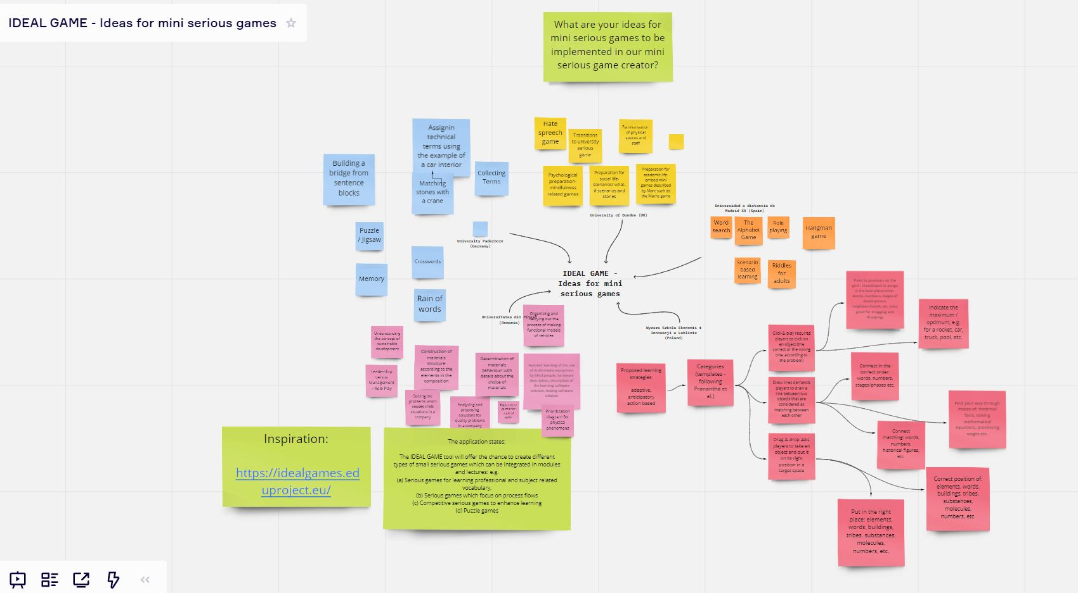

Hate speech game
Derek Robertson
Introduction
The idea for this game comes from a tradition of serious games that explores, highlights and challenges aspects of our social world. Games from studios like Mollendustria have shone a light on issues such as workers’ rights in iphone factories in China, the fast-food industry, paedophilia in the church and the advent of the Anthropocene.
Title of the game: How does it feel? (inspired by the Dylan song of the same name)
Premise of the game: Concerns about the way that social media channels have given platforms for hate speech and intolerant perspectives to be shared have led to their criticism. Indeed, many governments are talking about putting measures in place to ensure social media platforms take responsibility for the content of the material that appears on their channels and the way that they algorithmically use these to deliver content to what it appears that people may like. In the UK at least the Brexit debate gave rise to concerns about the way that mainstream media outlets such as newspapers helped contribute to ore even create a climate of islamophobia for example. This game is designed to ask players to reflect on the impact that intolerant, blaming and at times hateful content can have on minority groups targeted by such material.
Game play
The game play would allow the player to collect examples of hateful material from the web. They can then use a grading scale to code the impact that this material may have when viewed by a minority group person that is referred to in the source, almost like hate hit points. These can then be used against one of a set of pre-scripted characters in the game. The characters could be from a series of social settings: working-class white boy from a single parent family in poverty, a refugee from Syria recently arrived in a European country, third generation Muslim girl, a young woman going through gender reassignment etc.
These hit points could then be coded in some way to show how these chosen hate articles may have an impact on this person. It should lead to discussion points about the impact of these materials and the views they present.
Issues with the idea
This game is in danger of offering a simplistic view of the world and of minorities. Not everyone will feel or respond to issue in the same way. It doesn’t even take account of the intersectionalities of what it means to be human, irrespective of whether you are from a minority or not. Care would also need to be taken not to create stereotypes of people from minorities

Multiple and Multi-dimensional Transitions to University Mini-serious games
Divya Jindal-Snape

1: Objectives

1.1: Develop socio-emotional skills essential for successful transitions

1.1.1: Adaptability

1.1.2: Dealing with change

1.1.3: Making friends

1.1.4: Making choices

1.1.5: Ability to discuss concerns

1.1.6: Teamwork

1.1.7: Problem solving skills

1.1.8: Negotiation skills

1.2: Develop academic skills necessary for the move and transitions across university

1.2.1: Mathematical

1.2.2: Literacy

1.2.3: Science

1.2.4: Social Sciences

1.2.5: Problem solving

1.2.6 Academic writing skills

1.2.7 Essay writing skills

1.2.8 Referencing skills

1.3: Ability to deal with concerns that they might have-in a secure environment- also remembering that these same aspects are exciting and satisfying for most learners

1.3.1: University size

1.3.2: Travelling to university - maybe at a distance

1.3.3: Living in a new city

1.3.4 Managing finances, cooking etc.

1.3.4: Different staff in different roles

1.3.5: Finding their way around the university (physically around the campus)

1.3.6: Finding their way around the virtual learning environment

1.3.7: Change in people and routines

1.3.8: Making new friends

1.3.9: Change in the organisational culture and expectations of staff

1.3.10: Self-directed learning

1.3.11: Map navigation

1.4: Use a play based approach to facilitate the transition process

1.4.1: Therefore, computer games based approach

1.5: Enhance Self-esteem, Emotional intelligence and Resilience to change

2. Content

2.1: Role play based scenarios

2.1.1: Real life scenarios from transition to and through university context based on DJ-S's research

2.1.2: Safe environment to practice real life situation but can de-personalise

2.1.3: Avatars? If yes, opportunity to reflect on the shape/size/characteristics of their avatars.

2.1.4: 3D animation?

2.1.5: Augmented reality?

2.1.5: Different consequences leading to learning of skills and identifying the best way forward in certain situations

2.2: Quiz

2..2.1: Urban myth style- based on transitions myths

2..2.2: Could have curricular aspects, e.g., science questions

2.3: Skills based games

2.3.1: e.g., Wii Fit mental agility games (avoid the falling bricks, the labyrinth style games)

2.3.2: Problems related to Maths (Sudoku style/), Literacy, etc.

2.3.3: Other games like brain training games

2.3.4: Navigation skills, e.g., on Wii Fit- following the map to pop balloons, GeoGussr,
Geocaching, see slide with map of university and related questions
2.3.5: Team building through Escape Room type game, Pokemon Go- for navigation and team building

2.3.6: Critiquing/managing media/academic articles: Content that can be created using topical issues such as islamophobia

2.3.7: Simple feedback based game around referencing and other academic skills

3: Other aspects

3.1: Reinforcement built in- sounds, unlocking levels/accessories, etc.

3.2: Interactive game

3.3: Can be played individually

3.4: Can be used in a group setting with staff facilitating discussion

3.5: Safe

3.6: Progression for the player- easy and small steps to ensure success

3.7: In quiz- give the right answer for quick learning- repeat for checking retention

3.8: Accessible to students with specific needs, sensory disabilities, learning difficulties, etc.

3.9: Think about making it accessible to those for whom English is not the first language- will we have translated text?

Narrative: Technological Support
Helen Booth

Keywords: induction, welcome week, socialisation, building-friendships, emotion, discussion, conceptual problems, social-awareness, engagement, technology, anxiety, communication, classroom community, bonding, confidence.
Target audience: Classroom and remote students (hybrid)
Studies confirm that inadequate support for students to get familiarised and practice using digital tools in the first week of term is closely linked to poor student attrition rates (Creating a Sense of Belonging Toolkit, 2019). Including an induction game where you can track completion of tasks can offer an opportunity to highlight students who may potentially experience some challenges and identify learning needs early on to increase learner confidence and autonomy and opportunities for student and tutor interaction.
Objective: Most students will not only be unfamiliar with blended or online learning and the technologies we adopt in the University, but with the general nature of digital tools they need to effectively access and are expected to use and learn. The idea of this short game is to help learners think and reflect on their feelings about how to engage with technology before commencing studies as well as to identify IT issues and conceptual problems.
User-Interaction: Active, student-centred learning facilitated. User interaction starts with students colouring in a figure they identify with the most on a ‘technology tree’ about how they feel using digital tools. The figures on the tree represent cartoon-like characters with different emotions. [Words on tree – count accumulated hits]
Rich discussion: Students articulate their feelings. Supports tutor to identify differences amongst students early on and help accommodate individual needs. [Class or group discussion.]
Orientation (technical/learning): Students work in groups and choose a specific orientation task on a digital tool of their choice to help build their confidence.
User-interaction: Branching scenario (quiz)
Measure what they have learned from the orientation task. Build a branching scenario with consequences for active review to assess knowledge.

User-Interaction: Evaluate emotions and gauge how students feel compared to how they were feeling at the start of the activity.
Idea sourced from Blob Tree test created by behavioural psychologist Pip Wilson.
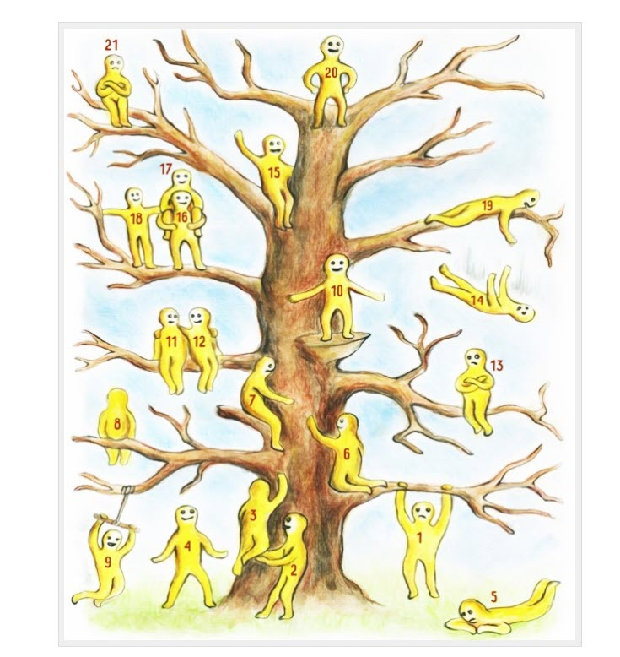

Nature connection game – exploring close, urban nature for wellbeing and pro-environmental behaviours
Alexia Barrable

Nature connection, our positive relationship with the natural world, has been found to support wellbeing (Capaldi et al., 2015), as well as pro-environmental attitudes and behaviours (Franzt & Mayer, 2014). This particular serious game aims to enhance HE students’ connection to the natural world through playful exploration of their close, urban spaces, such as a university campus. Nature connection has been found to decline in adolescence and into early adulthood in a variety of samples across the globe (see for example Keith et al., 2021; Richardson et al., 2019). Previous studies have showed that engagement with nature through technology can help build a positive connection to the natural world (Barrable & Booth, 2020; McEwan et al., 2019).
The serious game will focus on:
- Helping students notice and note nearby urban nature within the student campus, including gardens, plants, trees and urban animals
- Allowing students to notice beauty in nature and the passing of seasons
- Putting students in a position where they can empathise with non-human nature through stories and narratives within the game
- Promote mindfulness when engaging with nearby urban nature
- Include a sandbox activity (open-ended exploration)
All of the above are research-based ways to enhance nature connection.

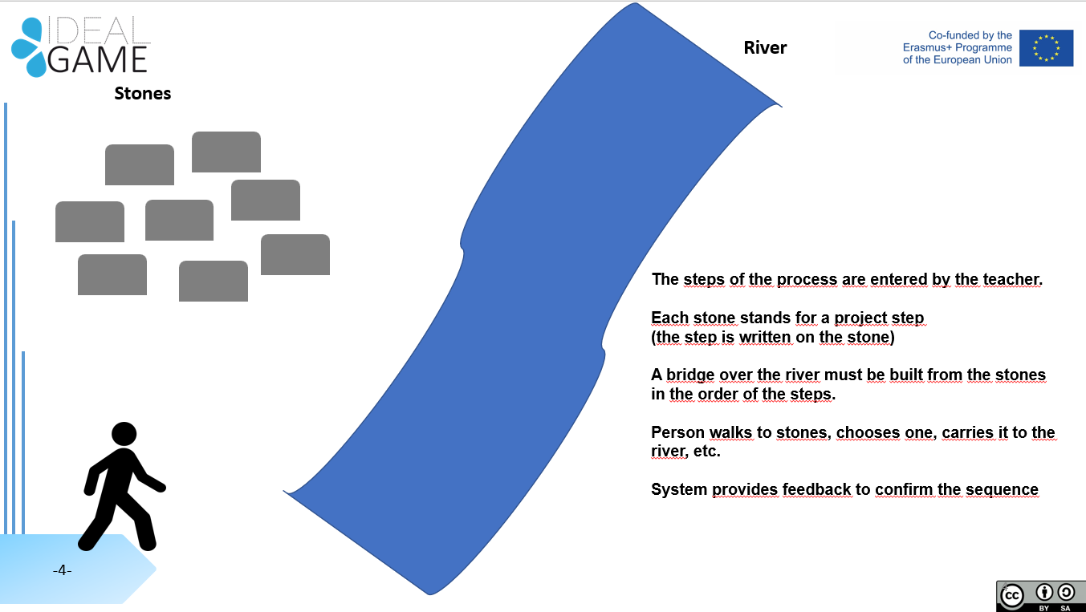

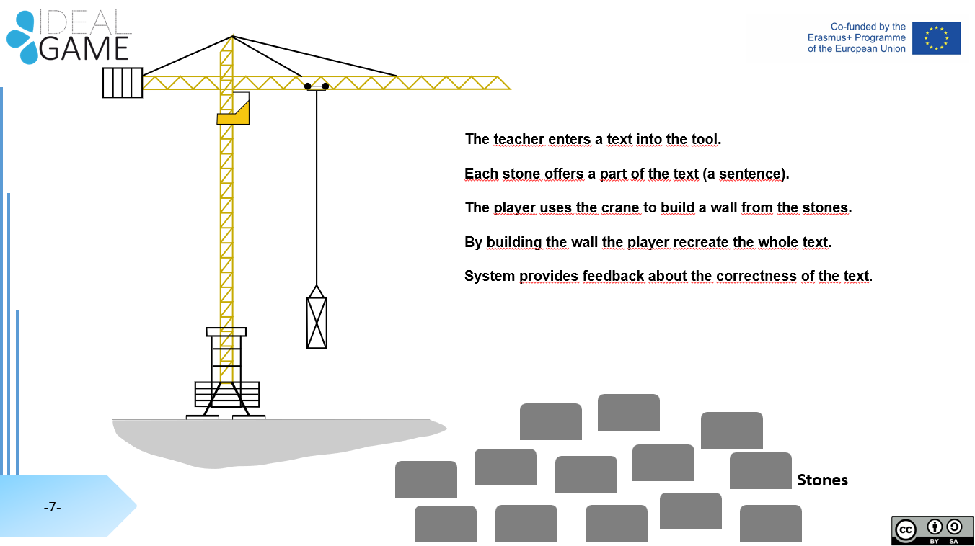

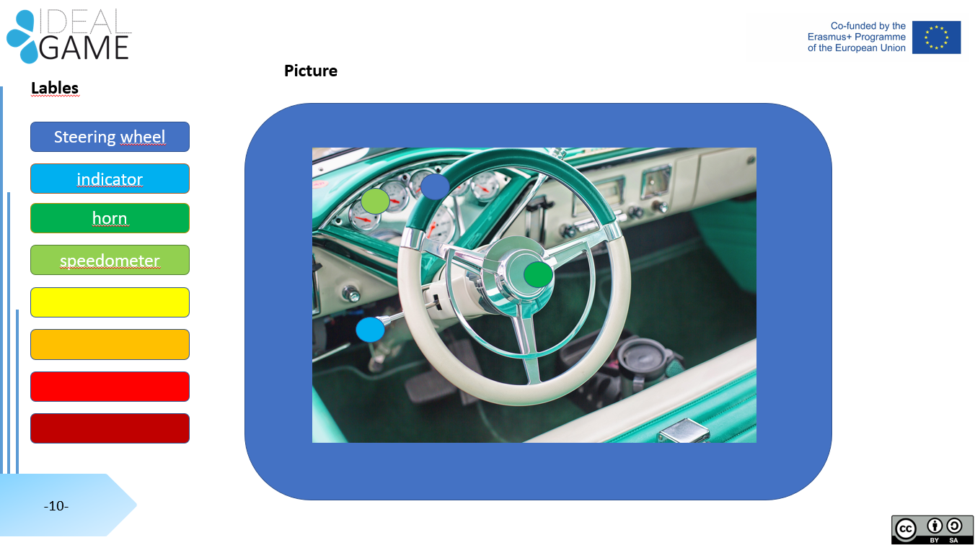
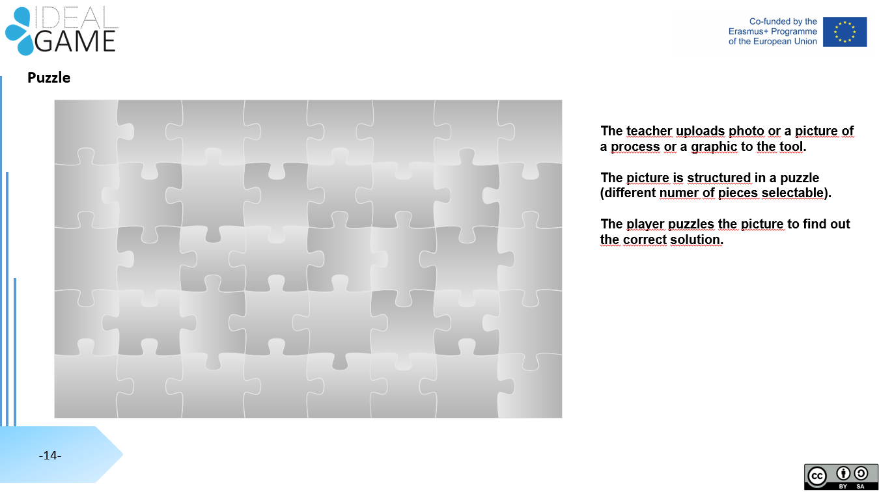
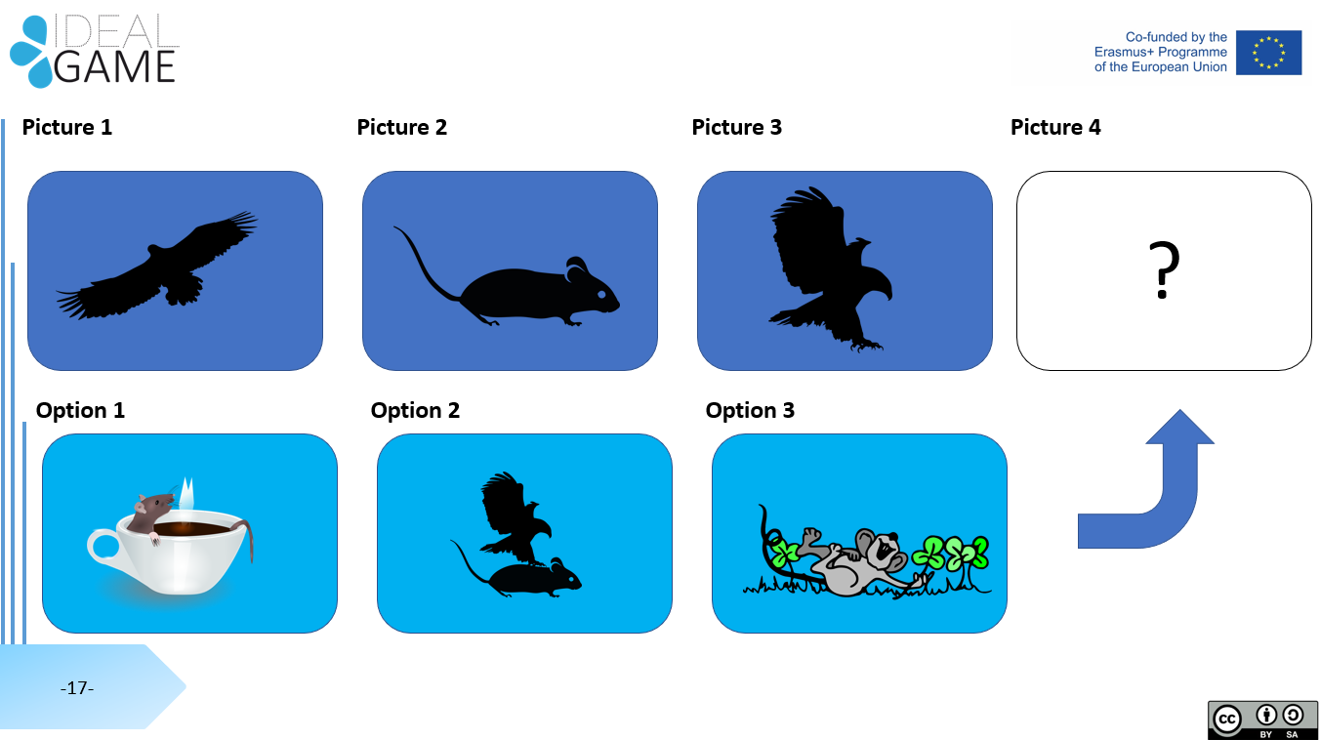

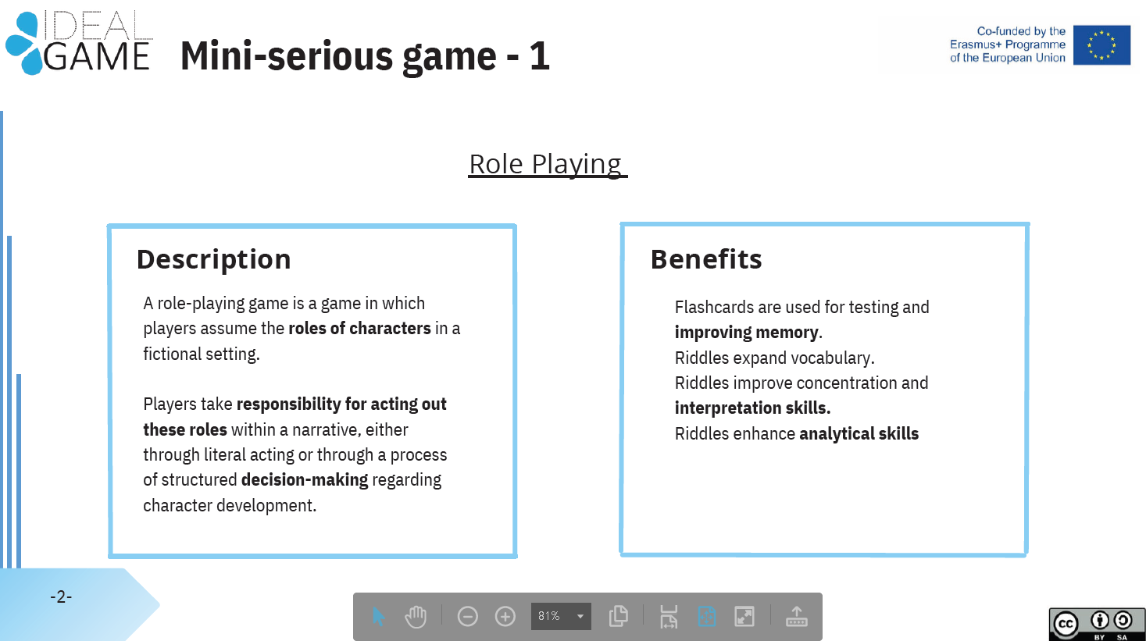
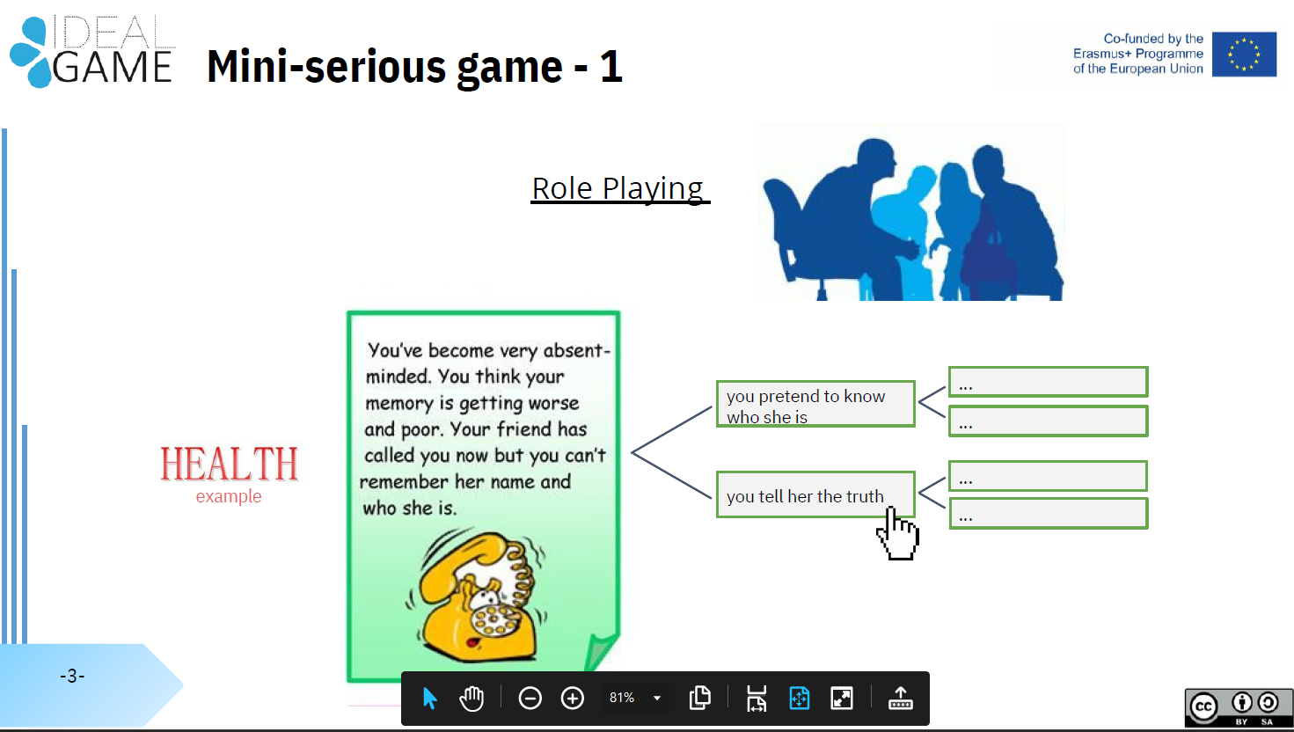
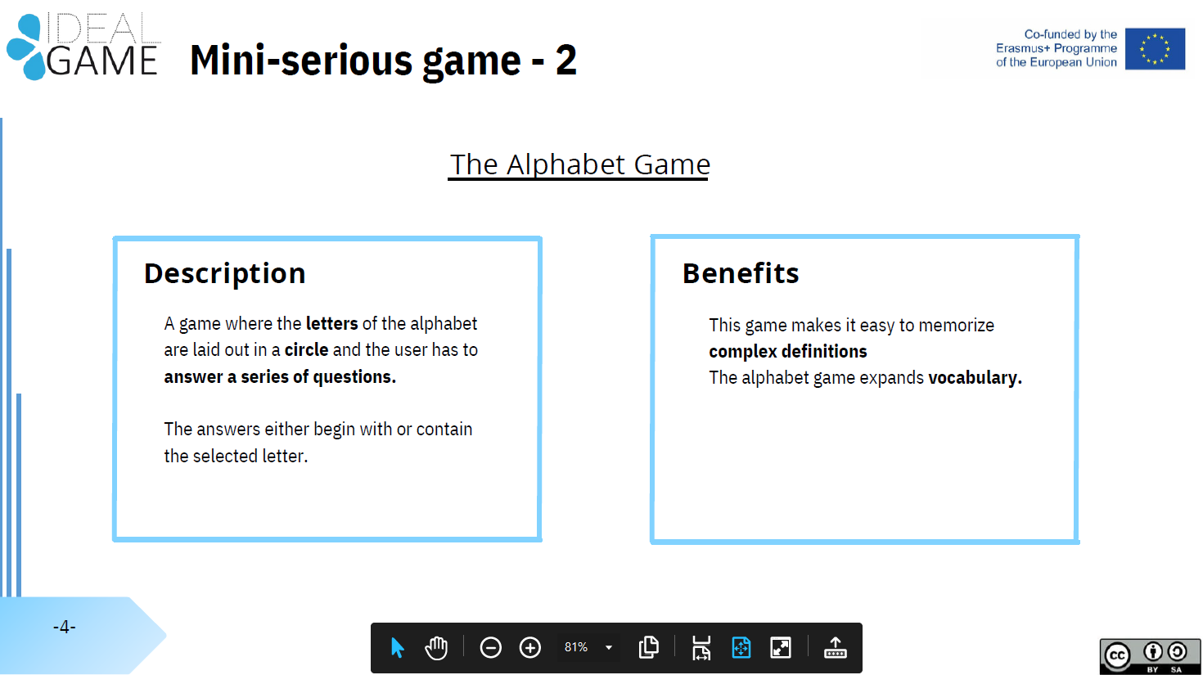
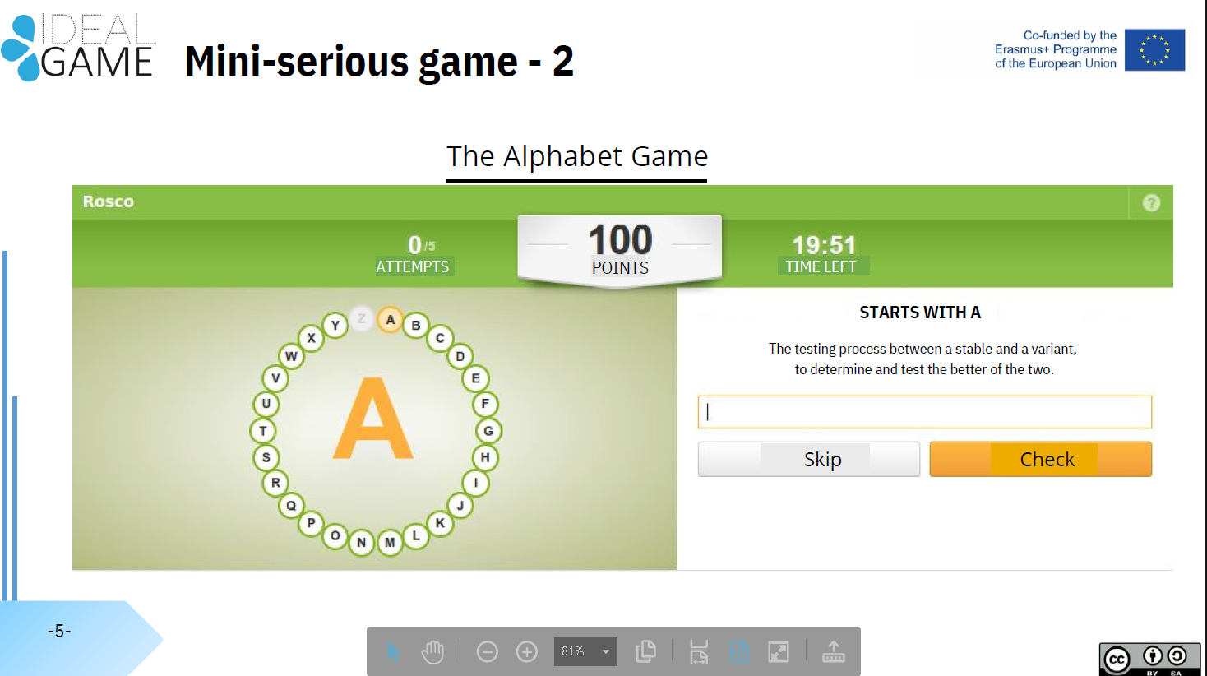
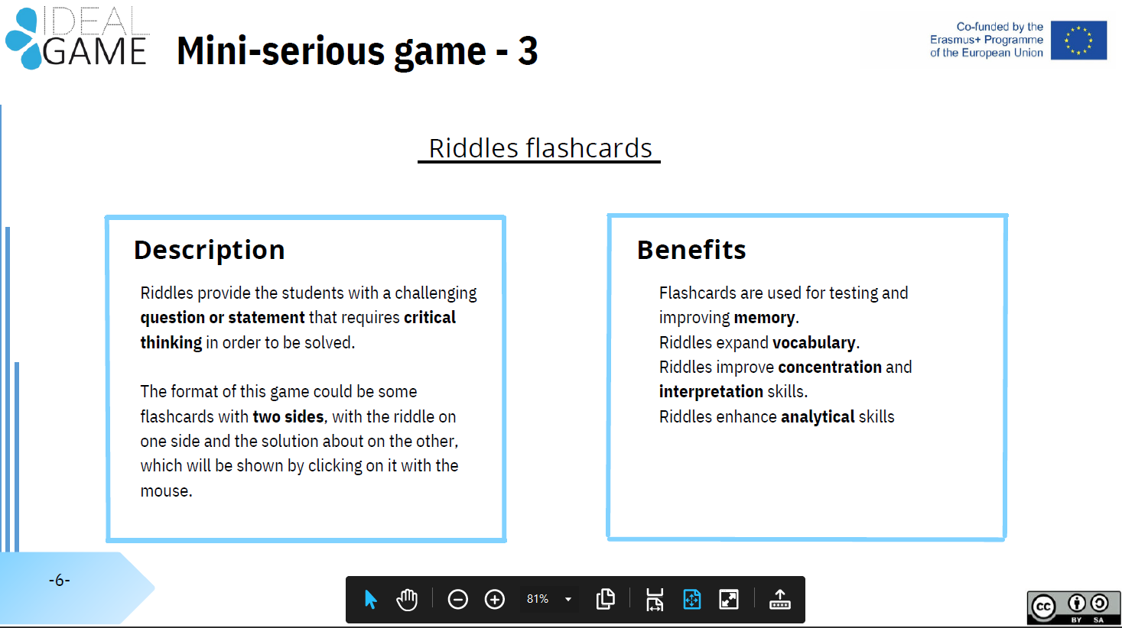
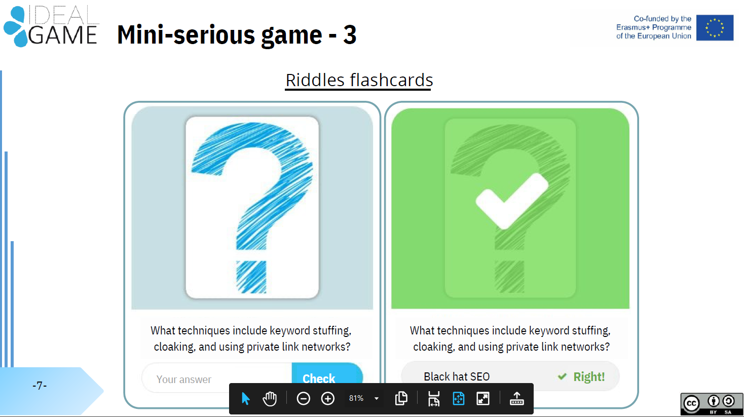
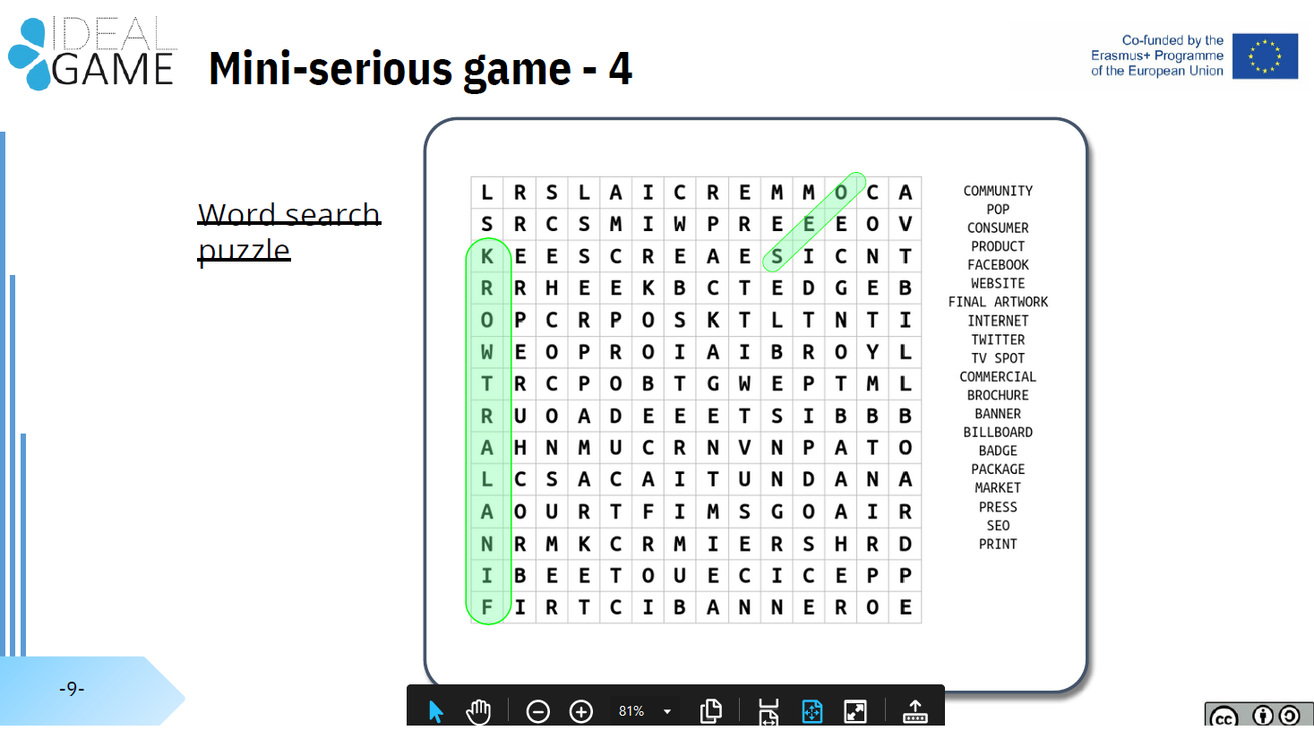

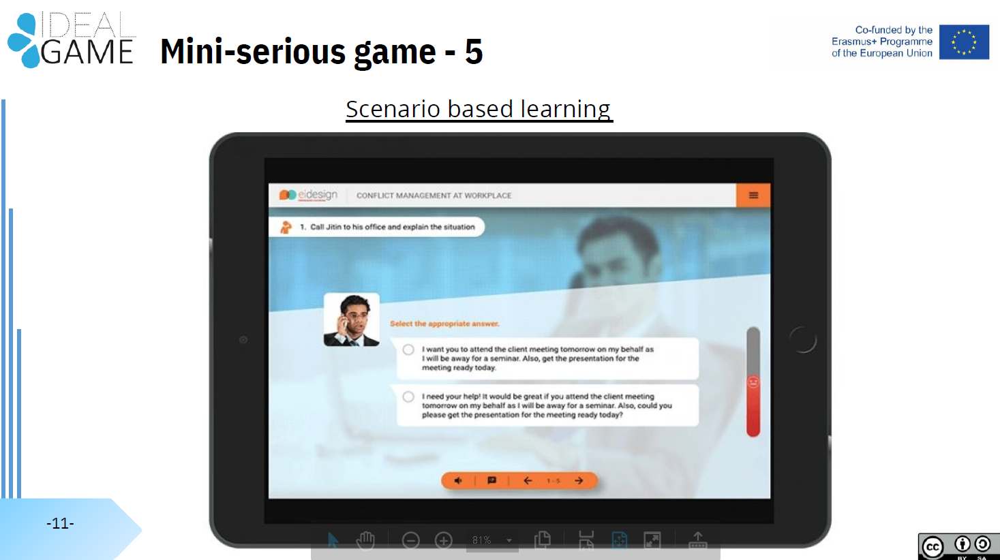

IO2: Creator Tool Development
10 ideas from UPIT for "mini" serious games

Idea no. 1:
Construction of materials structure according to the elements in the composition

Objectives:
- to help 1-year students from the study programs Industrial Economic Engineering, Environmental Engineering, Automotive Engineering, Road Traffic and Transport Engineering learn more about the microscopic world
- to visualize crystal and molecular structures
- you can build any kind of crystal or molecular structure

Learning (what to do):
- Click-and-drag with the mouse, use the keyboard, or toolbar the elements from periodic table
- Click on an element to view atomic radius, Z, atomic structure, cell structure, atomic forces
- Click on the one of the 7 crystallographic systems to view the example of elements
- Click on 2 elements and view if they can be bounded and form a structure (ionic or covalent structure)

Questions (quizz with 25 questions like the ones below):
- What are the crystal structures?
- What are cell parameters?
- What are atomic boundaries?
- What kind of cell structures do you know?
- Recognize a cell structure from a picture
- ……………

Idea no. 2:
Determination of materials behaviour: with details about the choice of materials

Objective/aim:
- to help 1-year students from the study programs Industrial Economic Engineering, Environmental Engineering, Automotive Engineering, Road Traffic and Transport Engineering learn more about the properties of materials: ferrous alloys (steels, cast irons), nonferrous alloys, ceramic materials (oxides, nitrides, carbides), polymer materials (PVC, PET, PE)

Learning (what to do):
- Click-and-drag with the mouse, use the keyboard, or toolbar the alloy type (ferrous alloys (steels, cast irons), nonferrous alloys, ceramic materials (oxides, nitrides, carbides), polymer materials (PVC, PET, PE)
- Click on a material (example: steel with 0,4%C)
- View what are mechanicals properties: hardness, resilience, resistance at traction, elongation
- View what are technological properties: hardening, weldability (calculus of equivalent carbon)

Questions (quizz with 25 questions like the ones below):
- What are the class of alloys?
- What are the mechanical properties?
- What is hardness?
- What is resilience?
- What is equivalent carbon?
- ……………………..

Idea no. 3:
Assisted learning of the use of multi-media equipment by blind people: hardware description, description of the learning software solution, testing software solution

Objective/aim:
- The purpose of the application is to help visually impaired people memorize the position of the keys / characters of a standard PC keyboard.

Learning (what to do):
  - generating a sound, specific to each key, when a key is pressed.
  - the sounds used are uploaded to a phonetic library, each being independent wav files.
  - displays alphanumeric characters corresponding to the keys pressed
  - displays the Braille shape of the character.
  - reports editing errors after dictation.

Questions (quizz with 25 questions like the ones below):
- Testing the speed of editing a listened text?
- Testing the level of correctness when editing a listened text?
- ……………………..

Idea no. 4:
Organizing and carrying out the process of making functional models of vehicles

Objectives:
- to help 3rd-year students from the study programs Automotive Engineering and Road Traffic and Transport Engineering to learn more about the manufacturing process of a vehicle;
- to help students improve their teamwork skills;
- to help students to organize their working time efficiently.

Learning (what to do):
- the students will form teams of 5-7 people, establishing the tasks for each of them;
- students will study the execution documentation;
- students will plan the production activities of the vehicle components;
- students will ensure the realization of the components and the assembly of the vehicle;
- students will control and appreciate the quality level of the final product obtained.

Questions:
- how were the tasks of the team set up?
- how were the tasks distributed to the team members?
- how were production activities planned?
- how do you assess the quality level of the final product?
- what were the major challenges encountered during this exercise?
- what are the lessons learned after completing this exercise?

Idea no. 5:
Analyzing and proposing solutions for quality problems in a company

Objectives:
- to help 3rd-year students from the study programs Automotive Engineering and Road Traffic and Transport Engineering to learn more about identifying and solving quality problems that may occur in the manufacturing process;
- to help students improve their teamwork skills;
- to help students to organize their working time efficiently.

Learning (what to do):
- students will form teams of 5-7 people, establishing the skills and tasks foreach of them;
- students will collect information related to quality problems claimed by customers or that may occur during the manufacturing process of the product;
- students will study various tools that can be used to analyze the identified quality problems;
- students will use at least two tools to identify the main causes and establish measures to solve some of the identified problems;
- students will appreciate the efficiency of the activity carried out by the team.

Questions:
- how was the information on quality issues collected?
- how were the tasks within the team established?
- how were the tools used for the analysis of the identified quality problems chosen?
- how do you appreciate the efficiency of the activity carried out in this exercise?
- what were the major challenges encountered during this exercise?
- what are the lessons learned after completing this exercise?

Idea no. 6:
Solving the problems which causes crisis situations in a company

Objectives:
- to help 3rd-year students from the study programs Automotive Engineering and Road Traffic and Transport Engineering to learn more about identifying and resolving crisis situations that may occur within a company (e.g. weather conditions that cause supply disruptions, power outages, explosions of combustible materials followed by massive fires, breakage of dams followed by catastrophic floods, etc.),
- to help students improve their teamwork skills;
- to help students to organize their working time efficiently.

Learning (what to do):
- students will form teams of 5-7 people, establishing the skills and tasks for each of them;
- students will collect information related to potential situations of crisis or force majeure that may occur in a company;
- students will analyze the identified crisis or force majeure situations and their implications on the company's activity;
- students will establish sets of measures, by categories of situations, which can be adopted to overcome the identified situations;
- students will establish preventive and backup measures that can be adopted to prevent the identified situations.

Questions:
- how was the information on crisis or force majeure situations collected?
- how were the tasks within the team established?
- how were the influences of the crisis or force majeure situations on the company's activities appreciated?
- how do you appreciate the efficiency of the activity carried out in this exercise?
- what were the major challenges encountered during this exercise?
- what are the lessons learned after completing this exercise?

Idea no. 7:
Understanding the concept of sustainable development

Objectives:
- Students will understand the concept of sustainable development, established by the 2030 Agenda for sustainable development;
- Students will identify the 17 objectives of sustainable development, established by the 2030 Agenda for sustainable development;
- Students will discuss the characteristics of the 17 objectives of sustainable development;
- Students will match the characteristics of the 17 objectives to create a puzzle.

Learning:
- Students will work in teams of 5-7 people, to collaborate in order to solve the puzzle;
- Students will read a short presentation of the 17 objectives of sustainable development, in order to understand the concepts presented;
- Students will read the explanations regarding the solving of each puzzle;
- Students will work together to solve the puzzle.

Questions:
- How were the tasks distributed within the teams?
- How was the puzzle of each puzzle planned?
- How will the solution of each puzzle be evaluated?
- How will we make sure that the assumed objectives have been achieved?

Idea no. 8:
Explanatory puzzle for applied optics

Objectives:
- to help 1st - year students from the study program Environmental Engineering and 2nd - year students from the study program Energetics and Nuclear Technologies to learn more about the construction of optical apparatus;
- to visualize and to recognize the components of various optical apparatus;
- to correctly assemble these components so that the optical apparatus obtained is functional;
- to describe the role of each component in the operation of the studied optical apparatus;
- to specify some practical applications of the studied optical apparatus;
- to help students to improve their teamwork skills and to efficiently organize their working time.

Learning:
- The teacher will provide the pieces of a puzzle consisting in separated and randomly mixed images displayed on PC screen, representing components of a certain optical apparatus. Finally, the teacher instructs the students to work in teams of 5-7 people.
- The students from each team will solve the puzzle by selecting the components and putting them in order to correctly assemble the studied optical apparatus. To do so, the students will click-and-drag with the mouse or use the keyboard or toolbar to move on PC screen the images corresponding to the selected components.
- Each student from a team will describe the role of at least two selected components and will specify at least one practical application of the studied optical apparatus.
- The students from each team will verify the correct assembling of the studied optical apparatus and the right answers using the explanatory information provided in the serious game menu.
- Depending on the correctness of students` results, each team will receive a score that will help establish the ranking within the group of students.

Questions:
- What are the optical components in these images? What optical apparatus do they form?
- How do you assemble the given components so that the optical apparatus obtained is functional?
- What is the role of each component in the operation of the studied optical apparatus?
- What are the applications of the studied optical apparatus?
- What are the major challenges encountered during this exercise?

Idea no. 9:
Prioritization diagram for physical phenomena
Objectives:
- to help 2nd - year students from the study program Environmental Engineering and 2nd - year students from the study program Energetics and Nuclear Technologies to prioritise and categorise key factors in a specific physical phenomena;
- to learn professional and subject related vocabulary to describe the studied physical phenomenon;
- to learn the mathematical language to explain the evolution of the studied physical phenomena;
- to discuss the practical applications of the studied physical phenomenon;
- to help students to improve their individual skills and to efficiently organize their working time.

Learning:
- The students will read and will understand the rules to complete the diagram:
- The most important factors are placed towards the top of the diagram.
- The least important factors are placed towards the bottom of the diagram.
- Factors of equal importance are placed in the same row. Each factor can be colour coded for further sophistication.
- The teacher will provide 10 diagram boxes randomly displayed on PC screen, containing one key factor each that characterize a certain physical phenomenon. Also, the teacher will provide another 2 empty boxes for additional key factors and one empty box especially designed for fill in with mathematical formulas. Finally, the teacher instructs the students to work individually.
- The students will fill in the 2 empty boxes with additional key factors provided by themselves.
- The students will place the given factors in the diagram according to the aforementioned rules. To do so, the students will click-and-drag with the mouse or use the keyboard or toolbar to move on PC screen the boxes corresponding to the selected key factors. The boxes will be colour coded.
- The students will use the keyboard to add in the special diagram box appropriated mathematical formulas expressing the physical laws that describe the studied physical phenomenon.
- The teacher will moderate a brainstorming discussion among students about the already known and the possible future practical applications of the studied physical phenomenon.
- Each student will verify the correct completion of the diagram and the right mathematical formulas using the explanatory information provided in the serious game menu.
- Depending on the correctness of students` results, each of them will receive a score that will help establish the ranking within the group of students.

Questions:
- How do you prioritize the key factors of this physical phenomenon? Put them in the diagram according to the aforementioned rules.
- Can you complete the diagram with 2 additional key factors provided by yourselves?
- What are the appropriated mathematical formulas expressing the physical laws that describe the studied physical phenomenon?
- Can you specify the current practical applications of the studied physical phenomenon? What about some possible future practical applications?
- What are the major challenges encountered during this exercise?
Idea no. 10:
Leadership versus Management – Role Play

Objectives:
- to help 1st - year students from the study program Management to deepen the differences between leadership and management within an organization by doing a role play as the leader and the manager based on an indicative scenario outline;
- to better understand the requirements to become a capable leader or manager;
- to develop leader skills and manager skills in order to rule an organization as well as possible;
- to improve the relation between the leadership and the management;
- to use optimally the resources of the organization.

Learning:
- The teacher will provide an indicative scenario outline about the differences between the leader and the manager, as seen for example in the following table:
No.  crt. | Differences in the characteristics of the activities carried out by
 | Leader | Manager
1 | He is concerned about the situation of employees relative to the production process (human resource) | He is concerned that employees actually perform their work tasks (production)
2 | It focuses mainly on the human problems of employees | It focuses mainly on the structure and norms of the organization
3 | It is based on the trust and respect of employees (informal authority) | It is based on the control of employees through its hierarchical position (formal authority)
4 | Communicates freely with employees, whom he guides and enthuses in carrying out work tasks (motivational character) | Orders employees what activities they must perform in order to carry out the duties of the service (authoritative character)
5 | Permanently develops the organization by creating new directions of action, encourages creativity and eliminates the constraints that determine conservative behaviours (innovative character) | Maintains the current level of development of the organization, complies with the established rules, ensures their observance and corrects deviations from standards (conservative character)
6 | Predicts a possible better future of the organization, identifying new development opportunities (it is visionary) | Manages production processes, human and material resources for the implementation of this vision (is an executioner)
7 | Establishes the direction of action of the organization by specifying its general objectives (leads the organization) | Plans, coordinates and controls the activities of the departments to achieve these objectives (manages the organization)
8 | Create long-term goals and change what exists in what's needed (act transformationally) | Plan short-term goals and control and optimize what already exists (act transactional)
9 | Conquers the situation (imposing attitude) | Obeys the situation (conformist attitude)
10 | It's an original creator | It's an executor, a copy of the leader

- The teacher will moderate a role play based on the indicative scenario outline. For this, the teacher will organize the group of students in two teams: the leadership team and the management team.
- The students will apply the scenario in a crisis situation that may occur within a company as: strikes, salary or staff reductions, national or global economic crisis, bankruptcy, natural disasters, etc. For this, the students from the two teams will collaborate to solve the crisis situation according to the directions in aforementioned table.
- The teacher will pursue compliance of the scenario, as well as of the general laws of economics management. Finally, the teacher will evaluate the performance of the two teams and will give a score that will help establish the ranking within the group of students.

Questions:
- What are the requirements to become a capable leader?
- What are the requirements to become a capable manager?
- How can you develop leader skills and manager skills in order to rule an organization as well as possible?
- What can you do to improve the relation between the leadership and the management?
- What solution do you have to use optimally the resources of an organization?

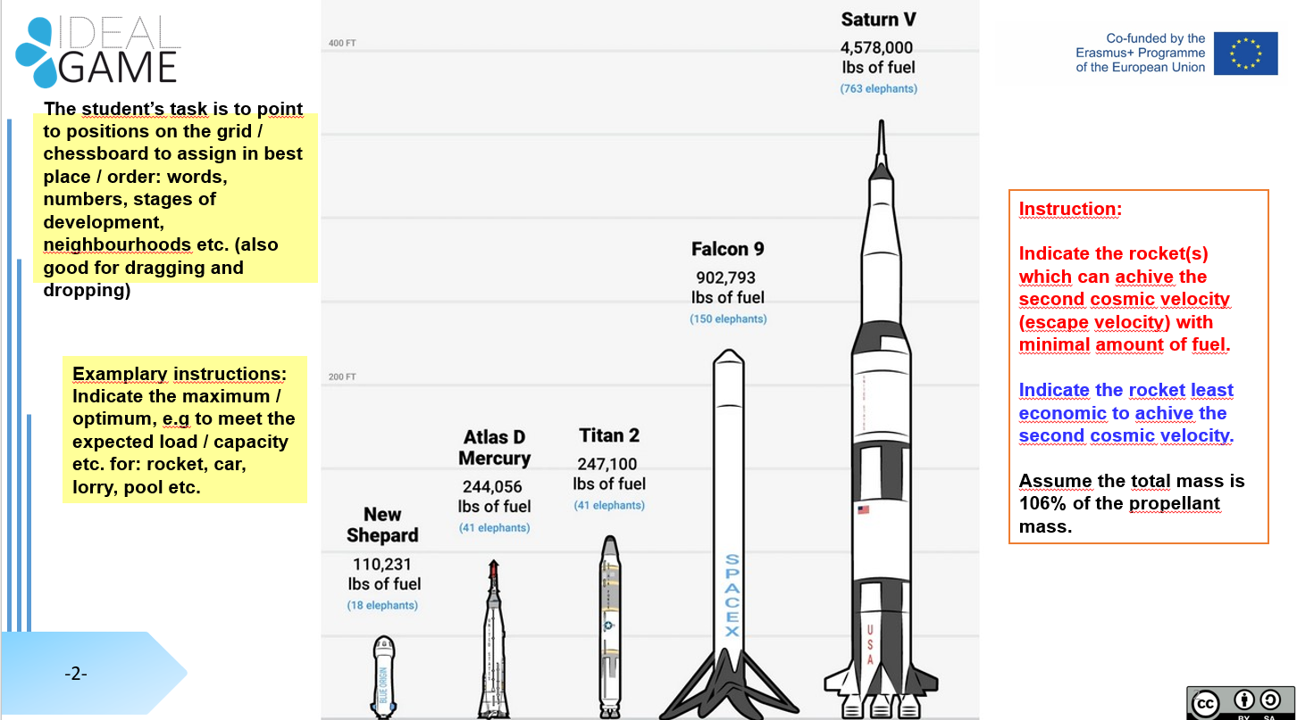
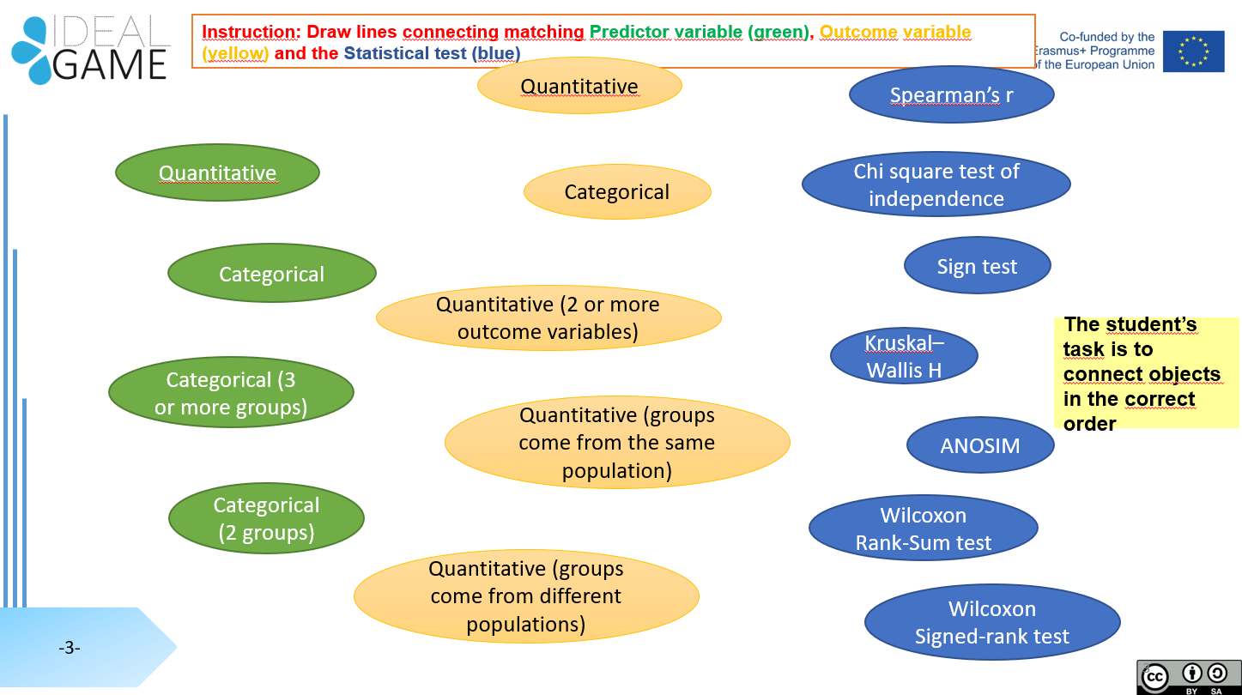

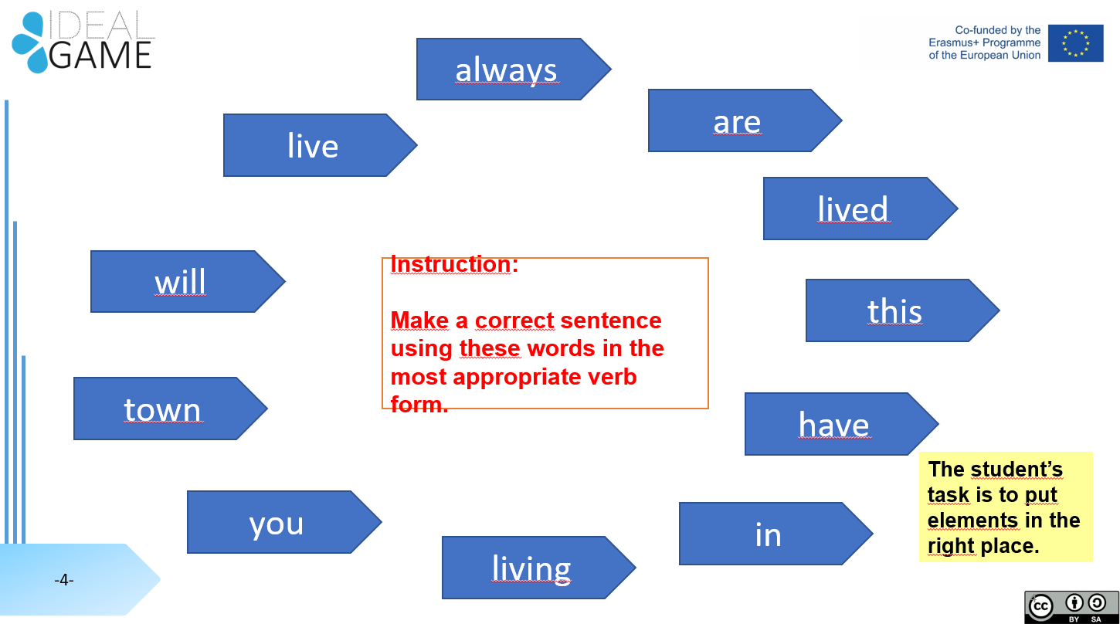

Transitions Game

As part of students’ induction to their courses the purpose of this game is for all new students to familiarise themselves with the geography of the campus, identify key locations on the campus which provide a range of students services to support students’ learning and physical and mental wellbeing (e.g. range of learning tools, support such as medical or finance, library and IT support along with social spaces and activities).

This game can be tailored to specific academic disciplines especially if there are designated rooms e.g. studios, labs, IT suites etc.

The aim would be to build in a series of questions with built in feedback responses to support student engagement. A variation of this game could be designed to support remote learners and help make them aware of the range of support they can access whilst studying.

This game could also be part of a marketing strategy to help prospective students learn about how they will be supported as they enter their studies.

A development of this game could be about supporting students’ welfare and mental wellbeing. A recent report from the Mental Health Foundation Scotland reported that nearly 75% of university students from all 19 Scottish universities reported low wellbeing. See: https://www.mentalhealth.org.uk/sites/default/files/MHF_Thriving_Learners_Report%20%281%29.pdf

