Madrid Open University
Learning Scenarios and Games
Lesson Plan 1

Social Media or Social Bookmarking - UDIMA1

Type: Raining words.
Subject: Information and Communication Technologies, Marketing and Advertising.
Theme: Social Media or Social Bookmarking.
Target group: This game would be appropriate for high school or college students, as a unit review.
Game description: Choose which group each term belongs to.

Learning aim: With this game, students will be able to learn to differentiate the platforms that belong to Social Media and those that are Social Bookmarking. For example, they will understand if a platform like “Facebook” is Social Media or Social Bookmarking.
It is intended to achieve especially the activation of the students and the clarity to differentiate similar concepts.

Didactical implementation:
1. Resources:
The What, Why, & How of Social Bookmarking: https://acortar.link/pjtyhk
Social Media: Definition, Effects, and List of Top Apps: https://acortar.link/9xiRFE

2. Development of the learning activity
- Presentation of the IDEAL-GAME: https://idealgame.eduproject.eu/play?game=5
- Play the game and discussion of the results
- Invite students to play the game as many times as they need to review the concepts presented.

3. Assessment
As long as it is a mini serious game to repeat the topic, the student is allowed to carry out a self-assessment.

Madrid Open University
Learning Scenarios and Games
Lesson Plan 2

Computer software terms - UDIMA2

Type: raining words.
Subject: Information and Communication Technologies, basic computing, and any software subject.
Theme: Software and Computer Technology.
Target group: It may be appropriate for high school or college students.
Game description: To which program does each term best correspond?

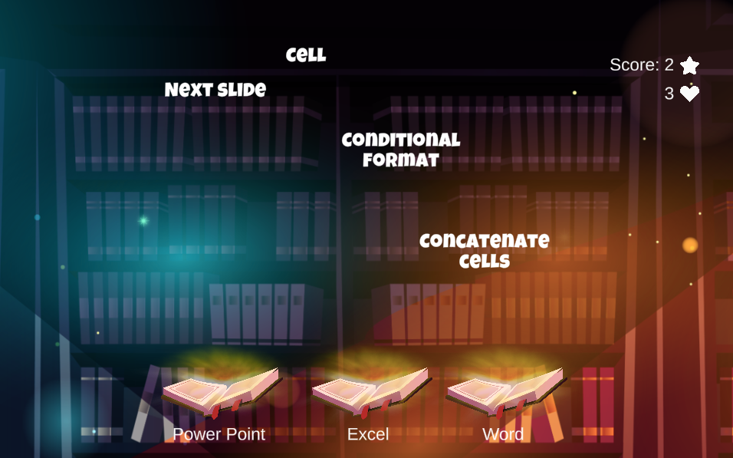

Learning aim: With this game, students should be clear about what the different Microsoft office packages are for: Excel, PowerPoint, and Word.
They will be raining terms that must match one of the three programs, in each case the one that best suits. For example, if the terms are relative to cells or functions, we will know that it refers to Excel.
In this case, the player will have 3 lives, so they can fail at most 3 times before ending the game early.
With the game it is intended to achieve especially the activation of the students, the clarity to differentiate concepts and structure the contents well according to the program to which it refers.

Didactical implementation:
1. Resources:
Learn Microsoft Office 2019: A comprehensive guide to getting started with Word, Power Point, Excel, Access, and Outlook. https://acortar.link/RvXVc3
2. Development of the learning activity
- Presentation of the IDEAL-GAME: https://idealgame.eduproject.eu/play?game=84
- Play the game and discussion of the results.
- Invite students to play the game as an introduction to these software programs or as a refresher.

3. Assessment
As long as it is a mini serious game to repeat the topic, the student is allowed to carry out a self-assessment.

Madrid Open University
Learning Scenarios and Games
Lesson Plan 3

Computer software terms - UDIMA3

Type: Swift.
Subject: English.
Theme: English learners, levels A2 and B1.
Target group: It may be appropriate for primary school, college, or university, depending on the level of English being taught. It could be used as a unit review and to prepare for an exam.
Game description: Hunt only irregular verbs in English.

Learning aim: On this occasion, the objective of the game is to differentiate the irregular verbs from the regular ones, "hunting" only the irregular verbs that appear.
It is a game to practice learning English, specifically a basic aspect such as differentiating irregular verbs, those in which the past simple and the participle are not built by adding "-ed" at the end.
The game is intended to achieve above all the activation of the students and the clarity to differentiate concepts.
Didactical implementation:
1. Resources:
Learn English - British Council: https://learnenglish.britishcouncil.org/grammar/english-grammar-reference/irregular-verbs
English page: https://www.englishpage.com/irregularverbs/irregularverbs.html

2. Development of the learning activity
- Presentation of the IDEAL-GAME: https://idealgame.eduproject.eu/play?game=22
- Play the game and review the most conflicting verbs.
- Invite students to play the game as many times as they need to review the concepts presented.

3. Assessment
As long as it is a mini serious game to repeat the topic, the student is allowed to carry out a self-assessment. It can be used to review before the exam.

Madrid Open University
Learning Scenarios and Games
Lesson Plan 4

Computer software terms - UDIMA4

Type: Swift
Subject: Calculus or basic mathematics, or any subject that aims to improve mathematical speed, concentration, and basic calculations.
Theme: Calculus, Mathematics, and Concentration.
Target group: It can be appropriate for primary, secondary, or university students.
Game description: Capture only the correct equations for 2 minutes.
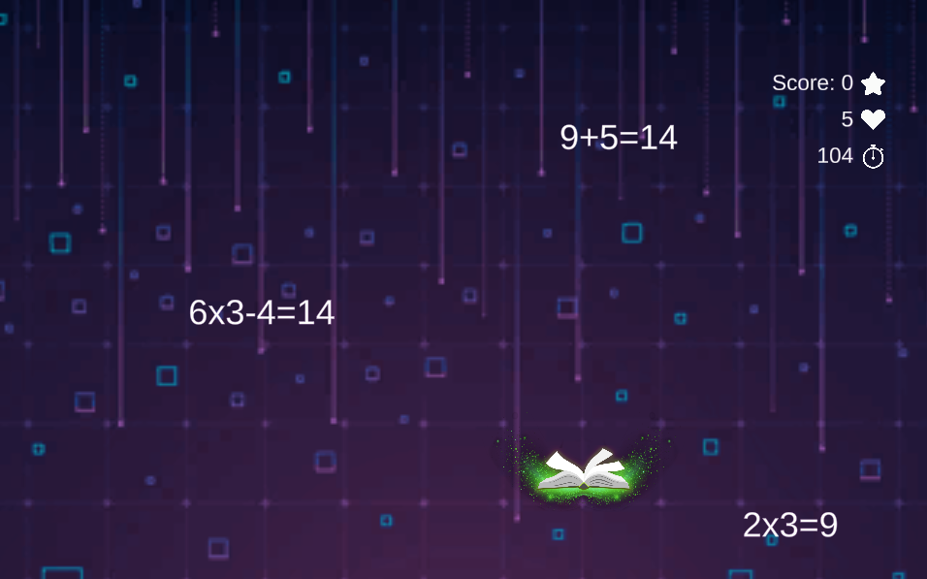

Learning aim: In this game, the player must be very attentive for 2 minutes to do simple mathematical operations (most of them) and capture the correct ones. The wrong ones have to be let go.
The player has 5 lives, therefore, if he fails the calculations 5 times, he will be eliminated. At the end of the time or being eliminated, the player will know the score achieved to be able to beat it in future attempts.
The objective of the game is above all to achieve the activation of the students, elements of reflection regarding concentration for several minutes, and assessment.

Didactical implementation:
1. Resources:
Teaching Primary Mathematics: https://acortar.link/XQr0Tf

2. Development of the learning activity
- Presentation of the IDEAL-GAME: https://idealgame.eduproject.eu/play?game=86
- Play the game and discuss the results of concentration and difficulty.
- Invite students to play the game as many times as needed to get better at quickly calculating basic maths operations and strengthen their concentration.

3. Assessment
As an additional activity to train the basic calculation speed and concentration of the student.
It can be used as class dynamics, to evaluate the level of mathematical calculation in real time in a class. At the end, students can share their grades to get a global idea.

Madrid Open University
Learning Scenarios and Games
Lesson Plan 5

Technology quiz - UDIMA5

Type: Quiz game.
Subject: Information and Communication Technologies, basic computing, any software subject or technology in general.
Theme: Technology.
Target group: It may be appropriate for high school or college students.
Game description: Answer the following questions.

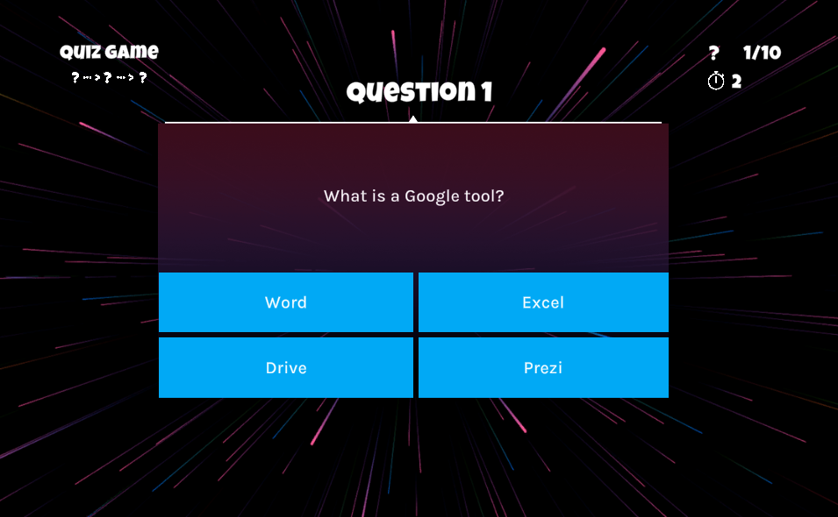

Learning aim: This game is a traditional quiz, where questions are asked and 4 possible answer options are given, of which only one is correct.
There are 10 questions in total, on topics related to new technologies, software, and office tools.
The aim of the game is above all to activate the students and structure the content well according to what is being asked, assessment, and different feedback possibilities.

Didactical implementation:
1. Resources:
Integrating Technology in the Classroom: Tools to Meet the Need of Every Student: https://acortar.link/jbi0EL
Information and Communication Technology: computerized information and electronic technology: https://acortar.link/SlzvxM

2. Development of the learning activity
- Presentation of the IDEAL-GAME: https://idealgame.eduproject.eu/play?game=24
- Play the game and share the results of the test with the rest of the class.
- Once done, the student will know the answers. He can do it again to strengthen his knowledge or as a review.

3. Assessment
As an introduction to these technologies or as a general review. It can be used as class dynamics, to evaluate the level of general knowledge of the students.
It can be used by the teacher at the beginning of the course to assess the general level of the students or as an icebreaker in an initial class.

Madrid Open University
Learning Scenarios and Games
Lesson Plan 6

Technology quiz. Final set - UDIMA6

Type: Conversation game.
Subject: Information and Communication Technologies, basic computing, any software subject or technology in general.
Theme: Technology.
Target group: This would be appropriate for high school or college students, as a unit review.
Game description: Answer the questions correctly until you reach the end. Pay attention because a failure will make you start over.

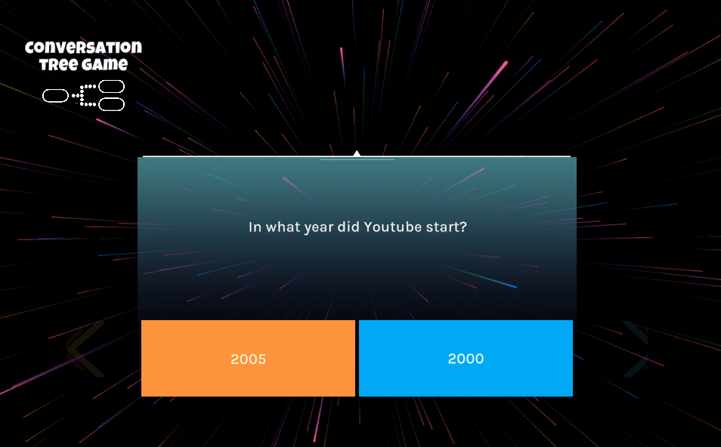

Learning aim: This game emulates a quiz, where a question is asked and there are two possible answers. If you get it right, you go on to the next question, but if you fail, the game ends.
The goal is for the player to get all the questions right and pass all 7 levels, but if he gets any wrong, he would have to start over.
Therefore, there are 7 questions in total, on topics related to new technologies, software, general knowledge about new technologies, and the Internet.
At the end of the last question, the player will get the score they have achieved and personalized feedback, depending on how they have done.
The aim of the game is above all to activate the students and structure the content well according to what is being asked, assessment, and different feedback possibilities.

Didactical implementation:
1. Resources:
Foundations of Web Technology: https://acortar.link/Pah5qH

2. Development of the learning activity
- Presentation of the IDEAL-GAME: https://idealgame.eduproject.eu/play?game=85
- Play the game and share the results of the test with the rest of the class.
- Multiple attempts can be made until all questions are answered correctly. You can do it again to reinforce knowledge or as a review.

3. Assessment
As an introduction to a class on technology or as a fun activity related to technology. It can be used as a class dynamic, to assess the level of general knowledge of the students.
It can be used by the teacher at the beginning of the course to assess the general level of the students or as an icebreaker in an initial class.

Madrid Open University
Learning Scenarios and Games
Lesson Plan 7

Social networks - UDIMA7

Type: Memory.
Subject: Information and Communication Technologies, Marketing and Advertising.
Theme: Social networks.
Target group: This game would be appropriate for elementary or high school students.
Game description: Search and memorize the pairs of social networks.

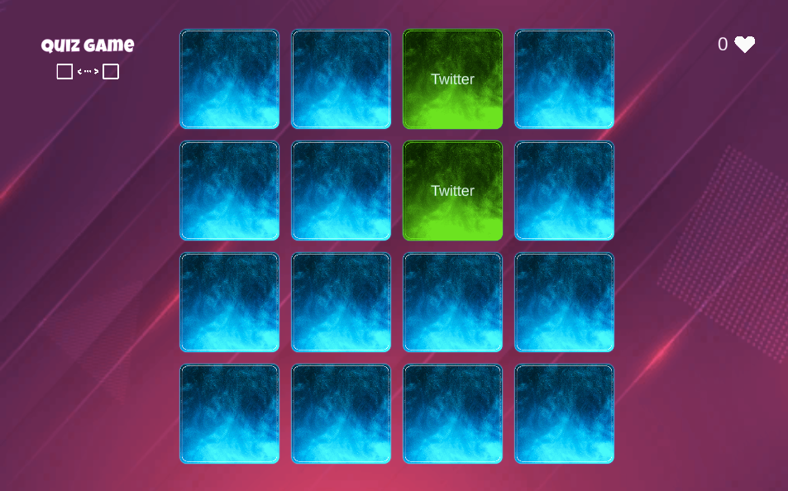

Learning aim: This game aims to discover cards with different social networks and make pairs, memorizing the place they occupied when discovered.
The objective of the game is to clarify and get elements of reflection and memory on the already uncovered networks.

Didactical implementation:
1. Resources:
- Beginner Guide of Social Media Marketing: Use Facebook, Twitter, Pinterest, Instagram, Linkedin and Google Plus for Business Growth. - Matthew Roy
- Social Media Marketing - Ultimate User Guide to Facebook, Instagram, YouTube, Blogging, Twitter, LinkedIn, TikTok, Pinterest. - Adidas Wilson

2. Development of the learning activity
- Presentation of the IDEAL-GAME: https://idealgame.eduproject.eu/play?game=4
- Play the game and discussion of the results. Reflection of the result of each one.
- Invite students to play the game as many times as they need to review the concepts presented.

3. Assessment
As long as it is a mini serious game to repeat the topic, the student is allowed to carry out a self-assessment.
It could be used as an introduction to technologies or as an extra activity to sharpen memory.

Madrid Open University
Learning Scenarios and Games
Lesson Plan 8

Speedy Noah's Ark - UDIMA8

Type: Crane.
Subject: Natural sciences.
Theme: Zoology.
Target group: This game may be appropriate for high school or college students.
Game description: Rank these animals from fastest to slowest. Hurry up, you only have 1 minute!

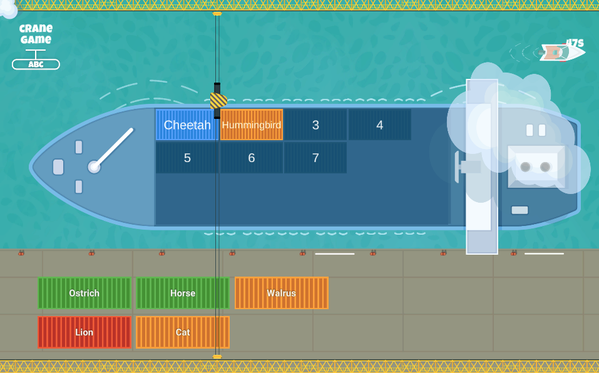

Learning aim: This game aims to place the animals in order, depending on their speed. If any animal is ordered in an incorrect position, it must be ordered again, before the end of the 1-minute time.
The objective of the game is above all to activate the students, structure the content well according to what is asked, and reflect on the options to get the correct order on time.

Didactical implementation:
1. Resources:
Vertebrates: Comparative Anatomy, Function, Evolution: https://acortar.link/8UTBQQ

2. Development of the learning activity
- Presentation of the IDEAL-GAME: https://idealgame.eduproject.eu/play?game=89
- Play the game and discussion of the results.
- Invite students to play the game as many times as they need to review the concepts presented.

3. Assessment
As long as it is a mini serious game to repeat the topic, the student is allowed to carry out a self-assessment.
It could be used as an introduction to natural science, or as an extra activity.
It can be used as a starting point to reflect on and order other animals in class.

Madrid Open University
Learning Scenarios and Games
Lesson Plan 9

Social networks chronology - UDIMA9

Type: Build a bridge.
Subject: Information and Communication Technologies, Marketing, Advertising, and Community Management.
Theme: Social Networks.
Target group: It may be appropriate for high school or college students.
Game description: Sort these social networks by launch date, from oldest to newest.

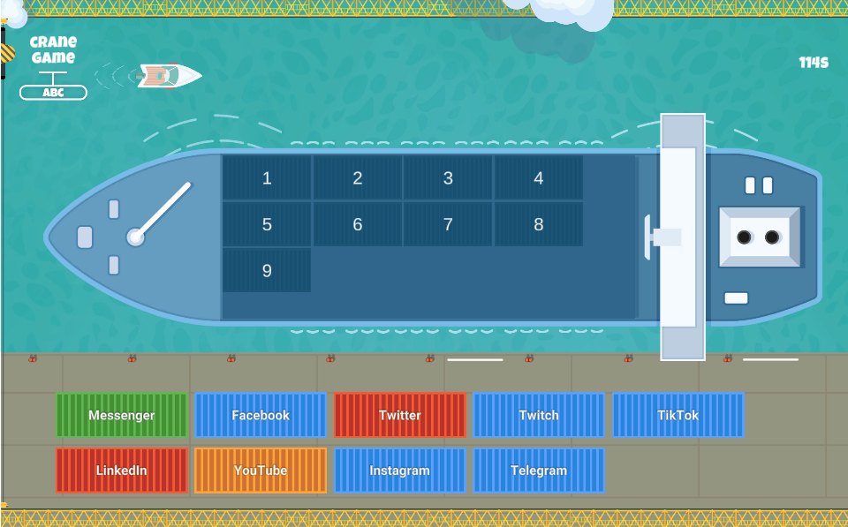

Learning aim: Students have 2 minutes. The nets in their correct position will stay and the rest will have to be put back. In this game, the player must order the applications and social networks that are proposed, according to the release date. In this way the bridge will resist, if any piece is poorly arranged, the bridge will fall and the player will have lost.
The student must think and choose if an application like Linkedin is before or after another like YouTube.
To assign the order and check if it is correct, the player will have a maximum of 2 minutes, before checking if the chosen order is correct.
The objective of the game is above all to activate the students, structure the content well according to what is asked, and reflect on the options to get the correct order on time or successive attempts.

Didactical implementation:
1. Resources:
Social Media Marketing 2020 Mastery. How to Create a Brand. Become a Skilled Influencer on Twitter, Facebook, Youtube, and Instagram: Personal Branding & Digital Networking Strategies. - Brandon J. Artley

2. Development of the learning activity
- Presentation of the IDEAL-GAME: https://idealgame.eduproject.eu/play?game=43
- Play the game and discussion of the results.
- Discuss in class how networks have evolved and what changes they have had from the first to the last to be launched.
- Invite students to play the game as many times as they need to review the concepts presented.

3. Assessment
As long as it is a mini serious game to repeat the topic, the student is allowed to carry out a self-assessment.
It could be used as an introduction to the technology, or as an extra activity.

Madrid Open University
Learning Scenarios and Games
Lesson Plan 10

Human evolution bridge - UDIMA10

Type: Build a bridge.
Subject: Natural sciences, ancient history, or similar.
Theme: Human evolution.
Target group: It may be appropriate for elementary or high school students.
Game description: Order the homos of the hominization process, from oldest to most recent.
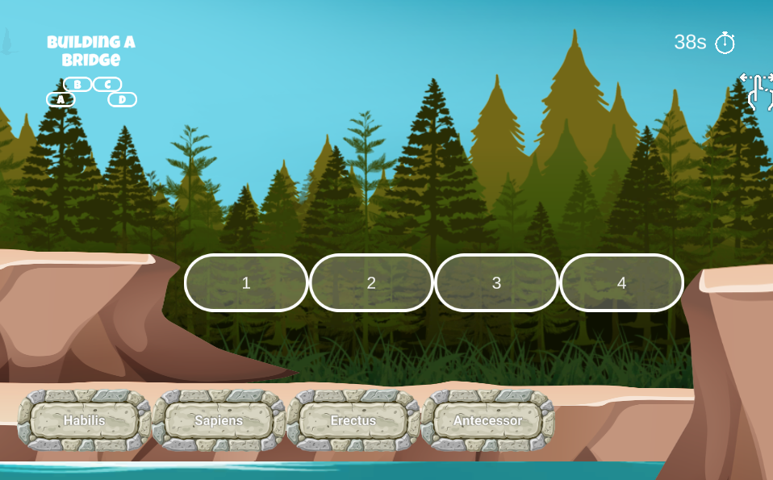
Learning aim: In this game, the player must order some phases of human evolution, choosing which was before and which was after. In this way the bridge will resist, if any piece is poorly arranged, the bridge will fall and the player will have lost.
To assign the order and check if it is correct, the player will have a maximum of 1 minute, before checking if the chosen order is correct.
The objective of the game is above all to activate the students, to clarify the different phases of human evolution, to structure these phases well to know which was before and which was after and to reflect on the options to get the correct order on time or successive attempts.

Didactical implementation:
1. Resources:
Human Evolution: A Very Short Introduction: https://acortar.link/LTOMlR
A Story of Us: A New Look at Human Evolution: https://acortar.link/Br2S2U

2. Development of the learning activity
- Presentation of the IDEAL-GAME: https://idealgame.eduproject.eu/play?game=87
- Play the game and discussion of the results.
- Expand the list with other evolutionary phases, following the dynamics proposed in the game.
- Invite students to play the game as many times as they need to review the concepts presented.

3. Assessment
As long as it is a mini serious game to repeat the topic, the student is allowed to carry out a self-assessment.
It could be used as an introduction to natural science, or as an extra activity to open the topic in class.

