IDEAL-GAME
Improving didactics, education and learning
in higher education with the Online Serious Game Creator

IO2: Final Development of the IDEAL-GAME Creator
University Paderborn

Project Title: Improving didactics, education and learning
in higher education with the Online Serious Game Creator
Acronym: IDEAL-GAME
Reference number: 2020-1-DE01-KA203-005682
Project partners: P1 University Paderborn (UPB), DE
P2 Ingenious Knowledge GmbH (IK), DE
P3 Universitatea din Pitesti (UPIT), RO
P4 Wyzsza Szkola Ekonomii i Innowacji w Lublinie (WSEI), PL
P5 University of Dundee (UoD), UK
P6 Universidad a Distancia de Madrid SA (UDIMA), ES

Final Development of the IDEAL-GAME mini serious game Creator

The current version of the IDEAL-GAME Creator can be found here: https://idealgame.eduproject.eu/

In the following, a few screenshots and explanations are presented, which are made available to the partners for trying out and further work. It represents a first step towards our final IDEAL-GAME Creator.

The website looks like this:

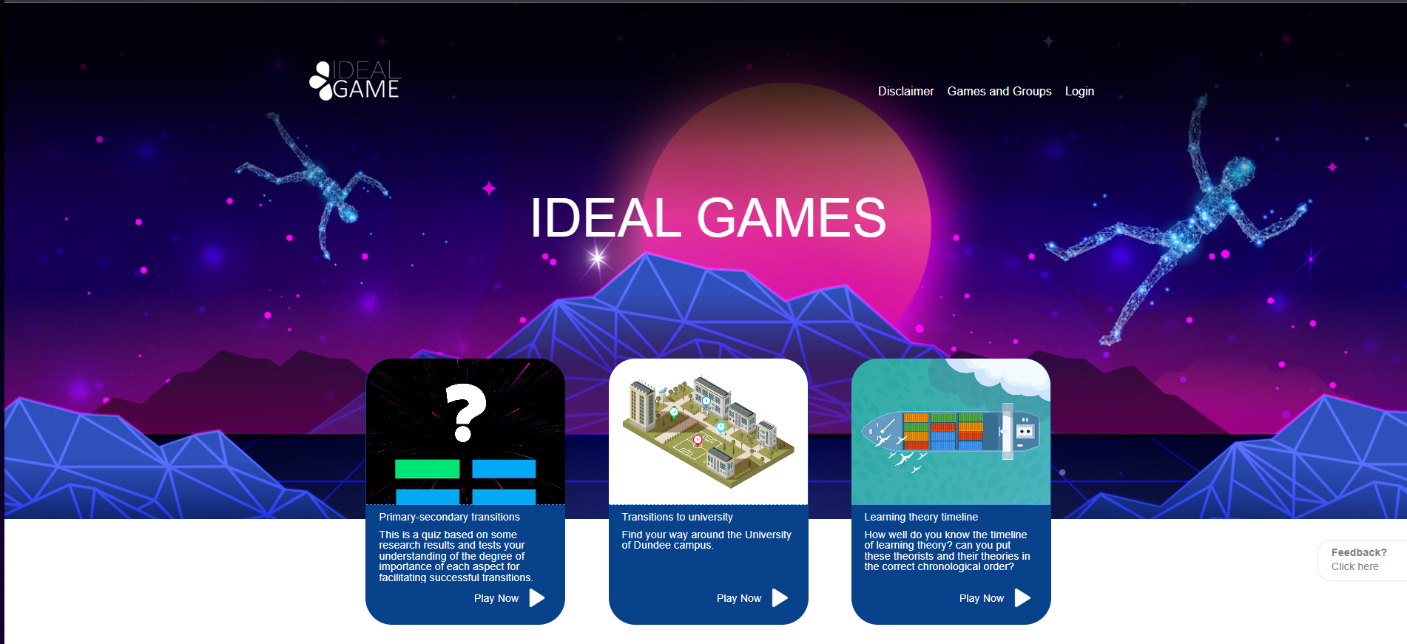
The website was deliberately designed in such a way that you have the following three categories to choose from.

- Disclaimer
- Games and Groups
- Login
Next to the categories, it is possible to see one's own games or the games that have been shared with one on the start page. We have also included a "Feedback" button, which gives the IT partner feedback if improvements, changes or updates are desired.
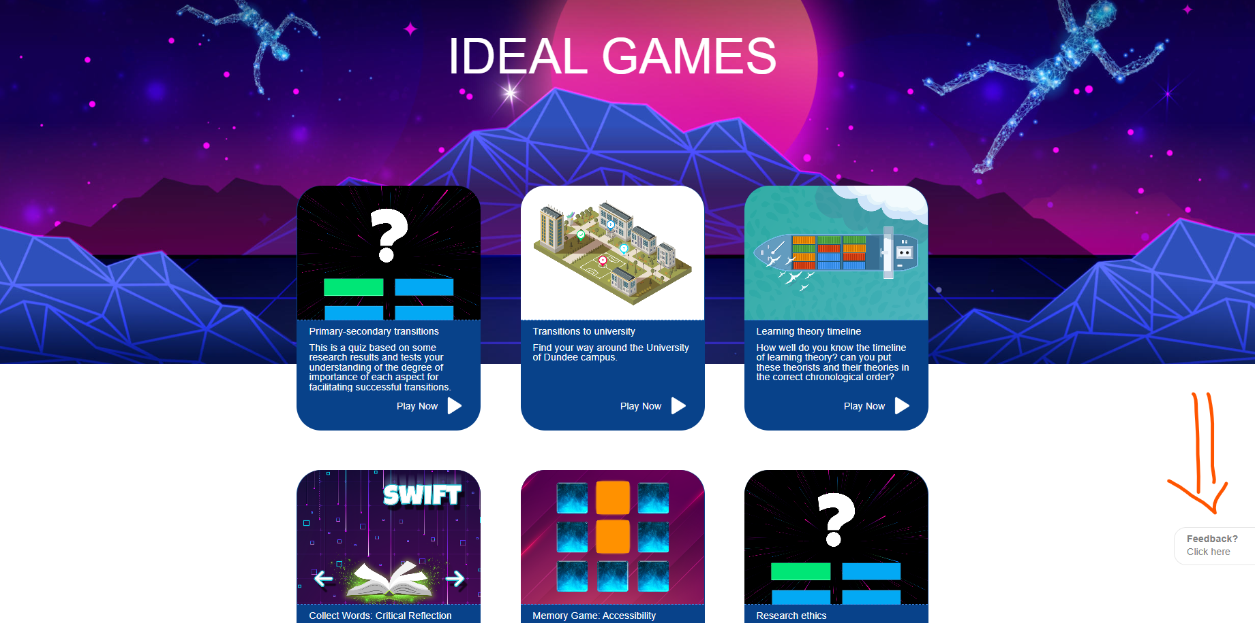

Here you can see a screenshot of the disclaimer of the IDEAL-GAME mini serious game creator. Moreover you can access to the Disclaimer by using this link: https://idealgame.eduproject.eu/disclaimer

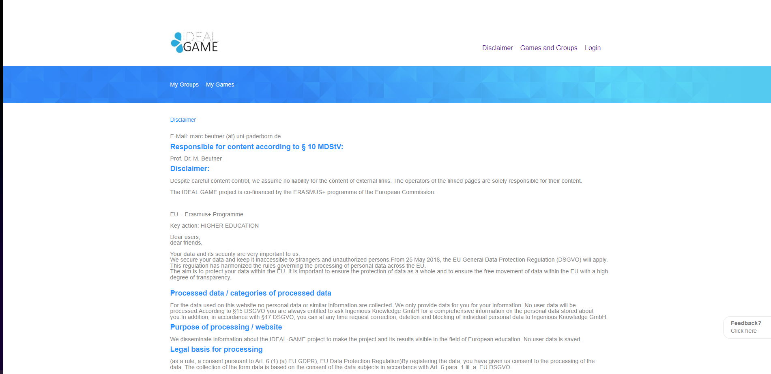

The following pictures shows the secrion Games and Gropus:
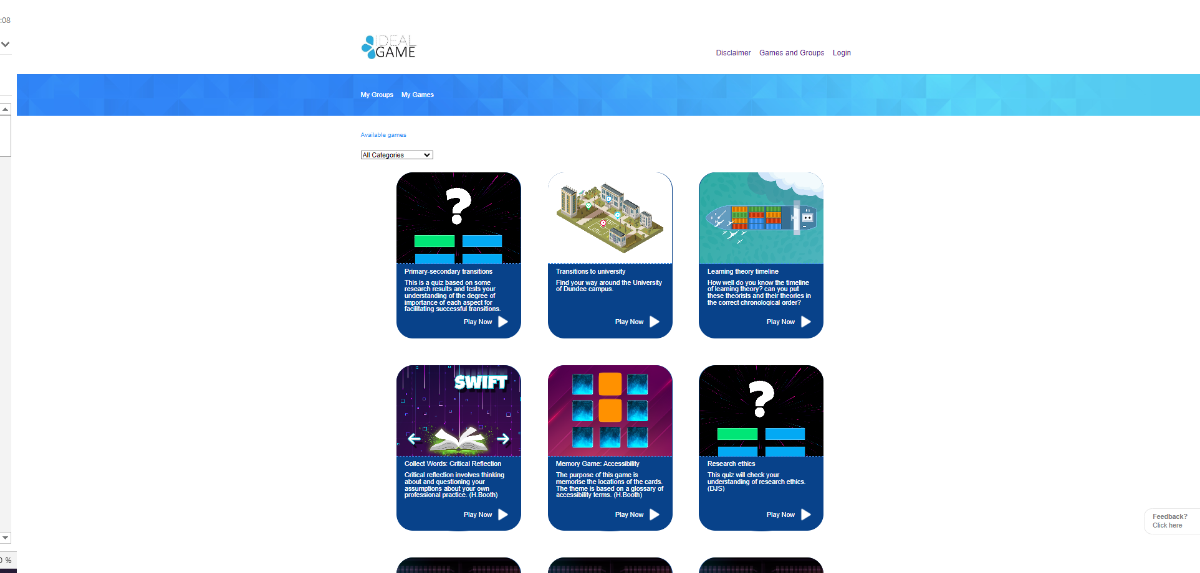

This way it is possible to create different groups and invite other partners to the groups. Only an e-mail address is needed for networking.

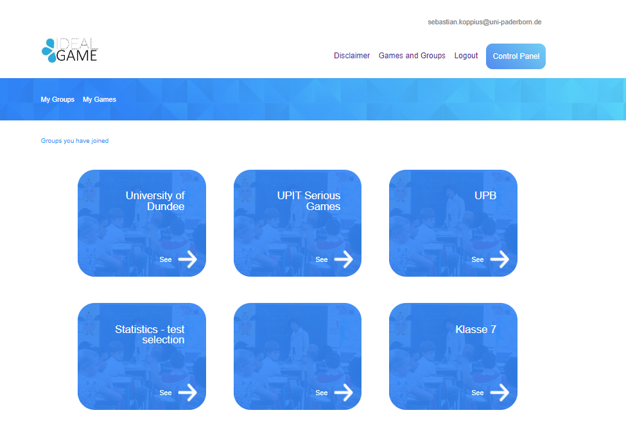

The Login is possible in the third section.
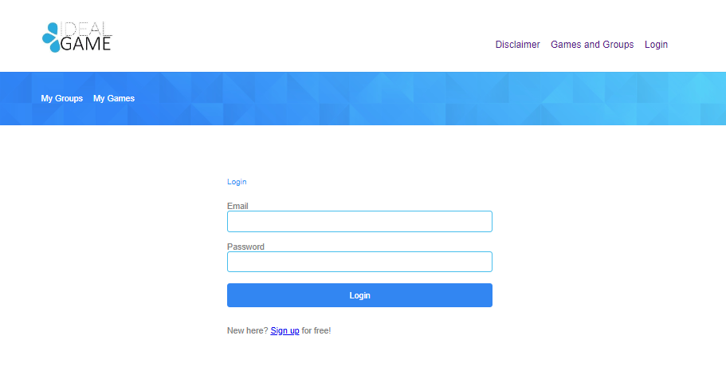
Please visit the website for more details. A more detailed presentation of the games is at IO3

