IDEAL-GAME
Improving didactics, education and learning in higher education with Online Serious Game Creator

IO2 – Results of the Usability Study

Project Title: Improving didactics, education and learning
in higher education with the Online Serious Game Creator
Acronym: IDEAL-GAME
Reference number: 2020-1-DE01-KA203-005682

Project partners: P1 University Paderborn (UPB), DE
P2 Ingenious Knowledge GmbH (IK), DE
P3 Universitatea din Pitesti (UPIT), RO
P4 Wyzsza Szkola Ekonomii i Innowacji w Lublinie (WSEI), PL
P5 University of Dundee (UoD), UK
P6 Universidad a Distancia de Madrid SA (UDIMA), ES

Table of content

List of Figures 3
Introduction 4
General Information of the usability study 5
Perceived Ease of Use 7
Attitude towards Using 11
Perceived Usefulness 14
Intention to use 17

List of Figures

Figure 1: My interaction with the IDEAL-GAME mini serious game creator is clear and understandable 7
Figure 2: The interaction with the IDEAL-GAME mini serious game creator does not require a lot of my mental effort. 8
Figure 3: I found the IDEAL-GAME mini serious game creator easy to use. 8
Figure 4: I find it easy to get the DIAEL-GAME mini serious game creator to do what I want it to do. 9
Figure 5: Learning to use the IDEAL-GAME mini serious game creator would not be easy for me. 10
Figure 6: It would not be easy for me to teach or learn with use of the IDEAL-GAME mini serious game creator. 10
Figure 7: I dislike the idea of using the IDEAL-GAME mini serious game creator. 11
Figure 8: I have a generally favourable attitude towards using the IDEAL-GAME mini serious game creator 11
Figure 9: I believe it is / would be a good idea to use the IDEAL-GAME mini serious game creator for quality reasons. 12
Figure 10: Using the IDEAL-GAME mini serious game creator is a foolish idea. 13
Figure 11: The use of the IDEAL-GAME mini serious game creator is helpful. 13
Figure 12: The use of the IDEAL-GAME mini serious game creator is interesting. 13
Figure 13: Using the IDEAL-GAME mini serious game creator improves my performance in my teaching or learning with Serious Games 14
Figure 14: Using the IDEAL-GAME mini serious game creator in my job increases my productivity especially concerning the use of blended learning. 14
Figure 15: Using the IDEAL-GAME mini serious game creator in my job increases my productivity especially concerning the use of flipped learning 15
Figure 16: Using the IDEAL-GAME mini serious game creator enhances my effectiveness especially concerning Serious Games. 15
Figure 17: To have the IDEAL-GAME mini serious game creator for leaning / teaching purposes is not useful. 16
Figure 18: The IDEAL-GAME mini serious game creator can’t improve my use of digital media. 16
Figure 19: Assuming I have access to the IDEAL-GAME mini serious game creator, I would not intend to use it. 17
Figure 20: Given that I have access to the IDEAL-GAME mini serious game creator, I predict that I would use it. 17
Figure 21: I don’t intend to use the IDAEL-GAME mini seirous game creator in future. 18
Figure 22: I will have another look at the IDEAL-GAME mini serious game creator. 18
Figure 23: I would visit the IDEAL-GAME mini serious game creator due to learning or teaching reasons. 19
Figure 24: I plan to use the IDEAL-GAME mini seirous Game creator. 19

Introduction

The following report presents the results of a usability survey conducted as part of the IDEAL-GAME project (IDEAL-GAME – Improving didactics, education and learning in higher education with Online Serious Game Creator – Project number: 2020-1-DE01-KA203-005682).
The object of evaluation was the IDEAL-GAME Creator. A tool for the development of mini serious games in the context of university teaching. Six project partners from five different European countries were involved. Among them were: University of Paderborn (Germany), Ingenious Knowledge (Germany), University of Pitesti (Romania), University of Dundee (UK), Distance Learning University of Madrid (Spain) and the University of Economics and Innovation in Lublin (Poland).
You can access the IDEAL-GAME Creator via the following link: https://idealgame.eduproject.eu/
At the current stage of the survey, 8 different types of mini serious games can be used. The games are:
- Raining words
- Collect words
- Memory
- Build a Bridge
- Conversation Game
- Quiz Game
- Crane
- Explore Campus

These are mainly assignment and application mini serious games. The example games that can already be found were created by the partner universities and represent illustrations of the teaching content of the respective faculties. Thus, areas from business education, physics, transition from school to work, mathematics puzzles or theoretical knowledge from statistics can be found in mini serious games.
The evaluation was carried out with the Technology Acceptance Model 2 from Davis, Bagozzi and Warshaw (1989) and refers to a criteria-based comparability.
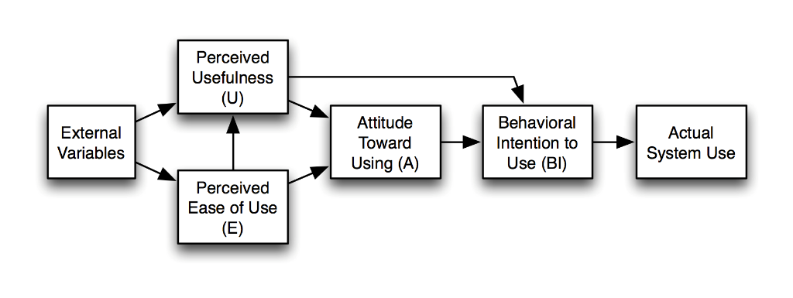
(Vgl. Davis, F., Bagozzi, P. and Warshaw, P. (1989), ‘User acceptance of computer technology - a comparison of two theoretical models’, Management Science 35(8), 982–1003.)
If you have any comments or questions, please contact us.

General Information of the usability study

232 participants from 5 European countries took part in the survey. In percentage terms, more men took part in the survey (36,96%) than women (34,78%). However, a large proportion did not decide regarding gender.

The age of the survey participants was also asked. Age groups from 18 to 59 years were eligible. This grouping was chosen for the reason that people usually only enter universities and start their studies at the age of 18. For some lecturers, the obligation to work ends at 59 and only a few continue to work in university teaching until 69.
Particularly noteworthy are the groups (25-29 years old) and 30-39 years old, which represent the majority of the survey participants.
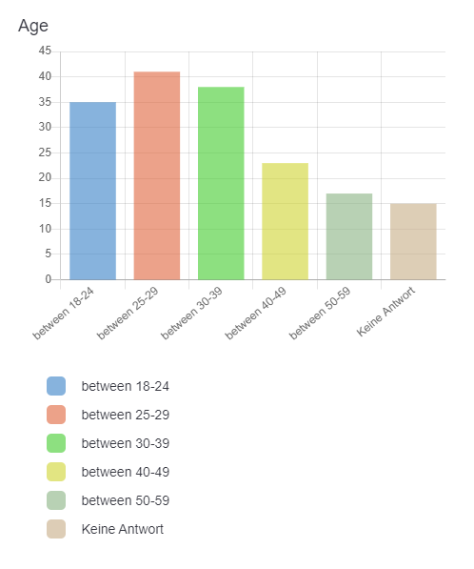

Perceived Ease of Use

Following the Technology Acceptance Model 2 from Davis, Bagaozzi und Warshaw (1989), which is structured by Perceived Ease of Use, Attitute Toward Using, Perceived Usefulness and Intention to Use. We estart with the topic Perceived Ease of Use.
Concerning the question: My interaction with the IDEAL-GAME mini serious game creator is clear and understandable
Most of the respondents to the survey voted "agree" with 74 mentions, likewise 35 voted "I strongly agree", and 28, I “agree a little".
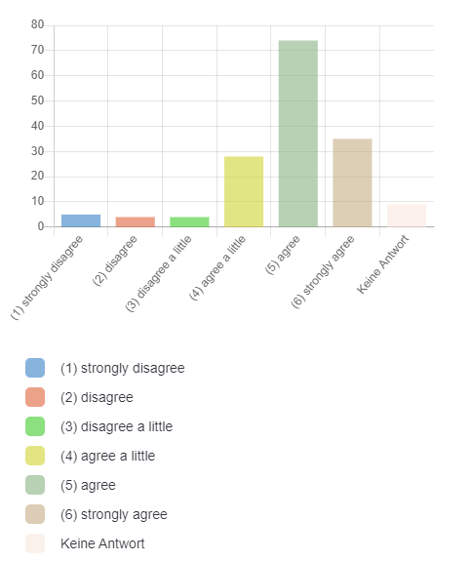
Figure 1: My interaction with the IDEAL-GAME mini serious game creator is clear and understandable

Related to the statement: The interaction with the IDEAL-GAME mini serious game creator does not require a lot of my mental effort. it indicates a very distributed opinion. Thus, all possible answers are frequented differently. Disagree and Agree are almost equally frequent.

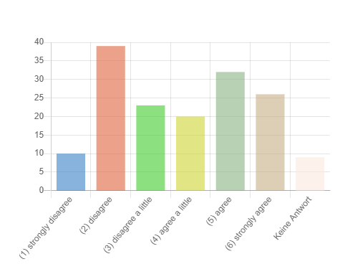
Figure 2: The interaction with the IDEAL-GAME mini serious game creator does not require a lot of my mental effort.

Concerning the statement: I found the IDEAL-GAME mini serious game creator easy to use. Positive agreement clearly predominates with Agree (75) and strongly Agree (41) mentions.
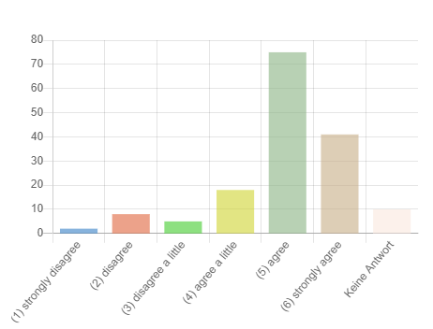
Figure 3: I found the IDEAL-GAME mini serious game creator easy to use.

Also the following statement: “I find it easy to get the DIAEL-GAME mini serious game creator to do what I want it to do.” and the extremely positive feedback indicates that the IDEAL-GAME Creator is built to be catchy.
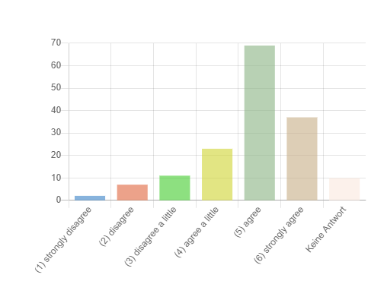
Figure 4: I find it easy to get the DIAEL-GAME mini serious game creator to do what I want it to do.

Also, the results show that engaging with the IDEAL-GAME Creator and especially learning with it is accessible to many (Learning to use the IDEAL-GAME mini serious game creator would not be easy for me.).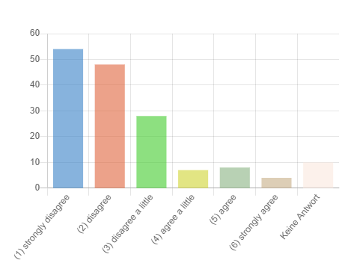
Figure 5: Learning to use the IDEAL-GAME mini serious game creator would not be easy for me.

Concerning the statement: “It would not be easy for me to teach or learn with use of the IDEAL-GAME mini serious game creator.” The participants in the survey also confirmed that they could very well imagine using the IDEAL-GAME Creator in teaching and lessons.
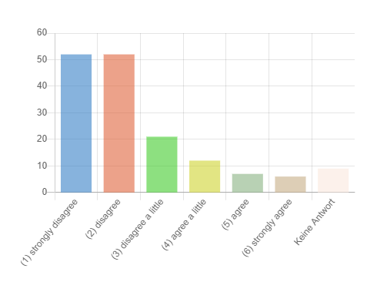
Figure 6: It would not be easy for me to teach or learn with use of the IDEAL-GAME mini serious game creator.

Attitude towards Using

Just as the following figure also indicates in relation to the statement (I dislike the idea of using the IDEAL-GAME mini serious game creator), as well as the statement (I have a generally favorable attitude towards using the IDEAL-GAME mini serious game creator), the IDEAL-GAME Creator is taken positively.
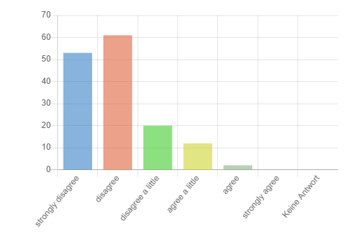
Figure 7: I dislike the idea of using the IDEAL-GAME mini serious game creator.
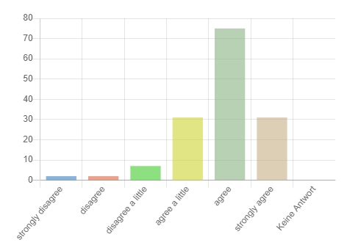
Figure 8: I have a generally favourable attitude towards using the IDEAL-GAME mini serious game creator

We conclude that the IDEAL-GAME Creator is well suited for quality reasons, such as consolidation and repetition of the teaching units.
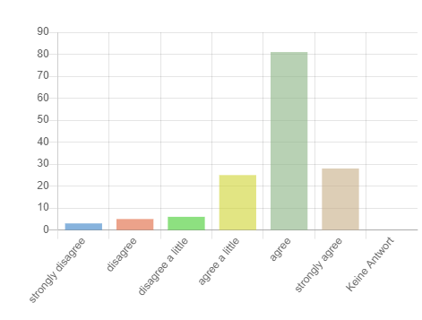
Figure 9: I believe it is / would be a good idea to use the IDEAL-GAME mini serious game creator for quality reasons.

Thus, the following results confirm that the majority of all respondents found the use of the IDEAL-GAME Creator helpful, interesting and not at all foolish.
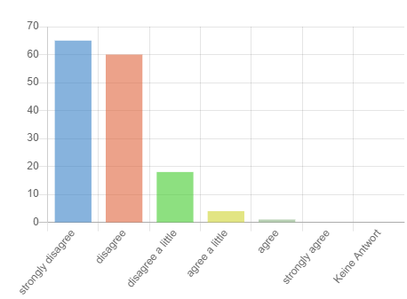
Figure 10: Using the IDEAL-GAME mini serious game creator is a foolish idea.
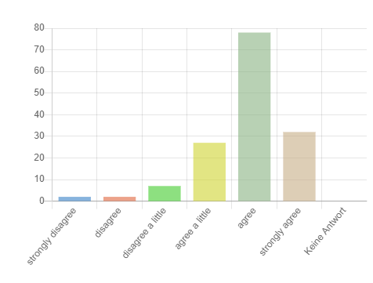
Figure 11: The use of the IDEAL-GAME mini serious game creator is helpful.
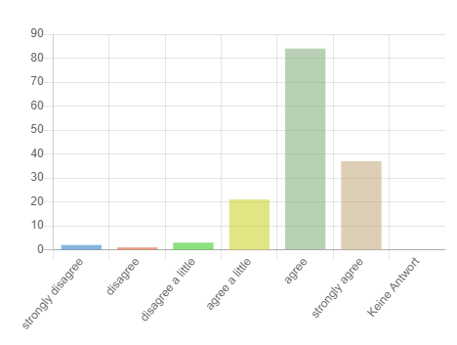
Figure 12: The use of the IDEAL-GAME mini serious game creator is interesting.

Perceived Usefulness
The IDEAL-GAME Creator was consistently rated positively in connection with teaching, for improving teaching, in the blended learning format, but also for use in the flipped classroom.
Here you can see an illustration of: Using the IDEAL-GAME mini serious game creator improves my performance in my teaching or learning with Serious Games
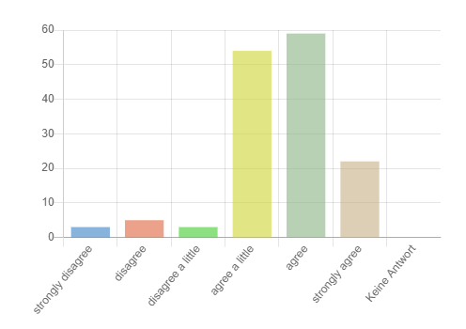
Figure 13: Using the IDEAL-GAME mini serious game creator improves my performance in my teaching or learning with Serious Games

As well as a representation of Using the IDEAL-GAME mini serious game creator in my job increases my productivity especially concerning the use of blended learning.
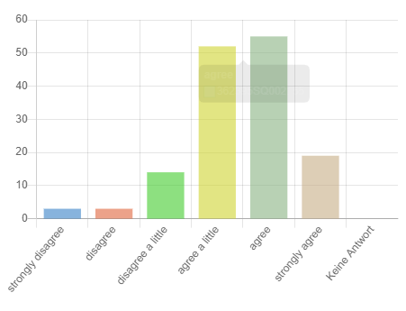
Figure 14: Using the IDEAL-GAME mini serious game creator in my job increases my productivity especially concerning the use of blended learning.

Last but not least an illustration by Using the IDEAL-GAME mini serious game creator in my job increases my productivity especially concerning the use of flipped learning
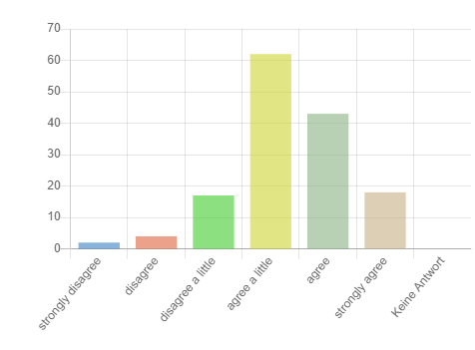
Figure 15: Using the IDEAL-GAME mini serious game creator in my job increases my productivity especially concerning the use of flipped learning
Using the IDEAL-GAME mini serious game creator enhances my effectiveness especially concerning Serious Games.
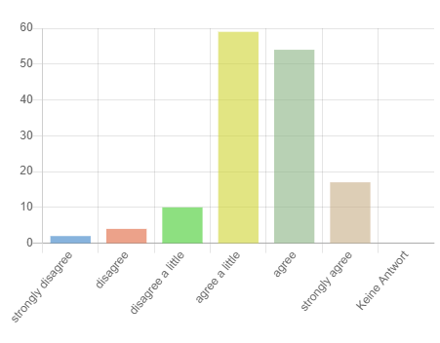
Figure 16: Using the IDEAL-GAME mini serious game creator enhances my effectiveness especially concerning Serious Games.

To the statement “To have the IDEAL-GAME mini serious game creator for leaning / teaching purposes is not useful”. The majority of all respondents answered strongly disagree or disagree.
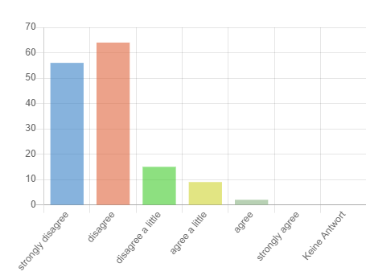
Figure 17: To have the IDEAL-GAME mini serious game creator for leaning / teaching purposes is not useful.
Also, the majority believes that using the IDEAL-GAME mini serious games can promote digital skills and the use of digital media.
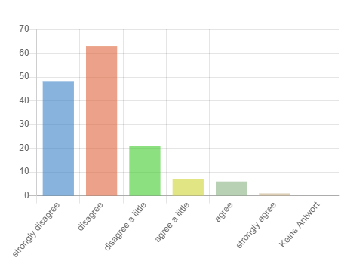
Figure 18: The IDEAL-GAME mini serious game creator can’t improve my use of digital media.

Intention to Use
At this point, it is confirmed again that the majority would use the IDEAL-GAME mini serious Game creator again. Particularly noteworthy is the reason that it is preferred for learning and teaching reasons.
Here is an exact illustration in response to the question: Assuming I have access to the IDEAL-GAME mini serious game creator, I would not intend to use it.
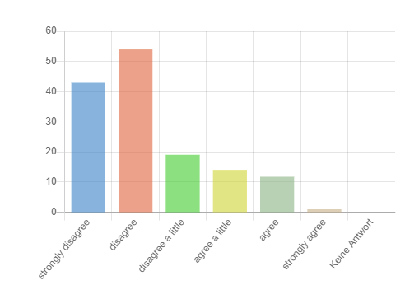
Figure 19: Assuming I have access to the IDEAL-GAME mini serious game creator, I would not intend to use it.
Here is an exact illustration in response to the question: Given that I have access to the IDEAL-GAME mini serious game creator, I predict that I would use it.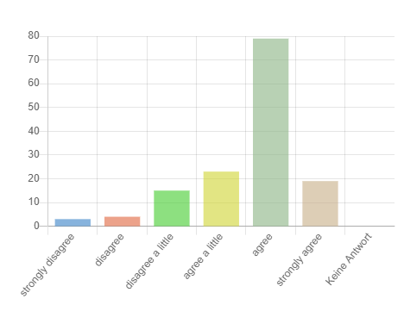
Figure 20: Given that I have access to the IDEAL-GAME mini serious game creator, I predict that I would use it.

Here is an exact illustration in response to the statement: I don’t intend to use the IDAEL-GAME mini seirous game creator in future.
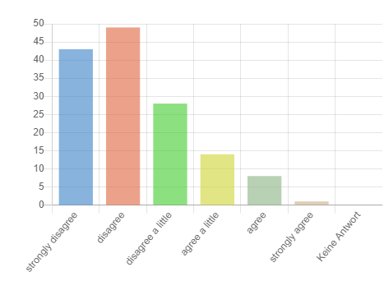
Figure 21: I don’t intend to use the IDAEL-GAME mini seirous game creator in future.

Here is an exact illustration in response to the statement: I will have another look at the IDEAL-GAME mini serious game creator.
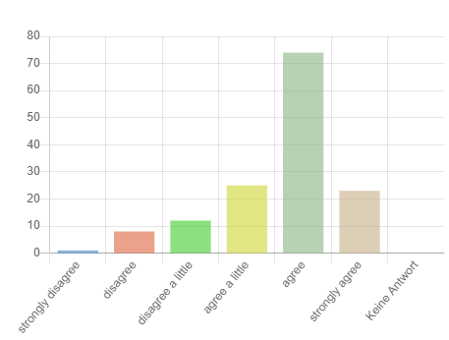
Figure 22: I will have another look at the IDEAL-GAME mini serious game creator.

Here is an exact illustration in response to the statement: I would visit the IDEAL-GAME mini serious game creator due to learning or teaching reasons.
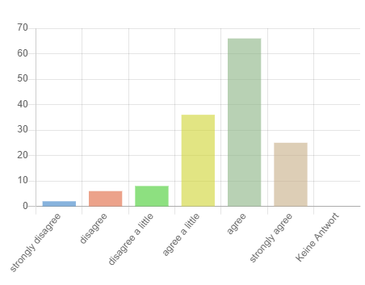
Figure 23: I would visit the IDEAL-GAME mini serious game creator due to learning or teaching reasons.

Here is an exact illustration in response to the statement: I plan to use the IDEAL-GAME mini serious Game creator.
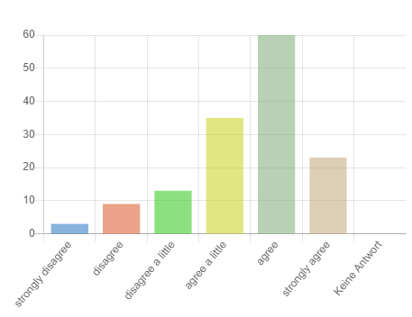
Figure 24: I plan to use the IDEAL-GAME mini seirous Game creator.

