IDEAL-GAME
Improving didactics, education and learning
in higher education with the Online Serious Game Creator

IO2: First insights IDEAL-GAME Creator
University Paderborn

Project Title: Improving didactics, education and learning
in higher education with the Online Serious Game Creator
Acronym: IDEAL-GAME
Reference number: 2020-1-DE01-KA203-005682
Project partners: P1 University Paderborn (UPB), DE
P2 Ingenious Knowledge GmbH (IK), DE
P3 Universitatea din Pitesti (UPIT), RO
P4 Wyzsza Szkola Ekonomii i Innowacji w Lublinie (WSEI), PL
P5 University of Dundee (UoD), UK
P6 Universidad a Distancia de Madrid SA (UDIMA), ES

First insight IDEAL-GAME Creator
Please bear in mind that the following illustrations represent an initial basic framework of the IDEAL-GAME Creator.

The current version of the IDEAL-GAME Creator can be found here: https://idealgame.eduproject.eu/

In the following, a few screenshots and explanations are presented, which are made available to the partners for trying out and further work. It represents a first step towards our final IDEAL-GAME Creator.

Here you can see the Dashboard of the first version of the IDEAL-GAME serious game creator.

One could choose between the following three categories.
- Dashboard
- Games
- Game types

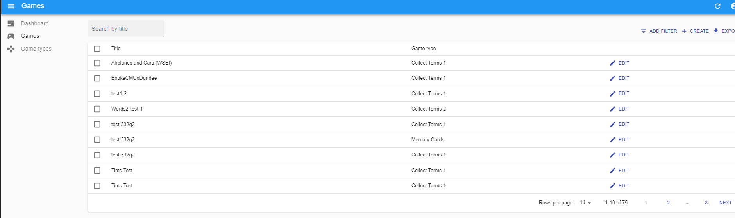
The project partners used this first version of the IDEAL-GAME Creator to test the self-designed mini serious games.

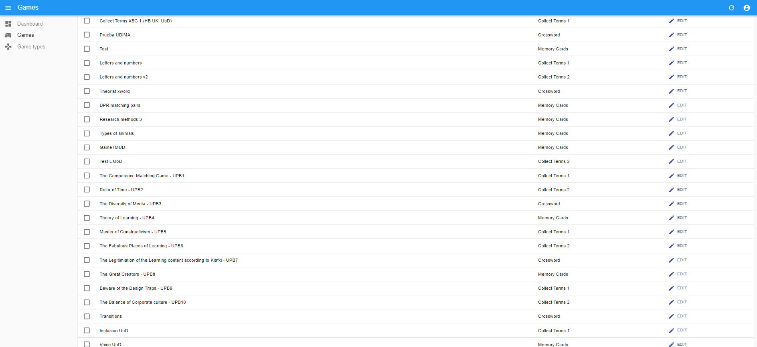

In the beginning there were only the 4 games, in the further course 6 more games were added
The games are called:
- Collect Terms 1
- Collect Terms 2
- Crossword
- Memory
