IDEAL-GAME
Improving didactics, education and learning
in higher education with the Online Serious Game Creator

Online article 3 (DE)
Sebastian Koppius

Project Title: Improving didactics, education and learning
in higher education with the Online Serious Game Creator
Acronym: IDEAL-GAME
Reference number: 2020-1-DE01-KA203-005682
Project partners: P1 University Paderborn (UPB), DE
P2 Ingenious Knowledge GmbH (IK), DE
P3 Universitatea din Pitesti (UPIT), RO
P4 Wyzsza Szkola Ekonomii i Innowacji w Lublinie (WSEI), PL
P5 University of Dundee (UoD), UK
P6 Universidad a Distancia de Madrid SA (UDIMA), ES

The great variety of mini serious games from the Online Serious Game Creator
– IDEAL-GAME –

„Varied, simple, yet complex!“

Eight different types of mini serious games were jointly developed within the Erasmus+ project IDEAL-GAME Improving didactics, education and learning in higher education with the Online Serious Game Creator (2020-1-DE01-KA203-005682). In the last 24 months, the project consortium consisting of 6 partners from 5 different countries designed the IDEAL-GAME Creator (https://idealgame.eduproject.eu/) with a variety of universally applicable mini serious games.

Game presentation of the individual mini serious games
The following games were designed within the framework of the IDEAL-GAME project and tested several times in higher education teaching in the European
- Raining Words
- Collect Words
- Memory
- Build a Bride
- Conversation Game
- Quiz Game
- Explore Campus
- Crane Game

Raining Words
Raining Words is a matching game. Categories and associated words are created. The categories are represented as books. The words fall from the top to the bottom. During the game, the players have to match the falling terms to the category books at the bottom.
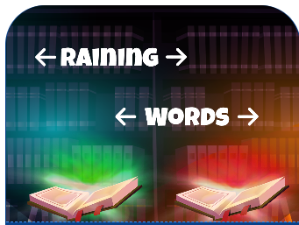

Collect Words
Collect Words is a matching game. Here, a category is created along with associated and unassociated terms. The category is represented as a book that can be moved by the players. The correct and incorrect terms fall from the top to the bottom. The players have to decide which terms belong in the category (the book) and which do not.

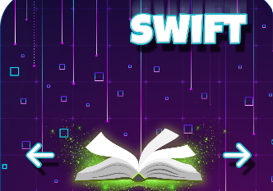

Memory
In the memory game, matching terms have to be found. On a covered sheet of cards consisting of several terms, the players have to turn the cards over one after the other and find the correct pairs of terms. A pair can consist of two to four terms.

Build a Bridge
The Build a Bridge Game is about building a bridge using terms. The aim is to use the terms to represent a process and thus build the bridge. The players have to put the terms in the right order so that a bridge can be built.
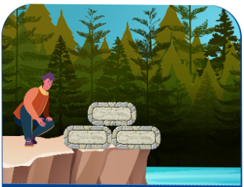

Conversation Game
The Conversation Game is about choosing a correct answer from two possible answers. For this, a statement or a question and two possible answers are created. If the correct answer is chosen, the players get a new question/statement and have to choose between two answers again.

Quiz Game
The quiz game is about choosing a correct answer from four possible answers. A question is created and four possible answers. The players have to choose the correct answer.

Explore Campus
The Exploration Game offers the possibility to make assignments on pictures. A picture and possible places or objects are selected and the players have to name them correctly.

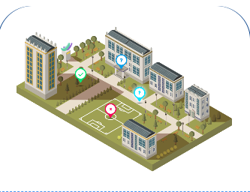
Crane Game
The Crane Game offers the possibility to arrange texts correctly. For this, excerpts from texts are displayed as containers that have to be placed in the correct order on a cargo ship to produce the correct text. The players have to select the text sections in the correct order on the cargo ship. Finally, a text is the result.

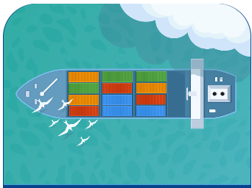

How can you get in touch with IDEAL-GAME?
Visit our website at https://ideal-game.eduproject.eu/ or contact the project partner in your home country directly!

