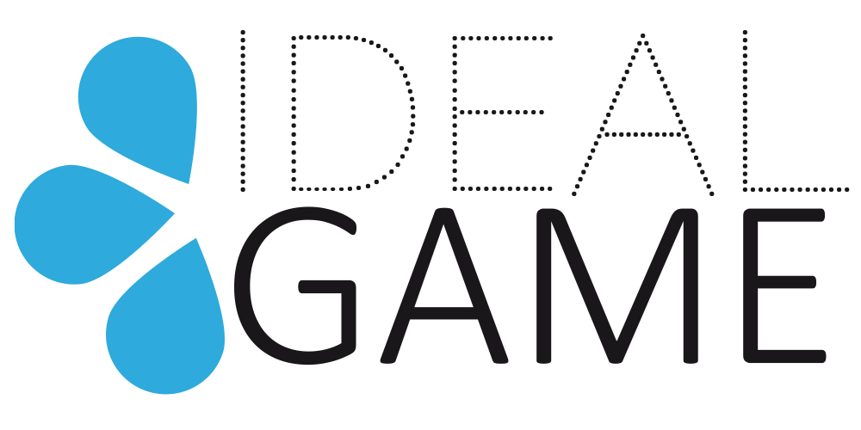

IDEAL-GAME
Improving didactics, education and learning
in higher education with the Online Serious Game Creator

Online article 1 (EN)
Sebastian Koppius, UPB

Project Title: Improving didactics, education and learning
in higher education with the Online Serious Game Creator
Acronym: IDEAL-GAME
Reference number: 2020-1-DE01-KA203-005682
Project partners: P1 University Paderborn (UPB), DE
P2 Ingenious Knowledge GmbH (IK), DE
P3 Universitatea din Pitesti (UPIT), RO
P4 Wyzsza Szkola Ekonomii i Innowacji w Lublinie (WSEI), PL
P5 University of Dundee (UoD), UK
P6 Universidad a Distancia de Madrid SA (UDIMA), ES

Serious Games in Higher Education - The Erasmus+ Project IDEAL-GAME
The lecture degenerates into a monotony of the teacher and the students threaten to lose interest and attention? Without doubt, everyone has already made this experience. In the future, the Online Serious Game Creator Tool - IDEAL-GAME could be a great solution.
Playfully expanding professional and subject-related vocabulary, correctly assigning facts and terms, or testing new problem-solving strategies are just a few examples of the great potential of serious games. With the right balance between knowledge transfer and game fun, serious games are also undoubtedly suitable for higher education. In this context, the use of serious games can make the course more varied and thus increase the students' activity and attention to the subject matter.
The limitations of implementing serious games into everyday university life are slowed down by a lack of platforms, design difficulties, and a lack of creativity, so that teachers often remain stuck in traditional teaching patterns.
This is where the Erasmus+ project IDEAL-GAME ("Improving didactics, education and learning in higher education with the Online Serious Game Creator"), funded by the European Union, comes in.
On the one hand, the project deals with the improvement of university teaching for an illustration of the lecture content on the part of the teachers. On the other hand, it promotes active immersive learning on the part of the learners.
The main objective of the IDEAL-GAME project is to create an online serious game creator tool for higher education. Teachers should be able to create tailor-made Serious Games for their lectures and seminars with the help of the created creator tool. Nevertheless, the project provides the user with already existing serious games, which in combination with supplementary learning materials serve as first inspiration for the creation of further games. In due course, a handbook will provide guidance for the creation of serious games as well as implementation strategies for lecture and seminars. Especially in the IDEAL-GAME project, Serious Games are tested in connection with the Flipped Classroom concept. In the Flipped Classroom, learners prepare new content, concepts and theories in self-directed learning (online) and use the lecture for discussions and comprehension questions.
The 28-month project (funding period 01.09.2020 to 31.12.2022) is coordinated by the University of Paderborn in Germany and represented by Prof. Dr. Marc Beutner. The other five European project partners are: Ingenious Knowledge GmbH (Germany), Universitatea din Pitesti (Romania), Wyzsza Szkola Ekonomii i Innowacji w Lublinie (Poland), University of Dundee (UK) and Universidad a distancia de Madrid SA (Spain).
What are the main objectives?
- Research on learning with serious games in higher education
- Development of the Online Serious Game Creator Tool
- Making Serious Games and learning materials available as OER, which have been embedded and tested in learning scenarios
- Providing a handbook with information about the creator tool and didactical guidelines
- Creation of a Policy Paper and Layman Report

What are the project aims to produce:

Based on the main objectives, the following aims are to produce:

(1) Online IDEAL-GAME Serious Game Creator Tool
(2) 50 Serious Games for inspiration and further usage
(3) Flipped Classroom concept
(4) Collection of best practice of teaching resources
(5) Research report on the use of Serious Games in higher education
(6) IDEAL-GAME Policy Paper
(7) IDEAL-GAME Website
(8) IDEAL-GAME Disseminations materials
(9) IDEAL-GAME Didactical handbook for lecturers
(10) IDEAL-GAME Tool handbook for lecturers
(11) IDEAL-GAME Handbook for students
(12) IDEAL-GAME Video presentation of the tool

What has already happened?
The project officially started on 1st September 2020. Shortly after, the project consortium met for the kick-off meeting. This meeting took place between 8th and 10th of December 2020 online due to the Corona pandemic and was hosted by the project partner Ingenious Knowledge (Germany).
The purpose of this meeting was to enable partners to introduce themselves to each other, to discuss the project objectives and activities along with planning the initial tasks for all partners.
All project objectives were considered and discussed in detail, including administrative & financial issues such as aspects of dissemination & exploration and evaluation & reporting procedures.

What are the next steps?
Until the second project meeting at the University of Dundee (Scotland) in June 2021, all project partners will start with desktop research as well as field-based research which focusses on using and learning with serious games in higher education. Also, each partner has to look for a best practice serious game in the respective country. The research results provide the basis for the development and creation of learning and teaching materials. In addition, the project consortium regularly conducts dissemination and dissemination activities.

How can you contact IDEAL-GAME?
Visit our website https://ideal-game.eduproject.eu/ or contact the project partner in your home country directly!

