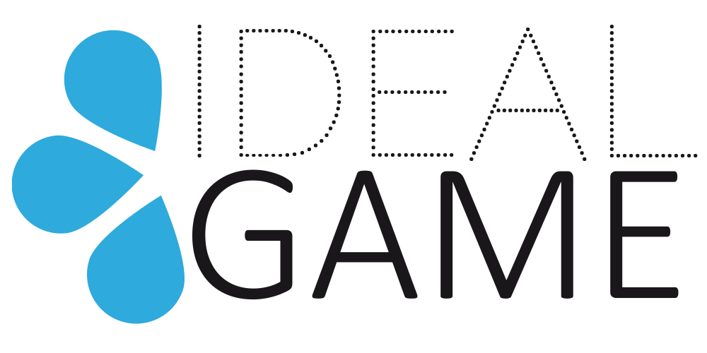
IDEAL-GAME
Improving didactics, education and learning
in higher education with the Online Serious Game Creator

The IDEAL-GAME OER strategy

Project Title: Improving didactics, education and learning
in higher education with the Online Serious Game Creator
Acronym: IDEAL-GAME
Reference number: 2020-1-DE01-KA203-005682
Project partners: P1 University Paderborn (UPB), DE
P2 Ingenious Knowledge GmbH (IK), DE
P3 Universitatea din Pitesti (UPIT), RO
P4 Wyzsza Szkola Ekonomii i Innowacji w Lublinie (WSEI), PL
P5 University of Dundee (UoD), UK
P6 Universidad a Distancia de Madrid SA (UDIMA), ES

The IDEAL-GAME OER strategy

The Erasmus+ Project IDEAL-GAME goes beyond the advantages of Open Educational Resources and the umbrella term of open education. This opening up idea is a way of carrying out education and knowledge by often using digital technologies. This aims to broaden the access and participation for everyone who is interested in the project, in its intellectual outcomes as well as in its IDEAL-GAME mini serious game creator, by removing barriers of time, space and access as well as monetary boundaries and limits. The idea of opening up education is an is an important item on the European policy agenda for many reasons:
- “First, it can help to reduce or remove barriers to education (e.g. cost, geography, time, entry requirements). This gives learners the opportunity to up skill or re-skill at a lower or nearly no cost, and in a flexible way.
- Second, it supports the modernisation of higher education in Europe, since contemporary open education is largely carried out via digital technologies.
- Finally, it opens up the possibility of bridging non-formal and formal education. This can take place if HE institutions and other accredited institutions recognised the credentials they each issue to learners.”
Therefore, the European Commission defines the open education idea as
"a way of carrying out education, often using digital technologies. Its aim is to widen access and participation to everyone by removing barriers and making learning accessible, abundant, and customisable for all. It offers multiple ways of teaching and learning, building and sharing knowledge. It also provides a variety of access routes to formal and non-formal education, and connects" (Opening up Education: A Support Framework for Higher Education Institutions, 2016)”
To guarantee the open education idea, the resources have to be open, too. This means, we need content that is “libre” – open licensed content and free of charge. One very popular and common free licence for educational materials is the Creative Commons License. The American non-profit organization Creative Commons has released several copyright licenses, which are known as Creative Commons licenses and are different in their openness. Regarding Open Educational Resources (OER) it is necessary and increases the usefulness and efficiency for learners, if the materials are free of charge and free to be used, shared, remixed, adapted, distributed etc. The factor of openness differs with the type of licence. The following six different license types of Creative Commons License are listed from most to least permissive:

Types of Creative Common License

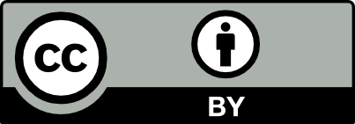 | “ CC BY: This license allows reusers to distribute, remix, adapt, and build upon the material in any medium or format, so long as attribution is given to the creator. The license allows for commercial use.  CC BY includes the following elements:  BY – Credit must be given to the creator
- CC BY-SA: This license allows reusers to distribute, remix, adapt, and build upon the material in any medium or format, so long as attribution is given to the creator. The license allows for commercial use. If you remix, adapt, or build upon the material, you must license the modified material under identical terms.
CC BY-SA includes the following elements:
BY – Credit must be given to the creator
SA – Adaptations must be shared under the same terms

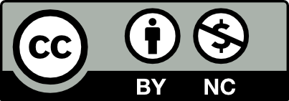 | - „CC BY-NC: This license allows reusers to distribute, remix, adapt, and build upon the material in any medium or format for noncommercial purposes only, and only so long as attribution is given to the creator.  It includes the following elements:  BY – Credit must be given to the creator  NC – Only noncommercial uses of the work are permitted”
- „CC BY-NC-SA: This license allows reusers to distribute, remix, adapt, and build upon the material in any medium or format for noncommercial purposes only, and only so long as attribution is given to the creator. If you remix, adapt, or build upon the material, you must license the modified material under identical terms.
CC BY-NC-SA includes the following elements:
BY – Credit must be given to the creator

NC – Only noncommercial uses of the work are permitted
SA – Adaptations must be shared under the same terms

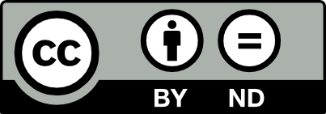 | - CC BY-ND: This license allows reusers to copy and distribute the material in any medium or format in unadapted form only, and only so long as attribution is given to the creator. The license allows for commercial use.  CC BY-ND includes the following elements:  BY – Credit must be given to the creator  ND – No derivatives or adaptations of the work are permitted
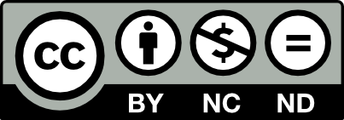 | - „CC BY-NC-ND: This license allows reusers to copy and distribute the material in any medium or format in unadapted form only, for noncommercial purposes only, and only so long as attribution is given to the creator.  CC BY-NC-ND includes the following elements:  BY – Credit must be given to the creator  NC – Only noncommercial uses of the work are permitted  ND – No derivatives or adaptations of the work are permitted”
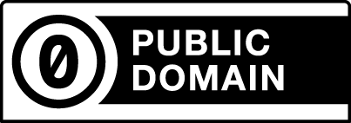 | “The Creative Commons Public Domain Dedication  CC0 (aka CC Zero) is a public dedication tool, which allows creators to give up their copyright and put their works into the worldwide public domain. CC0 allows reusers to distribute, remix, adapt, and build upon the material in any medium or format, with no conditions.”

Focus on IDEAL-GAME:

Erasmus+ has an open access requirement for all materials developed through its projects. That means, that if the European founded project is producing intellectual outputs/ tangible deliverables, the consortium has to describe how they intend to ensure free access for the public to a digital form of their material. If they intend to put any limitation on the use of the open licence a description of reasons, extent and nature of this limitation hat to be added.

Moreover, Pawlowski argued that it is crucial for Europe to engage a broad community in cross-border collaboration to be successful. His EU vision paper ´Open Education 2030´ shows six recommendations: (see Pawlowski, p. 78)
- to create an inventory of OER and OEP,
- to integrate existing communities,
- to integrate curricula,
- to create regional networks,
- to create global outreach programs,
- to support Open Education Policy.
This is well aware for the IDEAL-GAME partnership. The information and results will be available as open educational resources on the IDEAL-GAME website and on European portals.
The IDEAL-GAME team offers all information and will be rated with its results in the rating tool of the former ERASMUS+ project EU-StORe which provides information on high quality OER.

Creative Commons Licence for IDEAL-GAME:
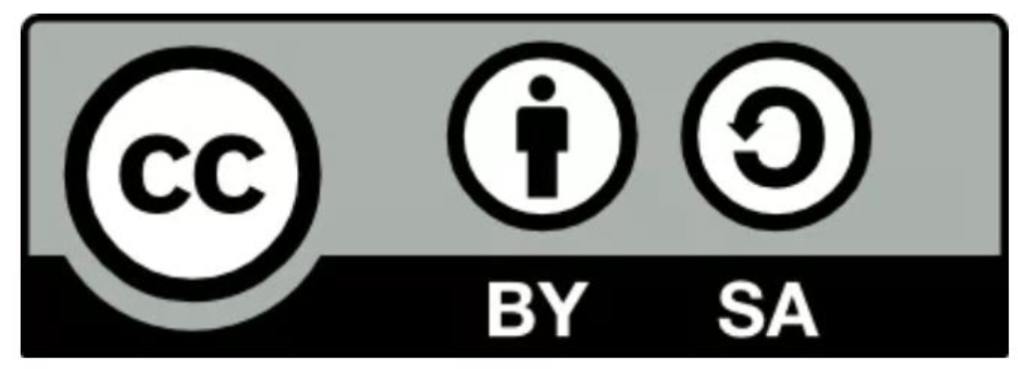

Target Group of IDEAL-GAME:
To reach a broad audience it is crucial that learning materials like the mini serious games as well as additional materials and resources are developed as open educational resources (OER) and can be accessed easily and without any cost. Only this can bring digitisation on HE a step ahead and offers the same possibilities to every HE provider and enterprise.

Intellectual Outcomes of IDEAL-GAME:
All created intellectual outcomes including IDEAL-GAME mini serious game creator, additional learning materials etc. are published under Creative Commons: CC- BY- SA 4.0

Insights from the IDEAL-GAME application:
- IO3 – OER Development of Serious Games and learning materials and Implementation
  - The partners create online mini serious games tailormade for their lecturers. In addition to the games, instructions and additional materials are created for the implementation of the games in the lectures.
  - The online observatory will be an open educational resource.
  - It will be integrated in a website.

- IO4 Development of Books
- The partners create an Ideal GAME tool handbook for students, IDEAL GAME tool handbook for lecturers as well as a didactical handbook for students. These books will support the use of IDEAL-GAME mini serious game creator as well as the learning materials for the lecturers.
- The handbooks will be an open educational resource

Link to Online Resource: https://ec.europa.eu/jrc/en/open-education, access date: 16.05.2022.
Link to Online Resource: https://ec.europa.eu/jrc/en/open-education, access date: 16.05.2022.
Online Source: https://ec.europa.eu/jrc/en/open-education/oer, based on OpenEdu Framework, 2016.
Creative Commons- Link: https://creativecommons.org/about/cclicenses/, access date: 01.04.2021.
Creative Commons- Link: https://creativecommons.org/about/cclicenses/, access date: 01.04.2021.
Creative Commons- Link: https://creativecommons.org/about/cclicenses/, access date: 01.04.2021.

