

**Newsletter - Issue 4**



**Coming next…**

* Multiplier Event
* Experience transfer
* 5th IDEAL GAME - Meeting in Germany (Paderborn)
* Creation of Handbooks

**What IDEAL GAME is about?**

The IDEAL-GAME mini serious game creator is the result of an Erasmus+ project of the same name (IDEAL-GAME - Improving didactis, education and learning in higher education with the Online Serious Game Creator [ IDEAL-GAME]), carried out in cooperation with 5 different partners from 4 different countries.

The tool promotes the universal implementation of mini serious games tasks in everyday university life. The tool should be as simple and straightforward to use as possible.

A total of 8 universally applicable game types are now available on the IDEAL-GAME Creator. They are as follows

But that is not the end of the story. If you have suggestions for new games, if you see improvements, please contact us and get in touch with us. We are willing to create more games for the IDEAL-GAME Creator.

**Serious Games**

**Get access to the IDEAL-GAME**

https://idealgame.eduproject.eu/

**What do I have to do to play games?**

No personal data is required to play games on the IDEAL-GAME Creator. Only an e-mail address and a password are required for registration.

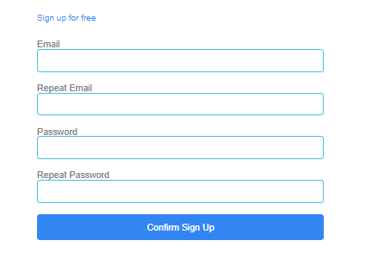

**How to get connected with IDEAL GAME:**

Visit our website:

https://ideal-game.eduproject.eu/

or contact the partner in your home country! (details on the website)

**Do you want to be kept up to date?**

Then visit our social media channels as well:

IDEAL GAME Facebook:

https://www.facebook.com/Erasmus-Project-IDEAL-GAME-100195691949187/?view_public_ for=100195691949187

IDEAL GAME Twitter:

@IdealGame3

**Games – Part 2**

|  |  |
| --- | --- |
|  | **Conversation Game**  The Conversation Game is about choosing a correct answer from two possible answers. For this, a statement or a question and two possible answers are created. If the correct answer is chosen, the players get a new question/statement and have to choose between two answers again. |
|  | **Quiz Game**  The quiz game is about choosing a correct answer from four possible answers. A question is created and four possible answers. The players have to choose the correct answer. |
|  | **Explore Campus**  The Exploration Game offers the possibility to make assignments on pictures. A picture and possible places or objects are selected and the players have to name them correctly. |
|  | **Crane Game**  The Crane Game offers the possibility to arrange texts correctly. For this, excerpts from texts are displayed as containers that have to be placed in the correct order on a cargo ship to produce the correct text. The players have to select the text sections in the correct order on the cargo ship. Finally, a text is the result. |