

**Newsletter - Issue 3**



**Coming next…**

* Implementation and testing of the games
* Creation of more games
* 4th IDEAL GAME - Meeting in Spain (Madrid)
* Usability Study

**What IDEAL GAME is about?**

Eight different types of mini serious games were jointly developed within the Erasmus+ project IDEAL-GAME Improving didactics, education and learning in higher education with the Online Serious Game Creator (2020-1-DE01-KA203-005682). In the last 24 months, the project consortium consisting of 6 partners from 5 different countries designed the IDEAL-GAME Creator (https://idealgame.eduproject.eu/) with a variety of universally applicable mini serious games.

University of Paderborn in Germany, presented by Prof. Dr. Marc Beutner. The other five European partners are: Ingenious Knowledge GmbH (Germany); Universitatea din Pitesti (Romania,); Wyzsza Szkola Ekonomii i Innowacji w Lublinie (Poland); University of Dundee (UK); and the Universidad a distancia de Madrid SA (Spain).

**Serious Games**

**Get access to the IDEAL-GAME**

https://idealgame.eduproject.eu/

**What do I have to do to play games?**

No personal data is required to play games on the IDEAL-GAME Creator. Only an e-mail address and a password are required for registration.

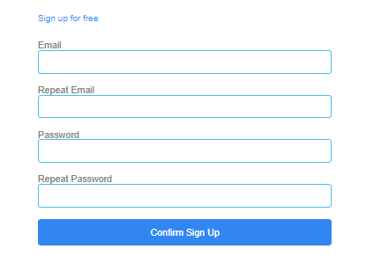

**How to get connected with IDEAL GAME:**

Visit our website:

https://ideal-game.eduproject.eu/

or contact the partner in your home country! (details on the website)

**Do you want to be kept up to date?**

Then visit our social media channels as well:

IDEAL GAME Facebook:

https://www.facebook.com/Erasmus-Project-IDEAL-GAME-100195691949187/?view_public_ for=100195691949187

IDEAL GAME Twitter:

@IdealGame3

**Games**

|  |  |
| --- | --- |
|  | **Raining Words**  Raining Words is a matching game. Categories and associated words are created. The categories are represented as books. The words fall from the top to the bottom. During the game, the players have to match the falling terms to the category books at the bottom. |
|  | **Collect Words**  Collect Words is a matching game. Here, a category is created along with associated and unassociated terms. The category is represented as a book that can be moved by the players. The correct and incorrect terms fall from the top to the bottom. The players have to decide which terms belong in the category (the book) and which do not. |
|  | **Memory**  In the memory game, matching terms have to be found. On a covered sheet of cards consisting of several terms, the players have to turn the cards over one after the other and find the correct pairs of terms. A pair can consist of two to four terms. |
|  | **Build a Bridge**  The Build a Bridge Game is about building a bridge using terms. The aim is to use the terms to represent a process and thus build the bridge. The players have to put the terms in the right order so that a bridge can be built. |

• • • • • •