

**Newsletter - Issue 2**



**Aims / Main objectives**

The IDEAL GAME project aims to design an Online Serious Game Creator and to create, test and evaluate Mini OER Serious Games within learning scenarios. Generally speaking, the approach aims to enhance didactics, education and learning in higher education with the help of an Online Serious Game Creator.

**What IDEAL GAME is about?**

The IDEAL-GAME mini serious game creator is the result of an Erasmus+ project of the same name (IDEAL-GAME - Improving didactis, education and learning in higher education with the Online Serious Game Creator [ IDEAL-GAME]), carried out in cooperation with 5 different partners from 4 different countries.

The tool promotes the universal implementation of mini serious games tasks in everyday university life. everyday university life. The tool should be as simple and straightforward to use as possible.

The project is financed by the European Union. The 28-month project (funding period 01.09.2020 to 31.12.2022) is coordinated by the University of Paderborn in Germany, presented by Prof. Dr. Marc Beutner. The other five European partners are: Ingenious Knowledge GmbH (Germany); Universitatea din Pitesti (Romania,); Wyzsza Szkola Ekonomii i Innowacji w Lublinie (Poland); University of Dundee (UK); and the Universidad a distancia de Madrid SA (Spain).

**Serious Games**

**Get access to the IDEAL-GAME**

https://idealgame.eduproject.eu/

**What do I have to do to play games?**

No personal data is required to play games on the IDEAL-GAME Creator. Only an e-mail address and a password are required for registration.

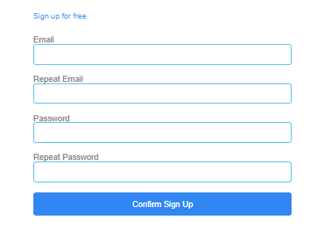



**How to get connected with IDEAL GAME:**

Visit our website:

https://ideal-game.eduproject.eu/

or contact the partner in your home country! (details on the website)

**Do you want to be kept up to date?**

Then visit our social media channels as well:

IDEAL GAME Facebook:

https://www.facebook.com/Erasmus-Project-IDEAL-GAME-100195691949187/?view_public_ for=100195691949187

IDEAL GAME Twitter:

@IdealGame3

**Coming next…**

* Discussion about possible games
* Implementation and testing
* 3rd IDEAL GAME - Meeting in Poland (Lublin)

**Groups**

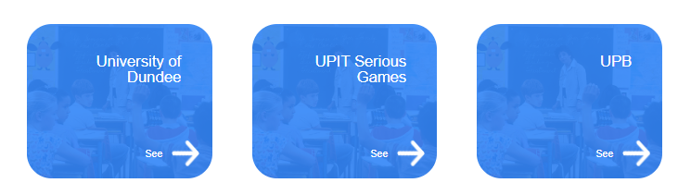

In addition to the games, it is possible to invite friends, students and colleagues in groups. These groups ensure networking of the partners and their games. All project objectives were considered and discussed in detail, including administrative & financial issues such as aspects of dissemination & exploitation and evaluation & reporting procedures.

• • • • • •