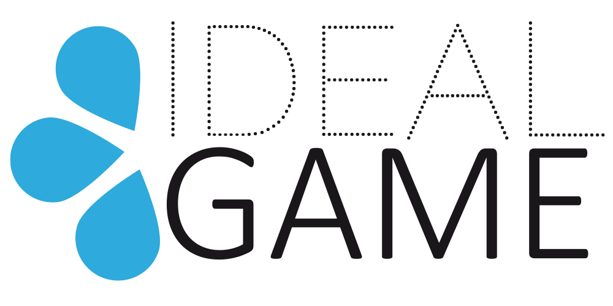
IDEAL-GAME
Improving didactics, education and learning
in higher education with the Online Serious Game Creator

M5 – Final Meeting
Meeting Evaluation

Project Title: Improving didactics, education and learning
in higher education with the Online Serious Game Creator
Acronym: IDEAL-GAME
Reference number: 2020-1-DE01-KA203-005682
Project partners: P1 University Paderborn (UPB), DE
P2 Ingenious Knowledge GmbH (IK), DE
P3 Universitatea din Pitesti (UPIT), RO
P4 Wyzsza Szkola Ekonomii i Innowacji w Lublinie (WSEI), PL
P5 University of Dundee (UoD), UK
P6 Universidad a Distancia de Madrid SA (UDIMA), ES

IDEAL GAME Final Meeting – Meeting Evaluation
The meeting evaluation of the 5th IDEAL Game project meeting shall give an overview of the feedback about the online partner meeting, hosted by UPB at the University of Paderborn.
This questionnaire will be handed out as an online survey after the meeting to evaluate the meetings content, the meetings design, the coordination and the results of the meeting.
The Final Meeting went very well. Experiences from the multiplier events and the daily work in teaching were exchanged. Tips and comments on the specification of the IDEAL-GAME Creator were brought to the programme makers and discussed via various dissemination channels.
The book is also almost finished at this point and is being proofread by the partners from the UK.

Please find below the summarised evaluation data:
----------------------------------------------------------------------------------- Question 1:
How do you agree with the following statements?
 | Totally disagree | Partly disagree | Partly agree | Totally Agree | I don´t know | Σ
The conference lived up to my expectations. |  |  |  | 7  (100,00% |  | n=7
The conference objectives were clear to me. |  |  |  | 7  (100,00% |  | n=7
The difficulty level of this conference was appropriate. |  |  |  | 7  (100,00% |  | n=7
The conference contents were presented in an engaging way. |  |  |  | 7  (100,00% |  | n=7
The conference was interesting. |  |  |  | 7  (100,00% |  | n=7
The coordination was well prepared. |  |  |  | 7  (100,00% |  | n=7
The coordination was helpful. |  |  |  | 7  (100,00% |  | n=7
Overall, I am happy with the conference results. |  |  |  | 7  (100,00% |  | n=7
I have a clear picture now of the projects’ next steps. |  |  | 1  (14,28%) | 6  (85,71%) |  | n=7
I know what my tasks for the upcoming period are. |  |  | 2  (28,57%) | 5  (71,43%) |  | n=7

Question 2:
Do you have any concerns regarding the development process in IDEAL GAME so far?
(n=12)
x Yes (n=0),
X No (n=7)
Do you have any concerns with the quality of the management or collaboration of the project so far?
(n=12)
x Yes (n=0),
X No (n=7)

Question 3:
What would you like to suggest for the future cooperation / communication in the IDEAL GAME project?
(n=4)
- The more in person meetings, the better cooperation and results
- n/a
- n/a
- table with tasks and deadlines was helpful for us.

Question 4:
Please describe any Dissemination & Exploitation activities or measures you undertook so far related to the IDEAL GAME project.
(n=4
- Promoting IDEAL GAME Creator among lecturers and students
- We designed and printed new flyers to dissemination of the project in the university. We also publish the progress of the project in our newsletter and publish posts in our website and social media
- Publishing materials on social media, professional groups and FB.
- Publication of materials on social media, facebook and professional groups

Question 5:
What else would you like to pass on? Are there any other issues for discussion?
(n=5)
- It is a very practical and useful tool. It would be fine to continue the development of the IDEAL GAME Creator in the future
- No
- It was fine
- All was clear, the organisation was very well done
- All was OK & clear

Thank you for participating in the survey!

