IDEAL-GAME
Improving didactics, education and learning
in higher education with the Online Serious Game Creator

3rd Steering Committee
03rd of March 2022, 4p.m. to 6p.m.
Meeting Minutes

Project Title: Improving didactics, education and learning
in higher education with the Online Serious Game Creator
Acronym: IDEAL-GAME
Reference number: 2020-1-DE01-KA203-005682
Project partners: P1 University Paderborn (UPB), DE
P2 Ingenious Knowledge GmbH (IK), DE
P3 Universitatea din Pitesti (UPIT), RO
P4 Wyzsza Szkola Ekonomii i Innowacji w Lublinie (WSEI), PL
P5 University of Dundee (UoD), UK
P6 Universidad a Distancia de Madrid SA (UDIMA), ES

2nd Steering Committee – Meeting Minutes
Date: 26th of August 2021
Start: 4p.m.
End: 6p.m.
Participations: Divja Jindal-Snape, Gabriela Plaiasu, Karolina Rzechula, Silvia Prieto, Marc Beutner
Name of transcript writer: Marc Beutner

These meeting minutes include the main statements from the IDEAL GAME 2nd Steering Committee - Meeting. This Steering Commitee Meeting was held online via Zoom on 26/08/202q from 4p.m. to 6p.m. The results are fixed in these minutes.

Agenda:
- Project timeline - Current status of IOs
- Project timeline - Transnational meetings

Topic 1: Project timeline - Current status of IOs
IOs:
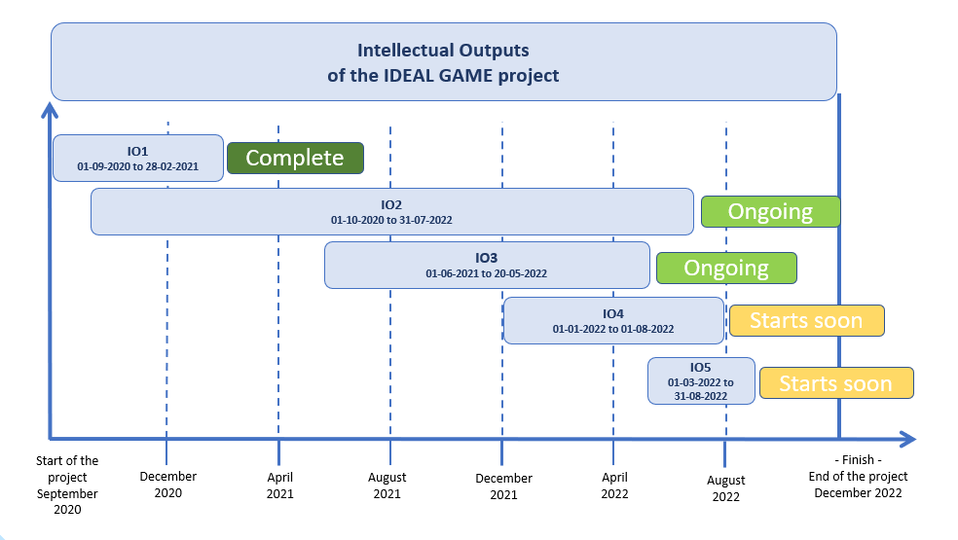

- IO1: almost successfully completed
- IO2: Organisation and planning is advanced (First ideas are implemented)
- IO3: Organisation and planning is advanced (Materials and games are being planned)
- IO4: starting soon
- IO5: starting soon

Topic 2: Project timeline - Transnational meetings:
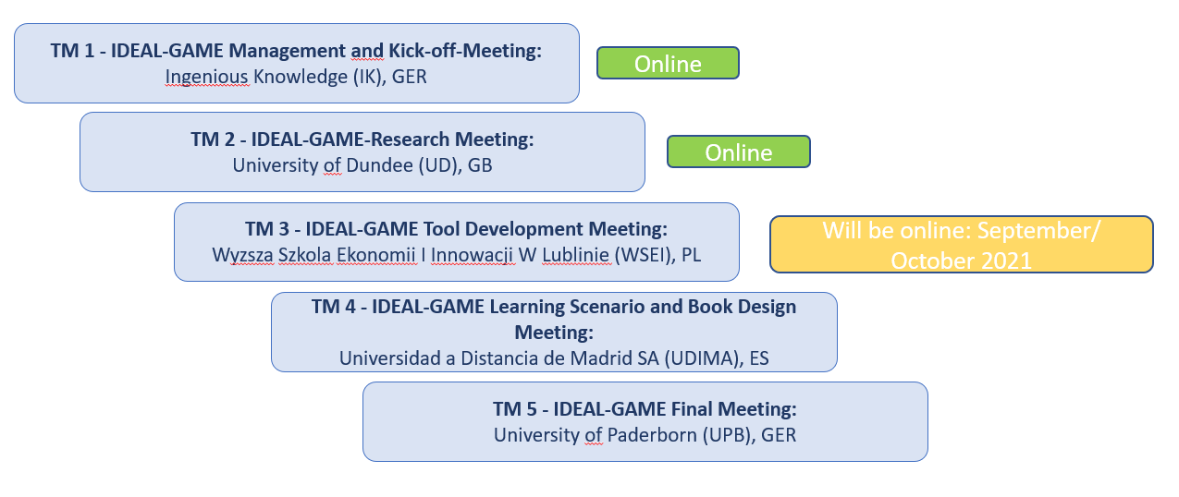

According to the plan, the third project meeting will take place in November 2021 at the University of Innovation and Economics in Lublin (PL).
- Due to the short time span between Meeting 2 and Meeting 3, the project meeting will rather take place in November.
- WSEI will decide on a date as soon as possible

As the project started in 2020 and all partners have already gained experience in dealing with projects during the Corona pandemic, no risks are expected.

Summarised, we are well in time.

